ESCUELA SUPERIOR POLITECNICA DEL LITORAL
Centro de Lenguas Extranjeras
CELEX – ESPOL
Basic B
Mid-term exam v14

- Reading Section (15 marks)
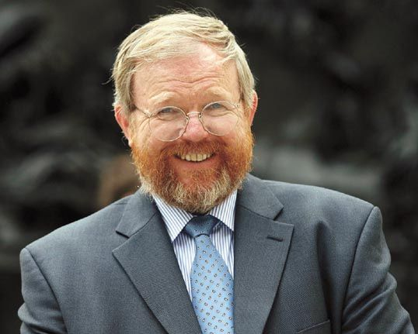

Read the article about Bill Bryson, a writer. Do the activities.

I was born in the United States but I have written several travel books about England. I lived there with my wife and four children for 20 years, but for the last three years we have lived in the United States. Our children are now learning about life in the United States. I’m sure they will be happier because they have lived in two countries. I like Britain I want to return, but my daughter Felicity, is going to start college here soon, so it won’t be for another four years.
I have just been to England for six weeks to work on a radio programme about the English language and also to talk about the book I’ve just written. Most writers don’t like doing this; they don’t like travelling around the country, selling their book. I don’t mind it. I like visiting new places and meeting lots of people. It’s very different from the life I have in the United States when I’m writing. In England, people drove me around in big cars and I stayed in expensive hotels. It was good because I didn’t have to pay any bills. Everyone was kind to me and it was fun.

Decide if these sentences are True or False. If they are false, correct them to make them true. (5 marks)
- Bill returned to the United States after living in England for a long time
- Bill has just visited England to finish writing his new book
- Bill thinks it will be good for his children to live in more than one country
- Bill doesn’t enjoy visiting new places.
- It cost bill a lot of money to travel around England for six weeks.

Find synonyms for these words in the text: (2 marks)
- Some (paragraph 1)
- University (paragraph 1)
- It’s OK for me (paragraph 2)
- Nice and helpful (paragraph 2)

Read the article about crocodiles. Choose the correct words (8 marks)

We can find crocodiles in tropical parts of (0) the/an/a world, for example Africa, South America and Northern Australia.
They spend most of the time (10) in/on/at slow-moving water but they (11) are/can/have move fast through the water and on land.
You often see crocodiles together in large groups. They (12) eats/eat/ate everything they catch (13) by/like/to fish, birds and small animals. And sometimes they make a meal of large animals or even people.
There are (14) more/most/many than ten types of crocodile. They all have very sharp teeth. They often lose (15) this/that/these teeth, but soon get new ones.
Crocodiles are usually about 3,5 metres long, but some are much (16) bigger/big/biggest. Crocodiles live (17) for/since/during a long time. The oldest one kept in a zoo was 66 years old.

- Use of English (25 marks)

Match the correct word or phrase from the box to the verb (6 marks)

this exam in love on a date a lot harder to Italy someone out ten kilos her for the first time married up with my girlfriend a new job smoking

18. get __________
19. lose __________
20. move __________
21. stop __________
22. work __________
23. pass __________
24. go __________
25. fall __________
26. meet __________
27. get __________
28. break __________
29. ask __________

Write the question for the information in bold (5 marks)
- ____________________
She’s very shy.
- ____________________
He likes cooking and painting.
- ____________________
They live in Spain with their grandma.
- ____________________
No, I haven’t. I’ve never eaten sushi.
- ____________________
Marco visited Galapagos last year.

Fill in the gap with might or the correct form of be going to. (4 marks)
- I _______________ meet tony for coffee at 5:30 this evening.
- We ______________ go to Australia or New Zealand on holiday but we’re not sure.
- She ______________ learn to play football or perhaps tennis. It depends on her friends.
- They _____________ start university in the UK on September 30th

Fill in the gap with a word from the box (2.5 marks)

Kind funny middle-aged generous shy
- My parents are about 55 years old. They’re ________
- She likes to buy presents for people. She’s ________
- He finds it difficult to talk to people. He’s ________
- Her aunt likes doing things to help people. She’s ________
- He’s really good at making people laugh. He’s ________

Fill in the gap with the correct form of the verb. Use the Present Perfect or Past Simple (5 marks)

- We ______________ to South America last year (go)
- Ian Fleming ___________ fourteen James Bond books before he died. (write)
- I _____________ here for twenty-five years. I love it. (work)
- We ____________ next door to my sister until last year (live)
- They _____________ to the west coast of America before (not go)

Choose the best answer (2,5 marks)

- I want _________ a computer course next year
- to do b. doing

- I don’t enjoy ________ in rivers
- to swim b. swimming

- I would like _______ an actor
- to become b. becoming

- I need _______ some more sugar
- to get b. getting

- Jim enjoys ________ his family every weekend
- visiting b. visit

- Listening Section (10 marks)

Listen to four conversations. Choose the correct answer (6 marks)

- 54. When was Oliver’s birthday?
- October 11th b. October 21st
- 55. When is the girl’s birthday?
- 11th May b. 11th April
56. Were they both born the same day?
- yes b. no
- 57. The woman was
- sad b happy
- 58. How many eggs do they need?
- 20 b. 12
59. How many potatoes do they need?
- a kilo b. 2 kilos

Have you ever? Listen and decide if these sentences are True or False (4 marks)

60. Ryan and Tara are going somewhere in Europe for their honeymoon.
61. They are going to go to Spain
62. Ryan hasn’t been to Paris.
63. Ryan has been to Venice
64. Ryan hasn’t been to Italy before
65. Tara’s visited Brazil
66. Tara’s been to Mexico
67. Tara has been to Europe before.

- Writing Section (15 marks)

Question One: Imagine you’re on holiday in a place you know well. Write a postcard describing the place you’re staying, the weather, places you went to and things you did there.

Question Two: What are your plans for next year? Any resolutions? Write about them.

Question Three: I really need to lose weight and get fit. What advice can you give me?

V. Oral (15 marks) VI. Homework and tests (20 marks)

