**Appendix 1**

**Chart 1.1 – Total Market: Imports, Volumes in TEU**



Source: Global Trade Navigator (GTN), JOC numbers used for MEX as not included in GTN data

**Chart 1.2 – Maersk Line imports by Country, volumes in TEU**

Source: RKMS2, Full Year 2008 volumes as per Freight List Estimate

**Chart 1.3 Maersk Line Import Market Share by Country**



Source: ML volumes RKMS2, Total Market Volumes GTN Global Trade Navigator, JOC used for MEX total mkt volumes

**Chart 1.4 Total Market Exports, Volumes in TEU**



Source: Global Trade Navigator (GTN), JOC numbers used for MEX as not included in GTN data

**Chart 1.5 Maersk Line Exports, Volumes in TEU’s**



Source: RKMS2, Full Year 2008 volumes as per Freight List Estimates

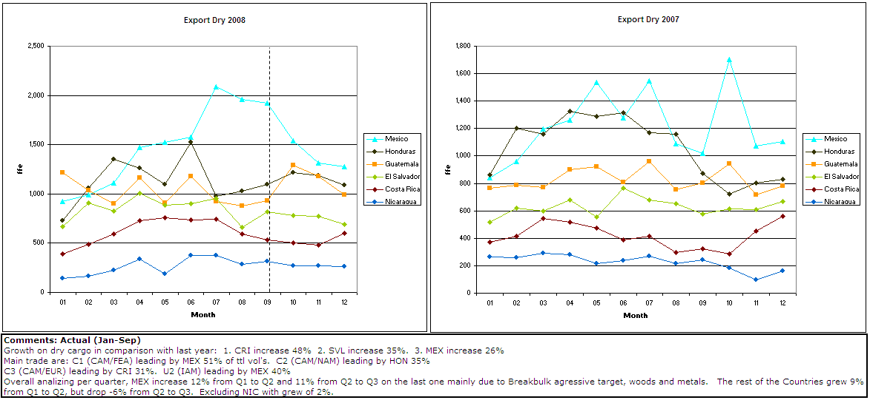

**Appendix 2**

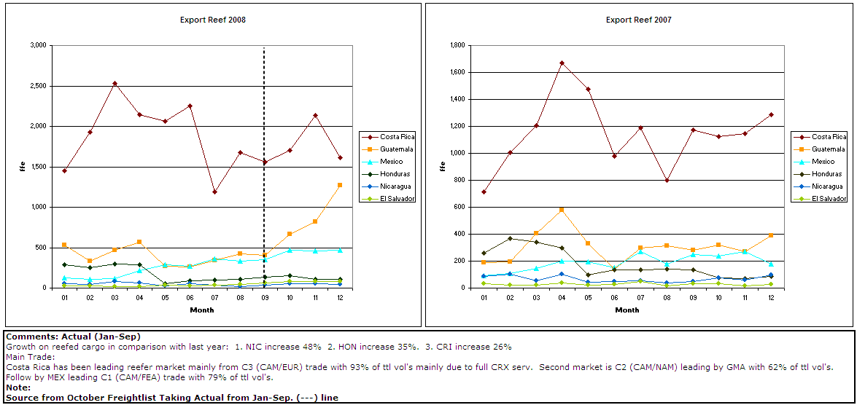

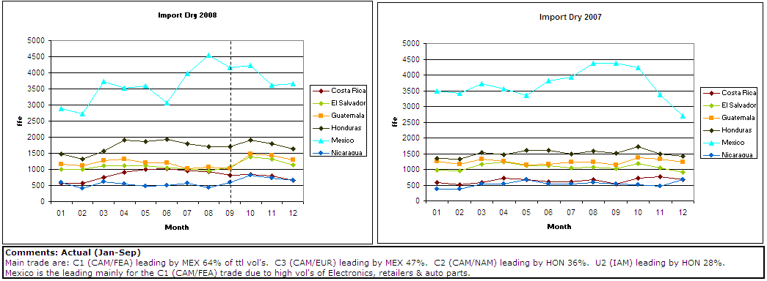

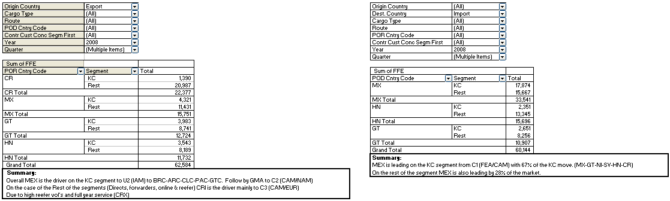

**Appendix 3**

**ML - Export 2008**

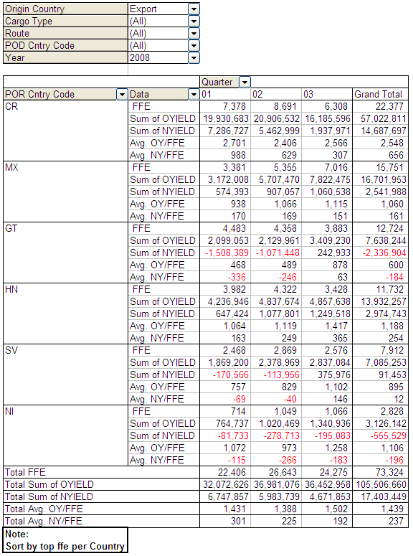

**ML - Export Dry 2008-2007**

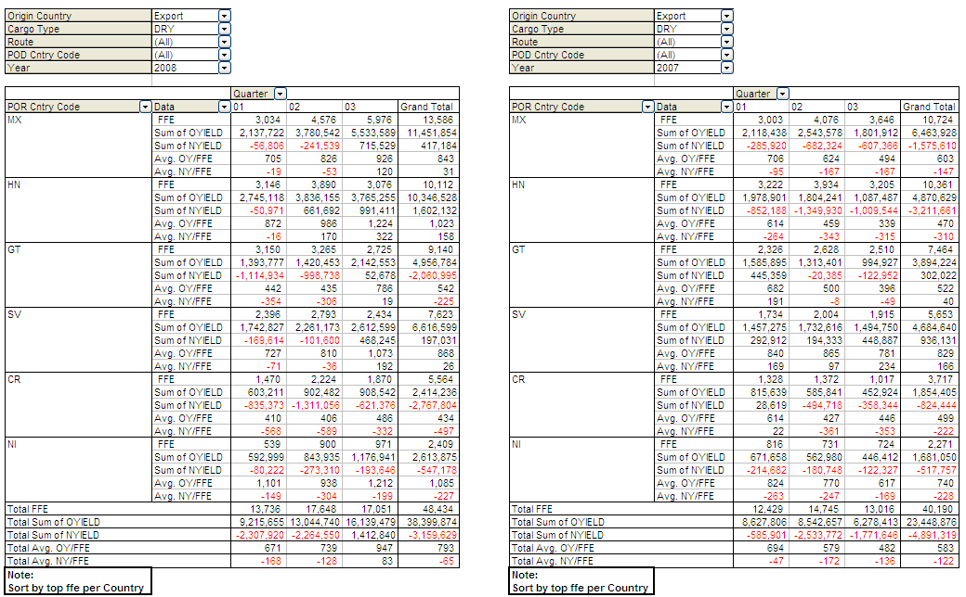

**ML - Export Reef 2008-2007**

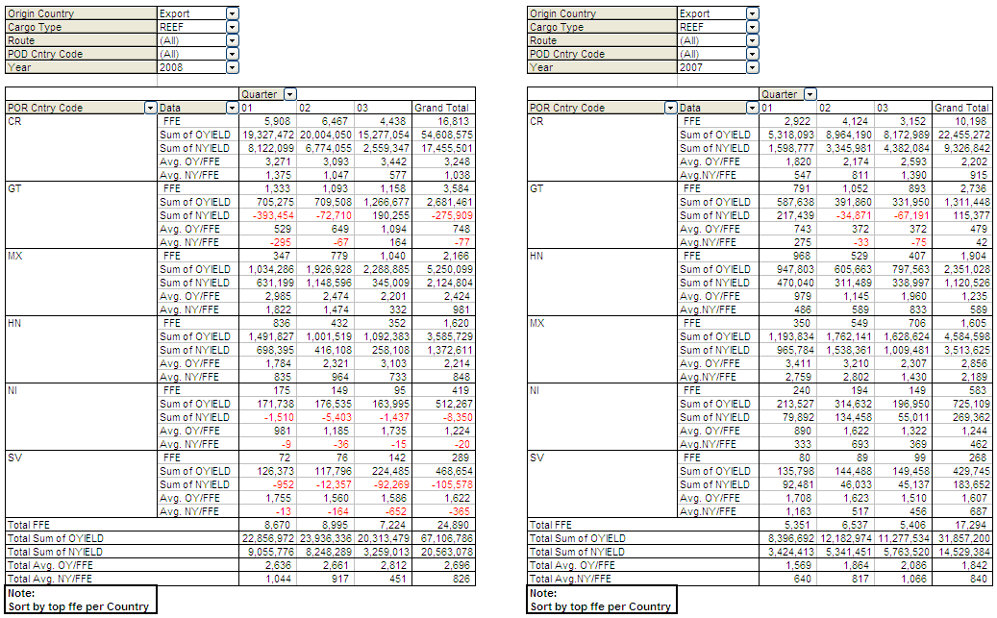

**ML - Import 2008-2007**

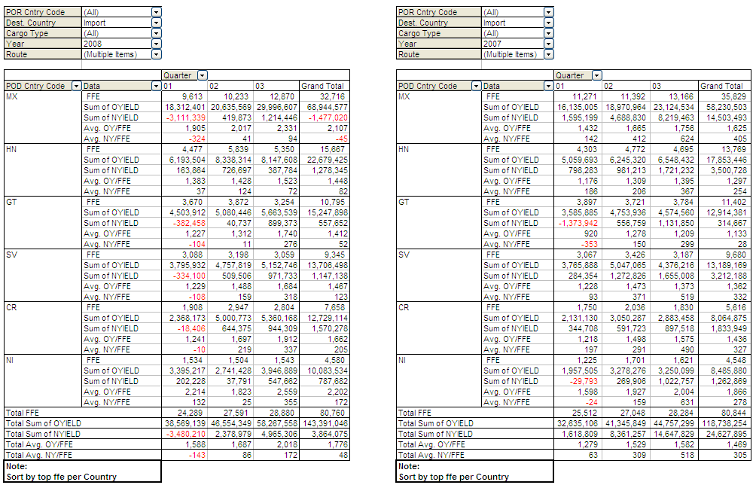

**Appedix 4**

**Economic Indicators**

|  |  |  |
| --- | --- | --- |
| **GDP Growth (%)[1]** | **2008** | **2009** |
| **Belize** | 4 | 2.5 |
| **Costa Rica** | 4 | 3.5 |
| **El Salvador** | 3 | 2.6 |
| **Guatemala** | 4.5 | 4 |
| **Honduras** | 4 | 4.2 |
| **Mexico** | 2.05 | 1.8 |
| **Nicaragua** | 3 | 3.5 |

* Mexico’s GDP is nine times larger than the combined GDP of Guatemala, Costa Rica, El Salvador, Honduras, Nicaragua and Belize. This is about the same ratio that the U.S. GDP has to the Mexican.
* Mexico’s GDP compared to the Guatemala’s, which is the second largest in the region, is twenty-six times larger.
* Comparing Guatemala (the largest) and Mexico (smallest) GDP growth in the region. The Mexican net growth represents twelve times more in US dollars.
* Mexican exports are 9.5 times larger than those of Guatemala, Costa Rica, Honduras, El Salvador, Nicaragua and Belize.
* Mexican imports are six times larger than those of the same countries.
* Mexico has the most equilibrated trade balance; imports are only three percent more than exports.
* El Salvador and Guatemala have the worst trade balance; imports are 100% and 82% more than exports, respectively.

**Appendix 5**

**Ahorros por reducción de personal**

**Appendix 6**

**Ahorros por en la cuenta corporativa**



1. IMF estimates.