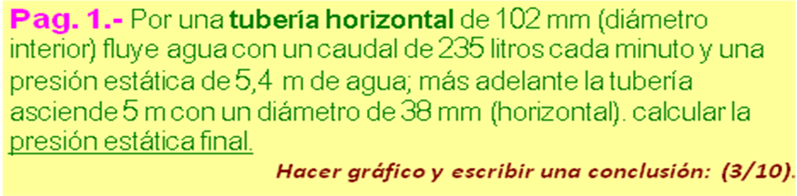
ρ _{AGUA =} | 1000 | kg /m³
1 m³ ₌ | 1000 | Litros



D1 | 102 | mm |  | 0,008171 | m2 (A1)
Q | 235 | Lt /min |  | 0,0039 | m3 /s
y1 | 5,4 | m
h2 | 5 | m
D2 | 38 | mm |  | 0,001134 | m2 (A2)
v1 =Q /A1 |  | v1 |  | 0,4793 | m/s
v2 =Q /A2 |  | v2 |  | 3,4535 | m/s
 | y2 =((g*(y1-h2)+(v1^2-v2^2)/2)/g)*100
 |  | y2 | -19,6782 |  | cm

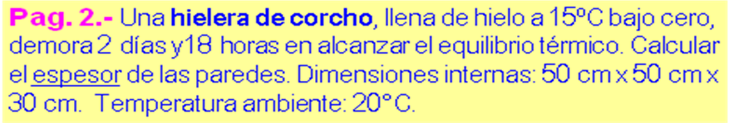
AGUA
c _{AGUA =} | 1,0 | cal /gr-ºC
HIELO
c _{HIELO =} | 0,5 | cal /gr-ºC
ρ _{HIELO =} | 0,92 | gr /cm³
L_{f HIELO =} | 80,0 | cal /gr
CORCHO
k _{CORCHO =} | 0,0004 | cal/ cm-s-ºC
ρ _{CORCHO =} | 0,15 | gr /cm³



t _{INT} | -15,0 | ºC | -15,0 | ºC
t _{EXT} | 20,0 | ºC | 20,0 | ºC
x | 50 | cm
y | 50 | cm | 11.000,0 | cm² (A)
z | 30 | cm | 75.000,0 | cm³ (Vol)
 | 2,0 | días | 69.000,0 | gr (m)
 | 18,0 | horas | 237.600,0 | s (Δt)
Δ_{Q} = m *(c_{HIELO}*abs( t_{INT}) +Lf _{HIELO} +c_{AGUA}*abs( t_{EXT}))
 |  | Δ _{Q} | 7.417.500 | cal
 | Esp = t* (A *k *(abs(t _{EXT)} + abs(t _{INT)}) / Δ_{Q}
 |  | e | 4,9330 | cm

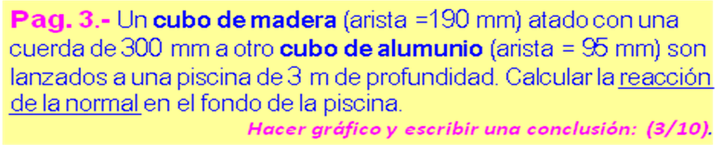
P_{ATM} = | 101325 | Pa
ρ _{MADERA =} | 810 | kg /m³
ρ _{ALUMUNIO =} | 2700 | kg /m³
ρ _{AGUA =} | 1000 | kg /m³



a _{MAD} | 190 | mm | 0,0069 | m³ (V_{M})
a_{ALUM} | 95 | mm | 0,0009 | m³ (V_{A})
 |  |  | 5,5558 | kg (m_{M})
 |  |  | 2,3149 | kg (m_{A})
 |  |  | 54,4467 | N (w_{M})
 |  |  | 22,6861 | N (w_{A})
 |  |  | 67,2182 | N (E_{M})
 |  |  | 8,4023 | N (E_{A})
 |  | F = w_{M} +w_{A} -E_{M} -E_{A}
 |  | F | 1,5124 | N

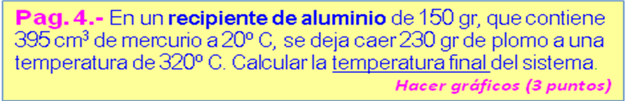
ALUMINIO
c _{ALUM =} | 0,2100 | cal /gr-ºC
ρ _{ALUM =.} | 2,7000 | gr /cm³
MERCURIO
c _{MERC =} | 0,0330 | cal /gr-ºC
ρ _{MERC =} | 13,6000 | gr /cm³
PLOMO
c _{PLOMO =} | 0,0310 | cal /gr-ºC
ρ _{PLOMO =.} | 11,4000 | gr /cm³
P.fusión _{PLOMO =.} | 327,00 | ºC



m_{ALUM} | 150,0 | gr
v_{MERC} | 395,0 | cm³ | 5.372,0000 | gr
T₁ | 20,0 | ºC
m_{PLOM} | 230,0 | gr
T₂ | 320,0 | ºC
T₃ ₌ (T₁*(m_{ALUM}*c_{ALUM} +m_{MERC}*c_{MERC} ) +m_{PLOM}*c_{PLOM}*T₂)
(m_{ALUM}*c_{ALUM} +m_{MERC}*c_{MERC} +m_{PLOM}*c_{PLOM})
 |  | T₃ | 29,9071 | ºC

