APÉNDICE A

TABLA DE RECOLECCIÓN DE DATOS

Semana #
PREAVISO |  |  |  |  | SEVERIDAD
Pl # | EF | H2 | H3 | H4 | 1 | 2 | 3 | 4 | 5 | 6 | 7 | 8 | 9 | 10 | 11 | 12 | 13 | 14 | 15 | 16 | TH
1 | 13.6 | -1 | -2 | -2 | 0 | 0 | 0 | 0 | 0 | 0 | 0 | 0 | 1 |  |  |  |  |  |  |  | 9
2 | 15.2 | 0 | 1 | -1 | 0 | 0 | 0 | 0 | 0 | 0 | c | 0 | c | 2 |  |  |  |  |  |  | 10
3 | 14.8 | -1 | -2 | 2 | 0 | 0 | 0 | 0 | 0 | 0 | 1 | 1 | 2 |  |  |  |  |  |  |  | 9
4 | 12.8 | -1 | -2 | -2 | 0 | 0 | 0 | 0 | 0 | 0 | 0 | 0 | 0 |  |  |  |  |  |  |  | 9
5 | 12.4 | -1 | 1 | -2 | 0 | 0 | 0 | 0 | 0 | 0 | 0 | 1 | 1 |  |  |  |  |  |  |  | 9
6 | 15.8 | 0 | 1 | 2 | 0 | 0 | 0 | 0 | 0 | 0 | 0 | 1 | 0 | 2 | 1 |  |  |  |  |  | 11
7 | 15.2 | 0 | -1 | -1 | 0 | 0 | 0 | 0 | 0 | 0 | 0 | 0 | 0 | 1 | 2 |  |  |  |  |  | 11
8 | 14.2 | 0 | -1 | -1 | 0 | 0 | 0 | 0 | 0 | 0 | 0 | 0 | 0 | 1 |  |  |  |  |  |  | 10
9 | 14.8 | -1 | -1 | -2 | 0 | 0 | 0 | 0 | 0 | 0 | 0 | 0 | 0 | 1 | 3 |  |  |  |  |  | 11
10 | 13.6 | -1 | -1 | 1 | 0 | 0 | 0 | 0 | 0 | 0 | 0 | 0 | 1 |  |  |  |  |  |  |  | 9
11 | 12.2 | -1 | -1 | -2 | 0 | 0 | 0 | 0 | 0 | 0 | 0 | 1 |  |  |  |  |  |  |  |  | 8
12 | 12.2 | 0 | 0 | -2 | 0 | 0 | 0 | 0 | 0 | 0 | 0 | 0 | 1 | 1 |  |  |  |  |  |  | 10
13 | 14.2 | 0 | -2 | -2 | 0 | 0 | 0 | 0 | 0 | 0 | 0 | 0 | 0 | 0 | 1 | 1 |  |  |  |  | 12
14 | 15.6 | -1 | 1 | 2 | 0 | 0 | 0 | 0 | 0 | 0 | 1 | 0 | 1 | 0 |  |  |  |  |  |  | 10
15 | 12.8 | -1 | 1 | 2 | 0 | 0 | 0 | 0 | 0 | 0 | 0 | 0 | 1 | 1 |  |  |  |  |  |  | 10
16 | 13.8 | 1 | -2 | -3 | 0 | 0 | 0 | 0 | 0 | 0 | 0 | 0 | 0 | 1 |  |  |  |  |  |  | 10
17 | 12.6 | -1 | -2 | -2 | 0 | 0 | 0 | 0 | 0 | 0 | 0 | 1 | 1 | 2 |  |  |  |  |  |  | 10
18 | 12.2 | -1 | -2 | 2 | 0 | 0 | 0 | 0 | 0 | 0 | 0 | 1 | 2 |  |  |  |  |  |  |  | 9
19 | 13.2 | 0 | 1 | 2 | 0 | 0 | 0 | 0 | 0 | 0 | 0 | 1 | c | 2 |  |  |  |  |  |  | 10
20 | 13.4 | 0 | 0 | -2 | 0 | 0 | 0 | 0 | 0 | 0 | 0 | 0 | c | 1 |  |  |  |  |  |  | 10
- | 13.6 | -1 | -2 | 2 | 0 | 0 | 0 | 0 | 0 | 0 | 0 | 0 | 2 |  |  |  |  |  |  |  | 9
- | 12.2 | 0 | 1 | -2 | 0 | 0 | 0 | 0 | 0 | 0 | 0 | 0 | 1 |  |  |  |  |  |  |  | 9
- | 12.2 | 0 | 1 | 2 | 0 | 0 | 0 | 0 | 0 | 0 | 2 | 1 |  |  |  |  |  |  |  |  | 8
- | 13.2 | 0 | 1 | 2 | 0 | 0 | 0 | 0 | 0 | 0 | 0 | 1 |  |  |  |  |  |  |  |  | 8
- | 12.8 | -1 | 2 | -3 | 0 | 0 | 0 | 0 | 0 | 0 | 1 | 1 |  |  |  |  |  |  |  |  | 8
- | 13 | 0 | -2 | -2 | 0 | 0 | 0 | 0 | 0 | 0 | 1 | 1 |  |  |  |  |  |  |  |  | 8
- | 13.8 | 0 | -2 | -3 | 0 | 0 | 0 | 0 | 0 | 0 | 0 |  |  |  |  |  |  |  |  |  | 7
- | 12.8 | -1 | 1 | 2 | 0 | 0 | 0 | 0 | 0 | 0 | 1 | 2 |  |  |  |  |  |  |  |  | 8
- | 14.2 | -1 | 1 | 2 | 0 | 0 | 0 | 0 | 0 | 1 | 2 | 3 |  |  |  |  |  |  |  |  | 8
- | 12.4 | -1 | -2 | -3 | 0 | 0 | 0 | 0 | 0 | 1 | 1 |  |  |  |  |  |  |  |  |  | 7
- | 12.4 | -1 | 2 | 3 | 0 | 0 | 0 | 0 | 0 | 0 | 1 | 1 |  |  |  |  |  |  |  |  | 8
- | 12.4 | 1 | -2 | 2 | 0 | 0 | 0 | 0 | 0 | 0 | 1 | 1 |  |  |  |  |  |  |  |  | 8
- | 11.2 | -1 | 1 | -3 | 0 | 0 | 0 | 0 | 1 | 1 | 1 |  |  |  |  |  |  |  |  |  | 7
- | 12 | 0 | -2 | -2 | 0 | 0 | 0 | 0 | 0 | 1 | 2 | 3 |  |  |  |  |  |  |  |  | 8
100 | 13.4 | -1 | 2 | 2 | 0 | 0 | 0 | 0 | 0 | 0 | 0 | 1 | 2 |  |  |  |  |  |  |  | 9
101 | 12.2 | -1 | -2 | 2 | 0 | 0 | 0 | 0 | 0 | 0 | 1 |  |  |  |  |  |  |  |  |  | 7
102 | 13.2 | -1 | 1 | 2 | 0 | 0 | 0 | 0 | 0 | 0 | 1 | 1 | 1 |  |  |  |  |  |  |  | 9
103 | 12.2 | -1 | 2 | 3 | 0 | 0 | 0 | 0 | 0 | 1 | 2 |  |  |  |  |  |  |  |  |  | 7
104 | 11 | 0 | -2 | 2 | 0 | 0 | 0 | 0 | 0 | 0 | 2 | 2 |  |  |  |  |  |  |  |  | 8
105 | 12.6 | 0 | -2 | 2 | 0 | 0 | 0 | 0 | 0 | 0 | 1 |  |  |  |  |  |  |  |  |  | 7

APÉNDICE B

ANÁLISIS UNIVARIADO PARA LAS VARIABLES ÍNDICE DE INFECCIÓN

 |  | IND1 | IND2 | IND3 | IND4 | IND5 | IND6 | IND7 | IND8 | IND9 | IND10 | IND11 | IND12
Mínimo |  | 0 | 0 | 0 | 0 | 0 | 0 | 0 | 0 | 0 | 0 | 0 | 0
Máximo |  | 14 | 18 | 17.78 | 20 | 17.78 | 27.27 | 17.14 | 21.82 | 21.82 | 16 | 20 | 13.33
Media |  | 4.17 | 4.48 | 4.44 | 5.10 | 5.60 | 7.57 | 5.07 | 5.97 | 7.61 | 5.49 | 6.76 | 5.19
Mediana |  | 2.86 | 2.5 | 2.86 | 4 | 4.44 | 5 | 4 | 5 | 6.67 | 4.44 | 6 | 4.44
Moda |  | 0 | 0 | 0 | 0 | 0 | 0 | 2 | 0 | 4.44 | 4.44 | 2.22 | 4
Desv. Estándar |  | 3.73 | 4.09 | 4.24 | 4.78 | 4.28 | 7.23 | 3.79 | 4.31 | 5.02 | 3.47 | 4.54 | 3.07
Varianza |  | 13.88 | 16.69 | 17.95 | 22.82 | 18.34 | 52.28 | 14.39 | 18.57 | 25.20 | 12.06 | 20.63 | 9.41
Sesgo |  | 0.63 | 0.84 | 0.88 | 0.81 | 0.87 | 1.39 | 1.29 | 1.02 | 0.89 | 0.58 | 0.94 | 0.73
Kurtosis |  | -0.44 | 0.29 | 0.28 | -0.09 | 0.26 | 1.25 | 1.49 | 1.11 | 0.16 | 0.06 | 0.61 | 0.28
CV |  | 0.89 | 0.91 | 0.95 | 0.94 | 0.76 | 0.96 | 0.75 | 0.72 | 0.66 | 0.63 | 0.67 | 0.59
Rango |  | 14 | 18 | 17.78 | 20 | 17.78 | 27.27 | 17.14 | 21.82 | 21.82 | 16 | 20 | 13.33
No. Observaciones |  | 105 | 105 | 105 | 105 | 105 | 105 | 105 | 105 | 105 | 105 | 105 | 105
Cuartiles | 25 | 0 | 0 | 0 | 0 | 2.22 | 2.22 | 2.22 | 2.68 | 4 | 3.095 | 2.68 | 2.5
 | 50 | 2.86 | 2.5 | 2.86 | 4 | 4.44 | 5 | 4 | 5 | 6.67 | 4.44 | 6 | 4.44
 | 75 | 6.67 | 7.5 | 7.085 | 8.165 | 8 | 10.455 | 7.27 | 8 | 10.385 | 7.5 | 9.545 | 6.67

APÉNDICE C

ANÁLISIS UNIVARIADO PARA LAS VARIABLES TIPO DE SUELO

 |  | Arena | Arcilla
Mínimo |  | 26 | 10
Máximo |  | 72 | 26
Media |  | 45.9 | 17.62
Mediana |  | 46 | 18
Moda |  | 26 | 16
Desv. Estándar |  | 11.26 | 3.54
Varianza |  | 126.72 | 12.55
Sesgo |  | 0.22 | 0.19
Kurtosis |  | -0.17 | 0.12
CV |  | 0.25 | 0.2
Rango |  | 46 | 16
No. Observaciones |  | 105 | 105
Cuartiles | 25 | 38 | 16
 | 50 | 46 | 18
 | 75 | 56 | 20

APÉNDICE D

GRÁFICO DE HISTOGRAMAS PARA LAS VARIABLES
ÍNDICE DE INFECCIÓN

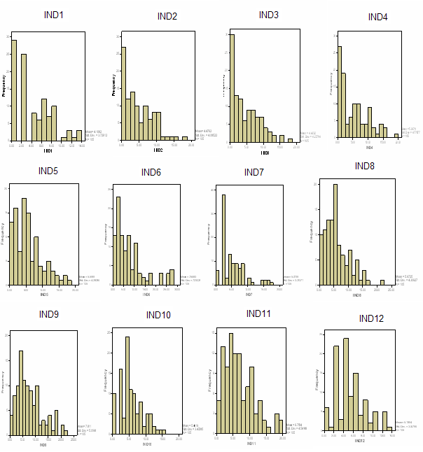

APÉNDICE E

GRÁFICO DE HISTOGRAMAS PARA LAS VARIABLES
TIPO DE SUELO

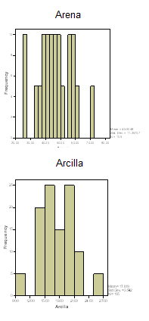

APÉNDICE F

DIAGRAMA DE CAJAS PARA LAS VARIABLES ÍNDICE DE INFECCIÓN

DIAGRAMA DE CAJAS PARA LAS VARIABLES TIPO DE SUELO

