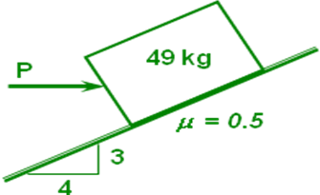

 | 49 | kN |  | 3
 | 0,5 | μ | 5 | 4
 | α =tan-1(8/15) |  | 36,8699
 | θ =tan-1 μ |  | 26,5651
 | Φ = θ −α |  | 10,3048
 | P = w ( tan Φ) |  | 8,9091 | kgf


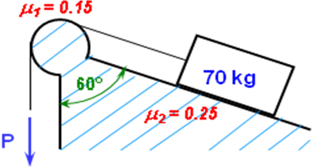

m | 70 | kg | 686,0000 | N (w)
μ₂ | 0,25
φ | 60 | º
 | T = w*(cos(φ*PI()/180) -μ2*sen(φ*PI()/180))
 |  | T | 194,4766433 | N
μ₁ | 0,15
 | Pmim = T / EXP(μ1*(180-φ)*(PI()/180))
 |  | P_{MIN} | 142,0463 | N
 | Pmax = T *EXP(μ1*(180-φ)*(PI()/180))
 | NO | P_{MAX} | 266,2595 | N

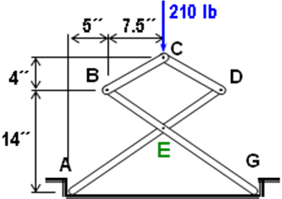

210 | lb | 4
7,5 | pulg | 7,5 | 8,5
5 | pulg | 14 | pulg
RBC=210/2 lb/(4/8,5); ΣFy
 | R_BC | 223,1250 | lb (C)
RGy=210/2 ; ΣMA
 | R_Gy | 105,0000 | lb
REy=RBC*(4/8,5)+RGy; ΣFy
 | R_Ey | 0,0000 | lb
 | EGy | 8,7500 | pulg
REx=RBC*((4/8,5)*20+(7,5/8,5)*14)/EGy; ΣMG
 | R_Ex | 555,0000 | lb

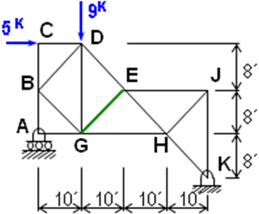

5 | K |  | 8
9 | K | 12,80624847 | 10
RA=(9k*3*10´+5k*3*8´)/(4*10´); ΣMK
 | R_A | 3,7500 | K
RDE=(RA*10´+5k*2*8´)/(2*8´*10/12,8); ΣMG
 | R_DE | 9,4046 | K (C)
REG=(RA-9k+RDE*(8/12,8))/(8/12,8); ΣFy
 | R_EG | 1,0005 | kN (C)

