**ANEXOS**

**ANEXOS 1.**

**Tabla de Datos.**

|  |  |  |  |  |  |  |  |  |  |  |  |  |  |  |  |
| --- | --- | --- | --- | --- | --- | --- | --- | --- | --- | --- | --- | --- | --- | --- | --- |
| **Macollos por planta** | | | | | | | | | | | | | | | |
|  | Tratamiento 1 | | | Tratamiento 2 | | | Tratamiento 3 | | | Tratamiento 4 | | | Tratamiento 5 | | |
| N. | R1 | R2 | R3 | R1 | R2 | R3 | R1 | R2 | R3 | R1 | R2 | R3 | R1 | R2 | R3 |
| 1 | 14 | 10 | 8 | 22 | 21 | 13 | 21 | 20 | 17 | 17 | 18 | 10 | 12 | 13 | 14 |
| 2 | 12 | 9 | 6 | 20 | 17 | 11 | 22 | 21 | 16 | 19 | 19 | 14 | 13 | 15 | 15 |
| 3 | 14 | 12 | 9 | 16 | 14 | 11 | 22 | 22 | 15 | 20 | 20 | 17 | 10 | 20 | 16 |
| 4 | 13 | 11 | 8 | 19 | 19 | 13 | 19 | 23 | 15 | 17 | 23 | 10 | 15 | 12 | 12 |
| 5 | 8 | 14 | 10 | 20 | 22 | 12 | 29 | 19 | 16 | 11 | 22 | 13 | 12 | 17 | 14 |
| 6 | 12 | 12 | 6 | 23 | 21 | 11 | 26 | 24 | 17 | 19 | 18 | 14 | 12 | 21 | 15 |
| 7 | 11 | 8 | 5 | 20 | 14 | 15 | 27 | 20 | 17 | 11 | 17 | 15 | 15 | 10 | 13 |
| 8 | 8 | 6 | 9 | 20 | 17 | 11 | 25 | 23 | 16 | 11 | 13 | 16 | 11 | 11 | 13 |
| 9 | 9 | 8 | 6 | 21 | 14 | 13 | 22 | 22 | 15 | 14 | 18 | 16 | 9 | 12 | 17 |
| 10 | 10 | 8 | 8 | 13 | 13 | 14 | 21 | 21 | 12 | 13 | 17 | 20 | 7 | 13 | 18 |
| 11 | 12 | 12 | 10 | 22 | 12 | 13 | 23 | 22 | 15 | 15 | 13 | 8 | 12 | 17 | 19 |
| 12 | 12 | 14 | 8 | 15 | 15 | 15 | 21 | 20 | 17 | 15 | 12 | 13 | 11 | 12 | 12 |
| 13 | 14 | 12 | 9 | 16 | 19 | 18 | 22 | 22 | 15 | 16 | 12 | 15 | 13 | 21 | 17 |
| 14 | 6 | 8 | 10 | 16 | 17 | 13 | 20 | 19 | 15 | 17 | 21 | 13 | 11 | 10 | 16 |
| 15 | 12 | 12 | 10 | 18 | 15 | 15 | 25 | 21 | 18 | 17 | 22 | 14 | 12 | 14 | 13 |
| 16 | 12 | 14 | 12 | 22 | 13 | 15 | 16 | 21 | 15 | 20 | 12 | 11 | 15 | 17 | 11 |

Tratamiento Variable n Media D.E. Var(n-1) Var(n) Mín Máx

1 Macollos 32 10.91 2.43 5.89 5.71 6.00 14.00

2 Macollos 32 17.69 3.28 10.74 10.40 12.00 23.00

3 Macollos 32 21.91 2.54 6.47 6.27 16.00 29.00

4 Macollos 32 16.53 3.53 12.45 12.06 11.00 23.00

5 Macollos 32 13.28 3.32 11.05 10.70 7.00 21.00

**ANEXO 2.**



***Amarillo. Repetición 1***

***Verde. Repetición 2***

***Gris. Repetición 3***

**ANEXO 3**

**Comparaciones de las medias de las medias de las repeticiones para cada tratamiento.**

T1: R1 = R2 = R3

T2: R1 = R2 = R3

T3: R1 = R2 = R3

T4: R1 = R2 = R3

T5: R1 = R2 = R3

|  |  |  |  |  |
| --- | --- | --- | --- | --- |
| Tratamiento | Repetición | n | Media |  |
| 1 | 1 | 16 | 11.19 | A |
| 1 | 2 | 16 | 10.63 | A |
| 1 | 3 | 16 | 8.38 | B |
| 2 | 1 | 16 | 18.94 | A |
| 2 | 2 | 16 | 16.44 | A |
| 2 | 3 | 16 | 13.31 | B |
| 3 | 1 | 16 | 22.56 | A |
| 3 | 2 | 16 | 21.25 | A |
| 3 | 3 | 16 | 15.69 | B |
| 4 | 1 | 16 | 17.31 | A |
| 4 | 2 | 16 | 15.75 | A B |
| 4 | 3 | 16 | 13.69 | B |
| 5 | 1 | 16 | 14.69 | A |
| 5 | 2 | 16 | 14.69 | A |
| 5 | 3 | 16 | 11.88 | B |

*Letras distintas indican diferencias significativas (p<= 0.05)****Tukey Nivel de confianza 95%***

**Anexo 4**

1. **Pruebas de normalidad**

|  | | | | | | | | | | |
| --- | --- | --- | --- | --- | --- | --- | --- | --- | --- | --- |
|  | | Kolmogorov-Smirnova | | | | | | Shapiro-Wilk | | |
| Estadístico | | gl | | Sig. | | Estadístico | gl | Sig. |
| Macollos_Planta | | .111 | | 160 | | .000 | | .968 | 160 | .001 |
| a. Corrección de la significación de Lilliefors   1. **Prueba de homogeneidad de varianzas** | | | | | | | | | | |
| Macollos_Planta | | | | | | | | | | |
| Estadístico de Levene | gl1 | | gl2 | | Sig. | |
| 2.755 | 4 | | 155 | | .030 | |

1. **Análisis de la varianza no parámetrica Kruskal Wallis.**

**Prueba de Kruskal Wallis**

Variable Tratamiento N Medias D.E. Medianas H p

Macollos 1 32 10.91 2.43 12.00 95.96 <0.0001

Macollos 2 33 17.55 3.33 17.00

Macollos 3 32 21.91 2.54 22.00

Macollos 4 32 16.53 3.53 17.00

Macollos 5 32 13.28 3.32 12.00

Trat. Medias Ranks

1 10.91 31.67 A

5 13.28 53.22 A

4 16.53 85.98 B

2 17.55 97.88 B

3 21.91 135.72 C

*Letras distintas indican diferencias significativas(p<= 0.05)*

**ANEXO 5**

**Tabla de datos para la variable rendimiento**

|  |  |  |
| --- | --- | --- |
| **Tratamiento** | **Repetición** | **Rendimiento** |
| 1 | 1 | 21.17 |
| 1 | 2 | 25.53 |
| 2 | 1 | 60.14 |
| 2 | 2 | 61.1 |
| 3 | 1 | 78 |
| 3 | 2 | 79.6 |
| 4 | 1 | 43.67 |
| 4 | 2 | 45.87 |
| 5 | 1 | 25.67 |
| 5 | 2 | 32.67 |

**Estadística descriptiva.**

Tratamiento Variable n Media D.E. Var(n-1) Mín Máx

1 Rendimiento 2 23.35 3.08 9.50 21.17 25.53

2 Rendimiento 2 60.62 0.68 0.46 60.14 61.10

3 Rendimiento 2 78.80 1.13 1.28 78.00 79.60

4 Rendimiento 2 44.77 1.56 2.42 43.67 45.87

5 Rendimiento 2 29.17 4.95 24.50 25.67 32.67

**ANEXO 6**

1. **Prueba de Homogeneidad de Varianzas**



1. **Prueba de Normalidad.**

**Shapiro-Wilks (modificado)**

Variable n Media D.E. W* p(Unilateral D)

Rendimiento 10 47.34 21.59 0.88 0.1905

1. **Análisis de la varianza.**

**Análisis de la varianza. Turkey 95%**

Variable N R² R² Aj CV

Rendimiento 10 0.99 0.98 5.84

**Cuadro de Análisis de la Varianza (SC tipo III)**

F.V. SC gl CM F p-valor

Modelo 4156.73 4 1039.18 136.14 <0.0001

Tratamiento 4156.73 4 1039.18 136.14 <0.0001

Error 38.17 5 7.63

Total 4194.89 9

Tratamiento Medias n E.E.

3 78.80 2 1.95 A

2 60.62 2 1.95 B

4 44.77 2 1.95 C

5 29.17 2 1.95 D

1 23.35 2 1.95 D

*Letras distintas indican diferencias significativas(p<= 0.05)*

**ANEXO 7**

**ANALISIS ECONOMICO DE CADA TRATAMIENTO**

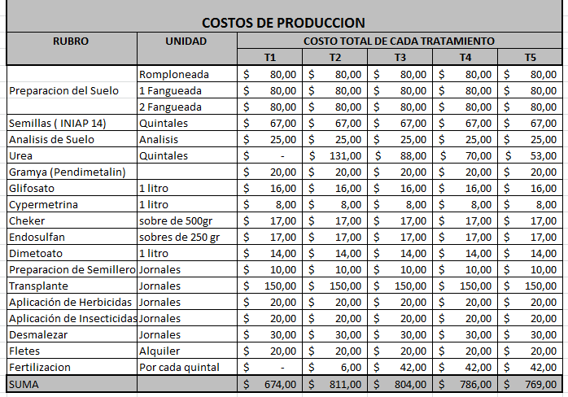

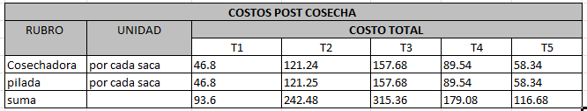

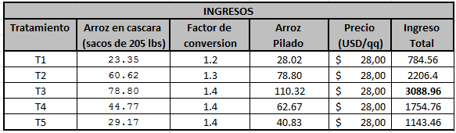

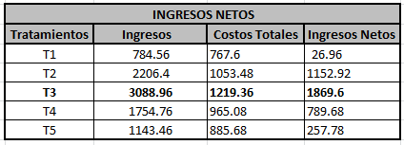

**APÉNDICES**

**Apéndice A**

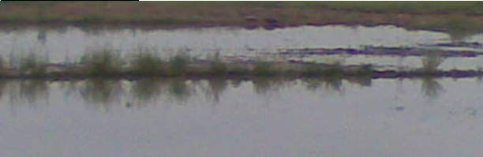**Secuencia de Fotos de las Primordiales Etapas de la Experimentación**

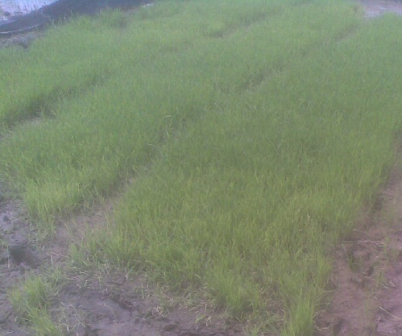

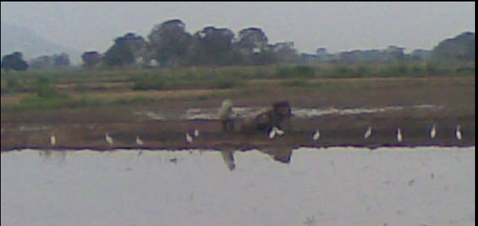

**Foto 1: Preparación y limpieza de Terreno Foto 2: Semillero de arroz**

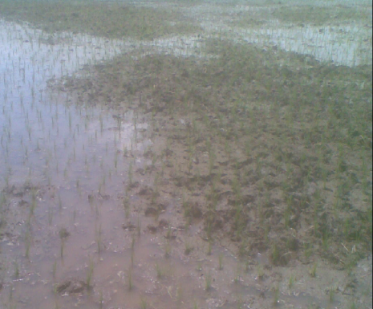

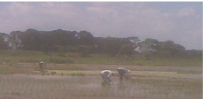

**Foto 3: Trasplanté de arroz Foto 4: Aplicación de Briquetas**

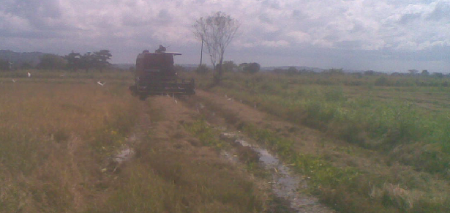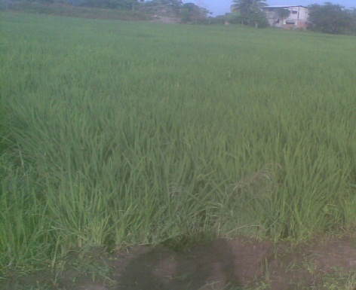

**Foto 5: Desarrollo del cultivo Foto 6: Cosecha de los tratamientos por etapas**

**Apéndice B**

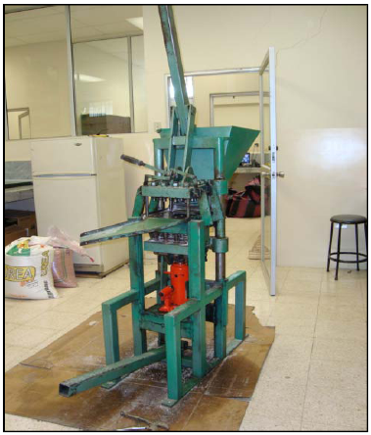 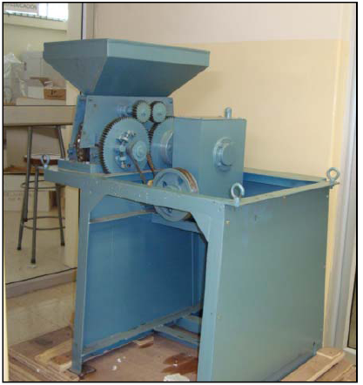

**Maquina Briqueteadora Manual Maquina Briqueteadora a Motor**



**Briqueta de 2.1 g Briqueta de 2.8 g Briqueta de 3.6 g**