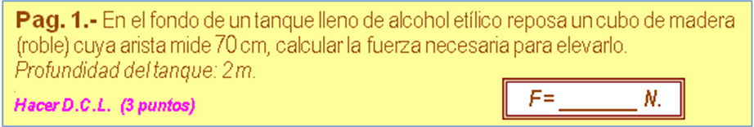
ρ _{AGUA} | 1000,00 | kg /m²
ρ _{ALCOHOL} | 790,00 | kg /m³
ρ _{MADERA} | 810,00 | kg /m³
P_{ATM} = | 101325 | Pa

a _{M} | 0,70 | m | 0,3430 | m³ (Vol)
 |  | m _{M} | 277,8300 | kg
 |  | w _{M} | 2.722,7340 | N
 |  | E _{M} | 2.655,5060 | N
 |  | F | 67,2280 | N

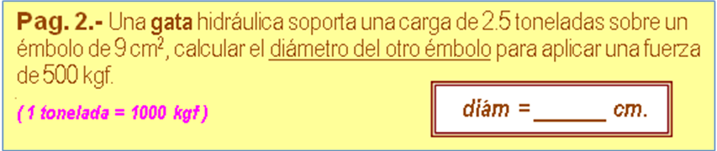

w | 2,5 | Ton | 2500,0000 | kgf
F | 500 | kgf
A₁ | 9 | cm2 | 3,3851 | cm (D1)
 | diám = (( F/w )^0,5)*D1
 |  | diám | 1,5139 | cm

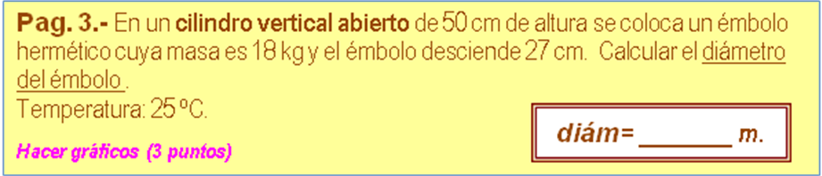

m | 18,00 | kg
T₁ | No | ºC
h₁ | 0,50 | m
Δh | 0,27 | m | 0,2300 | m (h₂)
 | D = (4*m*g /(pi()*(P_{ATM}*(h₁/h₂) -P_{ATM})))^0,5
 |  | D | 0,0435 | m

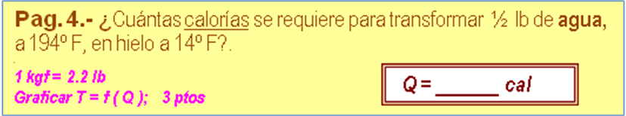
ρ _{HIELO =} | 0,92 | gr /cm³
ρ _{AGUA =} | 1,00 | gr /cm³
L_{f HIELO =} | 80,0 | cal /gr
L_{v AGUA =} | 540,0 | cal /gr
c _{HIELO =} | 0,50 | cal /gr-ºC
c _{AGUA =} | 1,00 | cal /gr-ºC
c _{VAPOR =} | 0,48 | cal /gr-ºC

t ₁ | 194,0 | ºF | 90,0000 | ºC
t _{f} | 32,0 | ºF | 0,0000 | ºC
t ₂ | 14,0 | ºF | -10,0000 | ºC
m | 0,50 | lb | 227,3 | gr
Δ_{Q} = (c_{AGUA}*(t f-T1) + c_{HIELO}*(T2 -t f ) -Lf _{HIELO} )*m
 |  | Δ _{Q} | -39.772,7 | cal

