STUDY OF THE WATER NOT ASSESSED FOR THE OPTIMIZATION OF AAPP's DISTRIBUTION SYSTEM IN THE HILL OF CARMEN.

Pedro Arévalo, David Matamoros

Facultad de Ingeniería en Ciencias de la Tierra, FICT-ESPOL, pedroarevalo_sms@hotmail.com
Ph.D., Facultad de Ingeniería Marítima y Ciencias del Mar, FIMCM-ESPOL, dmata@goliat.espol.edu.ec

Resumen

La presente Tesis de Grado es un proyecto realizado en coordinación con la concesionaria INTERAGUA en el Cerro del Carmen. INTERAGUA, a través de la Subgerencia de Agua No Contabilizada (ANC), realizó los estudios requeridos para el desarrollo del mismo. La Subgerencia de ANC, me encomendó este estudio como Jefe de Proyecto. El objetivo del estudio descrito a continuación persigue la reducción del agua no contabilizada (%ANC) en el Cerro del Carmen. Adicionalmente, se pretende optimizar el funcionamiento del sistema actual, obteniendo como resultado un sistema entendible, controlable y regulable en el tiempo estimado.

The present Thesis of Degree is a project realized in coordination with the concessionary INTERWATER in the Hill of Carmen. IT (HE,SHE) INTERWATERS DOWN, across the Submanagement of Not Assessed Water (NAW), it (he,she) realized the studies needed for the development of the same one. NAW's Submanagement, he (she) entrusted me this study as Project chief. The aim (lens) of the described study later Carmen chases (prosecutes) the reduction of the not assessed water (%NAW) in the Hill of. Additional, one tries to optimize the functioning of the current system, obtaining like proved an understandable, controllable and adjustable system in.

Abstract

- Introduccion

The concessionary INTERWATER gives his(her,your) services to the Canton Guayaquil from June 1, 2001. INTERWATER conciente of his(her,your) work in the Distribution system of Drinkable Water has begun a deep and meticulous study across AA.PP's Distribution management. It(He,She) manages this one, proposes to the Submanagement of Not assessed Water (ANC), the coordination of a project that allows to understand and to visualize the reality of the system in the city.
The principal directive of ANC's Submanagement, this one in finding those points (reasons and effects) that debilitate the service and with it to generate a project that corrects and regulates the system in estimated time.
This study divides in three Distribution zones: Zone North, divided in NORTH-EAST AND NORTHWEST; Zone Center and Zone South. Inside these zones there exist also a few subdivisions or sectors which allow that the study should be much more understandable, controllable and adjustable. The work in every subdivision it realizes across mike measurements which allow to visualize the reality in this point

- Location of the sector

The location of the sector, according to commercial cadaster it(he,she) is M-42-34. Distribution Center is located inside the Zone. This sector possesses(relies on) approximately 662 users in an area of 18.13 You have, and with a socioeconomic level of low type. The sector in study borders of the following way:
· In the northern part with the Avenue Pedro Menéndez Gilbert, as the Cooperative On June 29 and the citadel Dockyard.
· In the southern part with the street Julián Coronel and the central hull of the city (regenerated zone).
· In the eastern part with the street Morán of Wickerwork fish trap, as the hill " Holy Ana " and Rio "Guayas".
· In the western part with the citadels: Bolivariana, Poplars 1y 2.

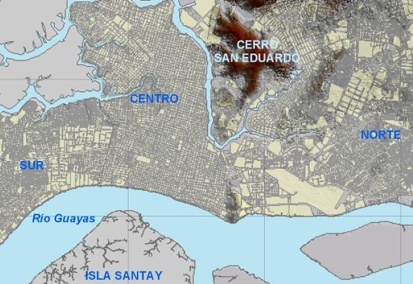
UBICACION DEL PROYECTO

Figura 1 Ubicación de la Zona en Estudio: Foto Satelital (INTERAGUA, 2007)

- Description of the system

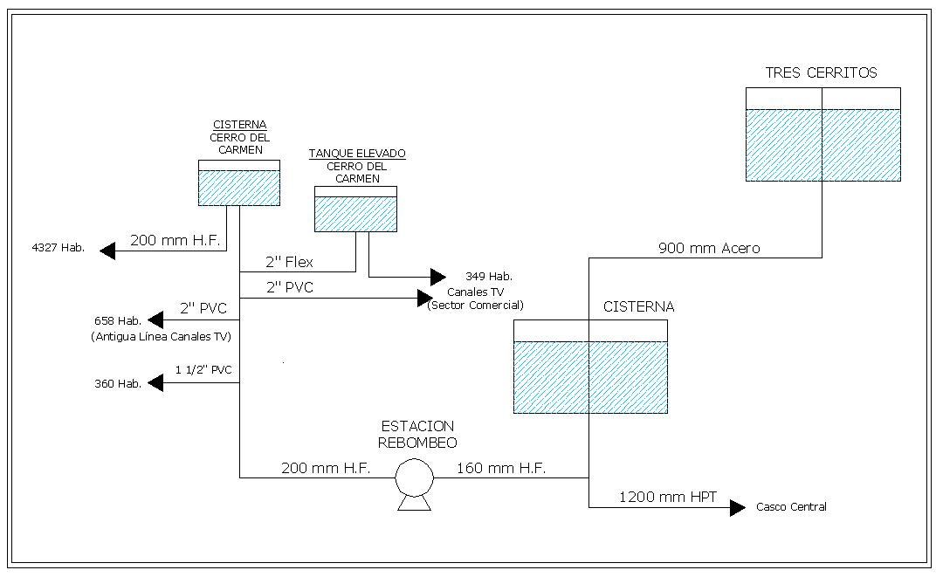
Figura 2 Esquema de Alimentación Actual – Cerro del Carmen

The Distribution system of Drinkable Water for the city Santiago of Guayaquil (Figure Sees 2), it(he,she) begins in the Plant(Floor) of Treatment " The Capture ". This Plant(Floor) of Treatment gathers the raw(unripe) waters or without treating of the river Daule, which are extracted by means of three stations of pumping. These waters are treated and sent to the station " Three Cerritos " for the supply of drinkable water of the City. " Three Cerritos ", it(he,she) supplies by means of a line of 1500 mm and 1200 mm to the west of the city and across a line of 900 mm it(he,she) supplies to a part of the central hull (regenerated zone) as well as also to the hills " Holy Ana " and " Carmen ".

The Hill of Carmen, belongs(concerns) to the zone Center in the distribution system of Drinkable water. Nowadays the distribution system in this sector realizes it by means of a CISTERN (160 m3), and a small HIGH TANK (10 m3), located in the high part of the hill to a level of +92.20 msnm.

These tanks supply across a system of pumping, which they suck directly of the reservorios 1A and 2A of 14500 m3 approximately, located on the level +41.00 msnm. The operation of the Station of Pumping is the following one: The system this one composed by two bombs of 75 HP and one of 60 HP, of which only one produces that of 75 HP the same ones that show themselves in the Photo 2, this one occurs manually. The pumping is realized in schedule of 4H45 to 13H00. During this time the cistern and high tank of the hill of Carmen constant are filled. The "problem" is generated in the water distribution, principally of the cistern. Or that, the distribution is not constant (unlike the pumping). Every hour and a half the distribution valve is opened (reguladamente) by the operators. Really they are 3 hours(o'clock) in which great part(report) of Carmen's hill is supplied during the day. The manual operation of the distribution valve, owes to that in the sector a regulation does not exist generating low pressures of up to(even) 3 mca in the high part and high pressures of up to(even) 50 mca in the low part.

The operation to the exit of the High Cistern is the following one: The pumping is realized in schedule of 4H45 to 13H00. Nowadays this sector supplies three times a day according to the level of the tank, this is, approximately of 06:00 to 07:30; of 09:30 to 10:30; of 12:00 to 13:30. This means that three times are closed the exits of the tank and one gives a service of discontinuous form from approximately 4 hours(o'clock) to the day. The high tank, it(he,she) possesses another dynamics of supply. This tank is supplied directly of the line of drive (hose flex 2 "), for it his(her,your) schedule of distribution depends directly on the schedule of the pumping. The problems that are generated in the zone of scope of the tank happen(pass) directly for the number of clandestine guides and the informality in his(her,your) connections generating visible escapes(fugues) in the system and big losses for the company.

- Aims(lenses)

4.1 Objective General

The aim(lens) of the described works later chases(prosecutes) the reduction of the not assessed water (%ANC) in the studied sector. Additional, it is claimed:
1. To optimize the functioning of the current system.
2. To look for the fulfillment of the contractual goals.
3. To obtain like proved an understandable, controllable and adjustable subsystem in the estimated time.

4.2 Specific aims (lenses)

· To reduce the ANC in the sector, by means of the detection and repair of physical losses (visible escapes(fugues)).
· To reduce the ANC in the sector, by means of the detection of commercial losses to orientate future actions(shares) on The part of the Commercial Submanagement. · Carmen Establishes the Regulation "tecnificada" of pressures in the sector of the Hill of, looking for the reduction of physical losses in the area. · Carmen Solves problems of high pressure in the low Part of the Hill of.
· To delimit and to form a sector of managing, control and total operation on the network(net).
· Education of the users on the rational use of the water.

5. Estimation of not assessed water

5.1 Fieldwork

Physical Losses

· The guide who supplies to the local channels presents three considerable escapes(fugues) in the first 20 m of tour, which have taken place(been produced) for escapes(fugues) due to the bad(wrong) existing unions in diverse sections of the same one and break of the guide of 2 ".
· In the high tank, the fraudulent connections of ½ ", ¾ " and 2 " possess escapes(fugues) due to break of hose, villains tie of the same ones and also badly adjustments of the keys of record, representing for the considerable company lost.
• What yes it exists between some people, is lack of consumption culture, because keys can be observed that properly are not closed, or that even, remain open.
• In the sector of alley 12 of October, visible flights appear each 2 ms, due to hose breakage of 2” and to the bad existing unions among them.

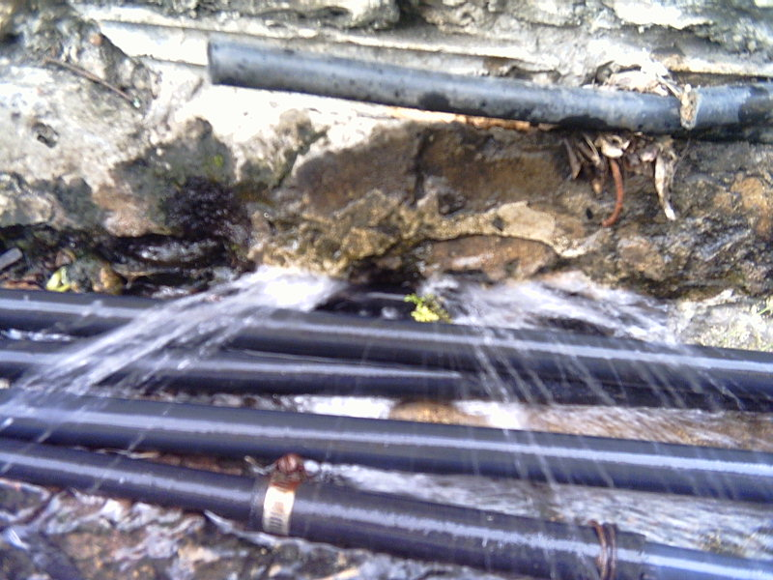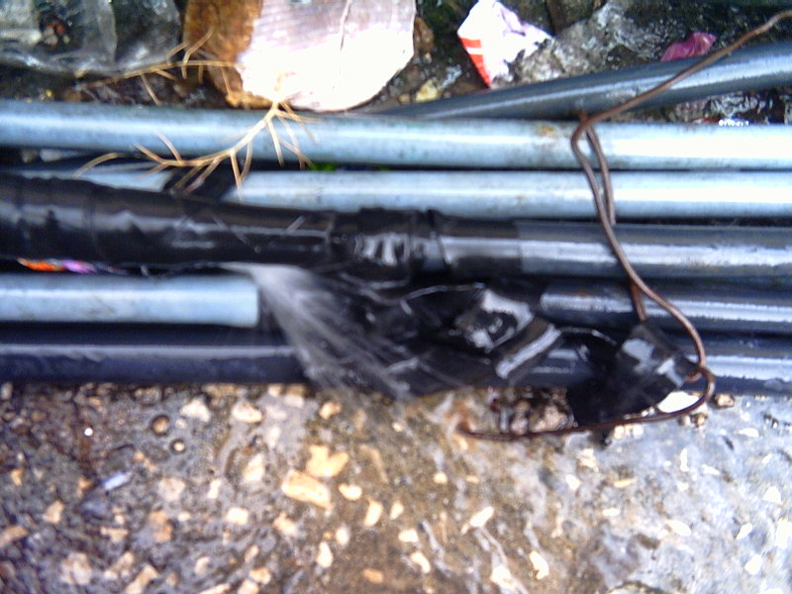
Foto 1 Callejón 12 de octubre, fugas visibles cada 2 m (roturas de mangueras)

Apparent losses

• From the month of August of the 2003 tank elevated in its line of distribution was altered by the inhabitants, connecting itself to her around 16 hoses of 2 “, of fraudulent way (they do not have measurer some), the same ones that but ahead are divided clandestinely. At the moment are three lines of distribution: first (connection which it supplies the house of the guardian) of 2”, a second pipe of 2” that connects to several lines of ½ and ¾ and finally one third of ¾ that is connected ahead with hoses of ½ but.
• One of the exits of the high tank has a hose of 2 “that supplies to the house of the guardian, does not have measurer some. According to version of the implied one, an agreement between the body of firemen and the old ECAPAG exists within which the loan of the facilities for the distribution use settled down whenever the gentleman guardian receives the service of water gratuitously.

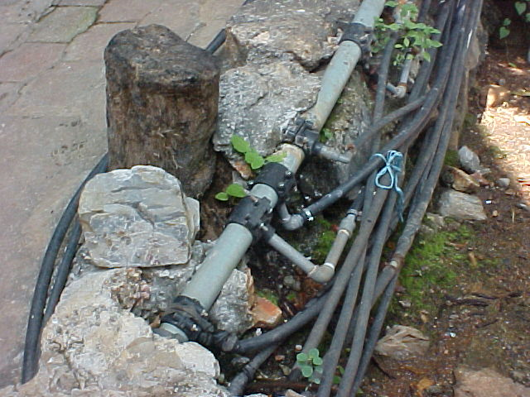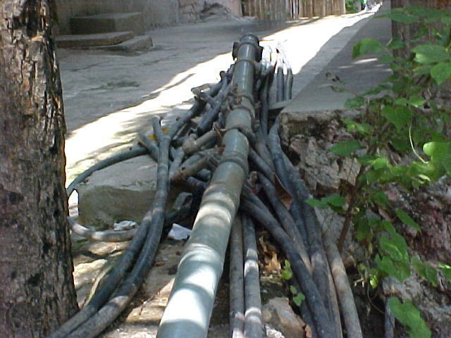

Foto 2 9no. Callejón, conexión ilegal de 30 mangueras de ½” a una tubería P.V.C de 2”.

5.2 Work of office

• To diminish the ANC in the sector, by means of the detection and repair of physical losses (visible flights).
• Reducer the ANC in the sector, by means of the detection of commercial losses to orient future actions on the part of Commercial Subgerencia.
• Establisher the Regulation “technified” of pressures in the sector of the Hill of the Carmen, looking for the reduction of physical losses in the area.
• Solucionar problems of high pressure in the low Part of the Hill of the Carmen.
• Delimiter and to form a sector of handling, control and total operation on the network. • Education of the users on the rational use of the water.
• The losses found in the zone of study, through a made census, as it indicates Table II, showing the following information:

Tabla 1 Usuarios y Consumo legal e ilegal, según censo.
USUARIOS |  | CONSUMO (m3/mes)
LEGALES | ILEGALES | LEGALES | ILEGALES
363 | 289 | 17808 | 13968

• The company at the moment loses $628,56, for month by clandestine connections. Within the users whom they have a legal consumption exists a 5% of them at the moment have debts (accumulated for several months) with the company that go from $30.00 to $ 350,00. These debts have a time margin that goes of 3 months to but of 2 years.
• Measurement of pressures in all the sector, obtaining the following results:

Tabla 2 Presiones máximas y mínimas, según medición de presiones
UBICACIÓN | PRESIÓN (m.c.a)
CERRO DEL CARMEN | MAXIMA | MINIMA
PARTE ALTA | 9 | 3
PARTE BAJA | 28 | 50

These pressure differentials are generated because in the sector a real regulation of pressures does not exist that allows a correct system of distribution.
• Macro measurements to the four zones supplied by the cistern and elevated tank of the Carmen, as it shows Table to it IV, obtaining the following results:

Tabla 3 Resultados de Macromedición
TIPO DE MACROMEDICION | CAUDALIMETRO PORTATIL ULTRASONICO
FECHA DE INICIO | 8/10/2004
TIEMPO DE MEDICION | 8 HORAS
CAUDAL MÁXIMO | 38,49 LT/SEG
CAUDAL MINIMO | 33,76 LT/SEG
CAUDAL PROMEDIO | 36,91 LT/SEG
CONSUMO DIARIO | 1063 M3/DIA
CONSUMO MENSUAL | 32887 M3/MES

6. Analysis of commercial information

With the data provided on the part of the Commercial Area referring to the invoicing based on micro measurement and the collected data of the macromeasurement we can calculate the water index nonentered.
%ANC calculates generally like a percentage of the net production, that is to say, a relation between the volume given to the distribution network and the invoiced consumption.

$$\text{\%}\text{ANC}=\frac{\text{Volumenproducido}−\text{Volumenfacturado}}{\text{Volumenproducido}}∗\text{100}$$

% ANC = 32887 m3/mes - 7765 m3/mes *100
32887 m3/mes

% ANC = 76,39%

7. Actions reacomendables to make

For the Area of Distribution, it is recommended to take into account the following suggestions:
• Procedure with the repair, of the existing flights:
a) Within the estates where one is located the cistern and high tank;
b) In Baquerizo Moreno and alley 12 of October
• To work altogether with the commercial area for the cancellation or legalization of all those fraudulent guides who at the moment exist in the sector. For the Commercial Area, it is recommended to take into account the following suggestions:
• Realize an exhaustive recognition of all those illegal connections that are in the impulsion pipe and those clandestine guides which they are born of the connections made in the elevated tank, coming to their cancellation or legalization according to is the case.
• Realize an exhaustive cadastre of user to legalize the 291 users who in the census made by the submanagement of ANC could be confirmed represented a loss for the company.
• Realize a campaign, more exhaustive of awareness with the inhabitants of the sector, so that the undertaken project, is the awaited successful. In case of Subgerencia of ANC, the following suggestions will be due to consider:
• To collaborate, in everything what is possible, to the success of the project to undertake on the part of the Commercial Area.
• To cordinate, with the Area of Distribution, a process of verification, all the raised work to make.
• Laborer, a detailed study more, as far as the possibility of improving the operating system of supplying, as well as the amounts and the time of recovery that could be obtained.
• Realize, a pursuit to the project in execution, in order to collect the data of the recovery levels that can be obtained. In order to reduce the percentage of Water Entered in the sector one does not consider to control the problem by means of two main points:
• Reducer the physical and commercial losses.
• Realize a return that allows me to optimize the present system.

8. Proposal of return of the network return.

Observing the obtained results, due to the high pressures that take place in the low part of the sector, and the fulfillment of contractual goals in the pressure on watch, is suggested to modify the scheme of present operation of the network of the following form:
1. To eliminate the connections that exist at the moment to the line of impulsion of the pump and to connect them to the line of distribution of the high cistern.
2. Construction of a small quarter of pump, with the installation of a pump of 2 HP, which will serve to supply to the channels and to the estates that at the moment are over the level of the high cistern.
3. The construction of a Regulating station of Pressures sets out (located on level +41,8), with the purpose of controlling the pressure waters under the station and thus to reduce the physical losses of water in the sector by future flights in the distribution network.
4. Automatization of the rebombeo station, obtaining a change of operation of the system.
5. To establish a return that allows to define a border between the high part and the low part, obtaining a better control of the system. The propose return will allow to have three defined zones affluent:
Zone of Pumping: which will be supplied from the high cistern with the implementation of a pump of 2 HP; it includes/understands to the channels and the estates (approximately 110) that are in the high part of the sector.
Zone Gravity: which will be supplied directly from the high cistern and includes/understands 341 estates approximately.
Zone Regulation: which will also be supplied of the high cistern, but it will have regulated pressures thanks to the installation of a regulating station of pressure, and includes/understands 211 estates approximately.

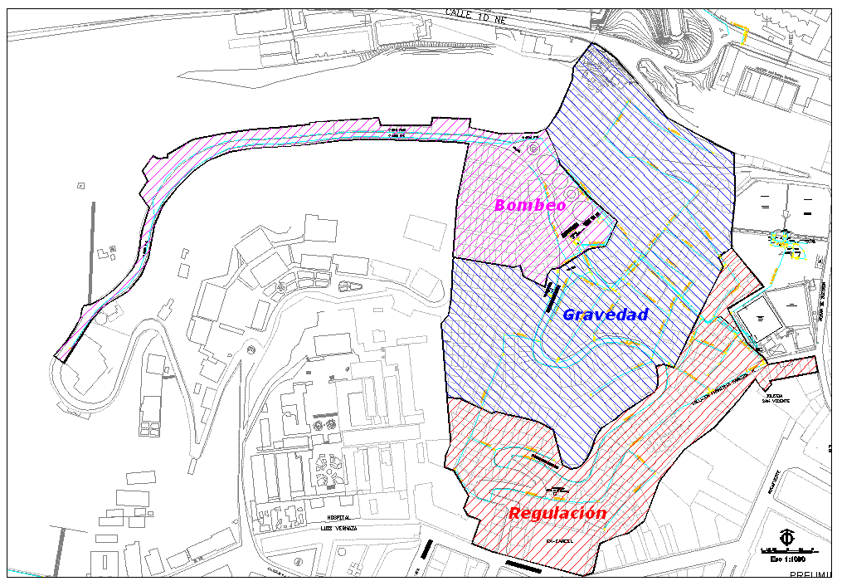
Figura 3. Sectorización propuesta

9. Awaited improvements and benefits

According to the results obtained by the hydraulic modeling the following thing was obtained:
• Improvement of pressures on watch in the part high and reduction of pressures in the low part.
• Return of the high and low part with which %ANC will be able to be determined of better way and will have greater control in the sector.
• Automatization of the rebombeo station, obtaining a change of operation of the system, with the possibility of being able to supply to the sector 24h with a minimum cost.

10. COST OF THE RAISED PROPOSAL

The general budget of the Works promotes a approximately:
Regulating station of Pressure $ 8.612
Return $ 4.606
Automatization of Station of Rebombeo $ 5.080
What = $ 20.494 is a total of $18,298 + 12% IVA

By means of the automatization of the system, return, regulation of pressures, repair of flights an uninterrupted supply by 24 hours could be obtained, by approximately he himself time of present pumping 8 hours.

11. Conclusions and recommendations

It is recommended, from the technical point of view, functional and economic, to advance the works by means of the following thing:
• Change of valves that are in badly been.
• Technified Regulation of pressures with the installation of the regulating valve. It is suggested, that in the pipe section (150mm H.F, L=70 m.) where is going away to install the station is cleaned since this type of pipes in its interior usually presents/displays oxide incrustations that cause considerable falls of pressure in the network.
• Automatization of the station of Rebombeo which would contribute to the continuity on watch of the sector and would allow to have a greater control of the system of pumping to a smaller operative cost.
• Reducer the physical and commercial losses
• Support on the part of the area of commercial distribution and for the repair of all those flights generated in the sector by breakage, bad hose unions and clandestine connections.
• Realize a return that allows to optimize the present system.
The project has without a doubt a benefit that to very short term will offer fruits, and is the fact that when making correctly the connections, and being discovering the line completely plugging correctly those that no longer are in good condition, will be managed considerably to reduce the waste of the sector.
- Since the existing flights are repaired and individual legalizations are made (for some inhabitants), this could be seen reflected in a clear diminution of this amount of water that really is not used, but wasted.
- Additionally, the project will allow to be inculcando in the inhabitants of the sector a consumption culture, and will lay the way doubtlessly so that in the future there is one better adaptation, to a program of total formalization of the supplying system.
- In synthesis, it is possible to be concluded that the taken actions, will offer short and medium term a solution that will allow to reduce the exaggerated losses of the sector, nevertheless, long term will not be the definitive solution to the problem.

12. References
$\left[1\right]$ Commercial department, Population Census and Dowry in the Hill of the Carmen, Interagua, February 2005.
$\left[2\right]$ Commercial department, Picture of Users and Consumption with Type of Facturabilidad sector Hill of the Carmen, Interagua, Abril 2007

