 | ESCUELA SUPERIOR POLITECNICA DEL LITORAL  Centro de Lenguas Extranjeras  CELEX – ESPOL  Intermediate A  Midterm V1 EU | 
- Reading Section (15 marks)

Read the text and do the activities

New Year Celebrations around the world
Different countries and cultures celebrate the new year in different ways. Many countries still follow the lunar calendar, meaning that their new year often starts in late January or in February. New Year celebrations for some countries (like China, Vietnam, and Korea) last not one day, but up to two weeks!
In the US, many peopleattendor throw New Year parties. They drink champagne, dance, and cheer at the stroke of midnight. US residents often make one or more New Year's resolutions, such as promising to quit smoking, lose weight, or stop drinking. Most of these resolutions last little longer than a month.
In the southern US, many people eat black-eyed peas for good luck in the new year. In Mexico and Venezuela, many people wear red or yellow underwear for good luck. In Brazil, residents wear white clothes for good luck, and in China, they wear red clothes and give children red envelopes with money in them. In Iran, people wear brand new clothes on the first day of the new year.
In Scotland, homeowners open the front door at midnight to let in the new year, and open the back door to let out the old year. In Switzerland, people kiss each other three times at midnight. In Spain, people eat 12 grapes—one per chime—as the clock chimes midnight. In Japan, they ring a bell 108 times to get rid of the 108 bad desires that people have. In Korea they ring a bell 33 times in honor of 33 ancient soldiers.
In Colombia, families make a rag doll called "Mr. Old Year." They dress it in old clothes and stuff it with things that the family doesn't want anymore. Then at midnight, they set the doll on fire, to rid themselves of all the bad things of the previous year.

Write true or false. Correct the false sentences. (5marks)

- People celebrate New Year the same way around the world.
- New Year celebrations can be for more than one day in some countries.
- New Year resolutions are things people want to change about their lives.
- People around the world do many different things for good luck in New Year.
- In Ecuador people do similar things as people in Spain and Colombia.
Match the underlined information in the text with their synonyms. (3 marks)

- …many people attendor throw New Year parties
- go to b. want c. watch
- ...to get rid ofthe 108 bad desires….
- eliminate b. leave c. have
- …theyset the doll on fire,-
- hang the doll b. sell the doll c. burnthedoll
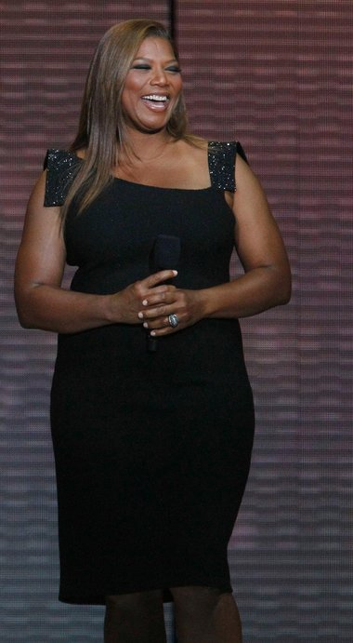

Is the term 'plus-size' offensive? Queen Latifah thinks so
By Rina Raphael

Funny girl Queen Latifah is the latest celebrity to join Home Shopping Network with a new line called the “Queen Collection.” The actress joins a laundry list of HSN stars (including Serena Williams and Molly Sims) but in addition to debuting her personal aesthetic, she has a cause: remove “plus-size” from the style vocabulary.
“[Plus-size] is a word we need to bury at this point," Latifah told WWD, noting that her new apparel and accessories line will be simply “for all sizes." Latifah specifically took issue with what she thinks is disrespect for “larger girls” as consumers, who are often relegated to their own areas in stores and online.
"I felt the marketplace didn't respect us in the way it should,” she said. “I was not going to step out with a clothing line that didn't respect a fuller-figured woman or a curvaceous woman, and really all women."
The Queen Collection apparel and outerwear lines, set to launch on Aug. 27 on HSN, will be priced under $100, whereas the handbags and outerwear styles – constructed in genuine leathers and suede – will be between $170 and $300. In addition to fashion items, Latifah will also debut a custom line of clip-on hair extensions at just over $100.
“I wanted to make something size two and up,” Latifah said. "We all would like to wear the same clothes. We all want to wear beautiful, fly clothes no matter what size you are, and so for me it was important to match with a company that understood and respected that ideal."
Answer the questions. (7 marks)

- What’s the name of the collection?
- What other celebrities have clothes lines in the Home Shopping Network(HSN)?
- Does Latifah agree with the use of the term “plus size”?
- Are Latifah’s clothes designed for a specific group of women?
- Is the collection already in stores?
- What does the word apparel mean in the article?
- Do you think the term “plus size” is offensive? Why

- Use of English (20 marks)

Fill in the gaps with a, an, the, or no article. (4 marks)

Gianni Versace was born in 1946 in a town called Reggio Calabria. Even when he was 16.______ child he loved clothes. When he was 25 he decided to go to 17.______ Milan and become 18. ______ fashion designer, and in 1982 he won his first award for being 19. ______ best designer of women’s clothes. He created 20. ______ new perfume for men in 1984.
In 1995 he organized 21. ______ party for AIDS patients. At 22.______ party he signed copies of his new book Men without ties, and gave all 23. ______ money from the book to charity.

Fill in the gaps with the correct form of the verbs. Use Simple Present, Present Progressive, Present Perfect or Simple Past. (6 marks)

not like get be buy go ask read

Dina: Hey Joseph 24. _______ you ever_______ to Paris?
Joseph: No. Why 25. _______ you _______?
Dina: I 26. _______ a magazine article about people who have been there. Apparently they are very romantic people.
Joseph: That’s not true! I 27. _______ a romantic person, I just _______ big famous cities.
Dina: Yeah right. I didn’t know you were a romantic. 28. _______ you ever _______ flowers for a woman?
Joseph: Of course! I 29._______ my girlfriend flowers for her birthday a week ago
Dina: Ok, I believe you.

Complete the sentences with your own information. (6 marks)

- I would like to….. in ten years.
- Before I start the new semester I’m going to….
- I’m hoping to………… after I finish this class.
- After this exam I’m going to……
- I would like to ….. when I graduate.
- I’mhopingto …… nextyear

Choose the correct answer. (4 marks)

- I was on a party / at a party / in a party last night.
- He took a tablet/ drink a tablet / had a tablet for a headache.
- A castle/ museum / palaceis a place where there are art things like paintings and sculptures.
- When I don’t get enough/ too much / very sleep, I feel tired all day.
- She goes / plays / does aerobics everyday in the morning.
- He very / really / too much likes chocolate. He eatsiteveryday.
- They were at the home / at house / at home all afternoon.
- If I eat enough / too much / very candy I get a stomachache.

- Listening Section (15 marks)

Match the people in column A to the information in column B (5 marks)

A  - Harry  - Mandy  - Fiona  - George  - Sam | B  - Isveryrich  - Livesupstairs  - Is a pilot  - Is a writer  - Is a musician

Listen and fill in the gaps. (10 marks)

- Ryan ________ in Osaka for a year.
- He _________ thefood.
- He _________ for a big company.
- He has never stayed in an ___________ hotel
- He doesn’tlike ____________ much.
- He’s never _________ a famous person.
- He once __________ a famous politician at the airport.
- When he was at ___________ he saw Romeo and Juliet.
- Hisbrother has a ___________
- He’snever ________ thelottery.

- Writing Section (15 marks)
Question one:
Choose one of the following topics and write an e-mail asking your best friend for advice. Give reasons why you want to do this. Write 50 words. (7.5 marks)

- Get a different job.
- Learn a new language.
- Redecorate your house cheaply.
- Give your boyfriend / girlfriend a surprise party.

Question two:
Write about something you are really interested in. What is it? When and how did your interest start? Why do you like it? How much time does it take? When and where do you do it? Write 50 words. (7.5 marks)

