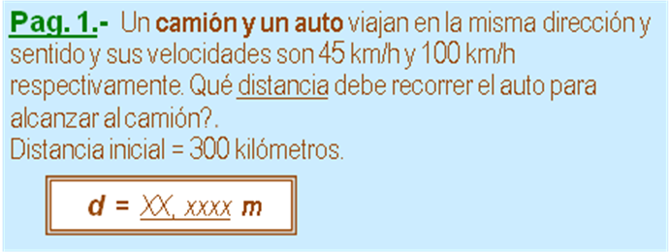

m |  | kg | 0 | N (w)
v_{C} | 45 | km/h | 12,5000 | m/s
v_{A} | 100 | km/h | 27,7778 | m/s
d | 300 | km | 300000,0000 | m
 |  | x = v_{A}*d/(v_{A} -v_{C})*1000
 |  | x | 545.454,5455 | m

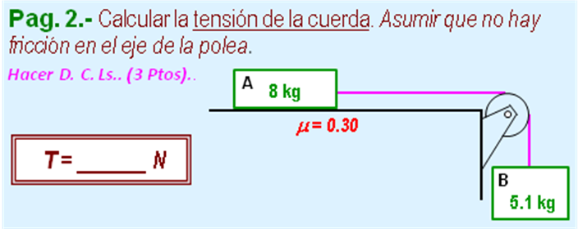

m_{A} | 8 | kg
m_{B} | 5,1 | kg
μ | 0,3
 | a = g*(m_{B} - μ *m_{A}) /(m_{A} +m_{B})
 |  | ay | 2,0198 | m/s²
 | T = m_{B} *( g -a)
 |  | T | 39,6788 | N

