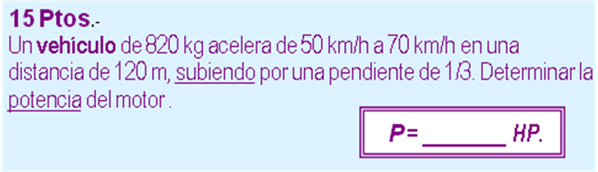

m | 820 | kg | 8036 | N (w)
v₁ | 50 | km/h | 79089,5062 | J (Ec)
v₂ | 70 | km/h | 155015,4321 | J (EC)
d | 120 | m | 37,94733192 | m (h)
tg α | 0,333 | 0,3218 | 304944,7593 | J (Epg)
 |  | T =E_{C2} +E_{PG2} - E_{C1}
 |  | T | 380870,6853 | J
 |  | t = 2d / (v₂ + v₁ )
 |  | t | 7,200000 | s
 |  | P | 70,9098 | HP

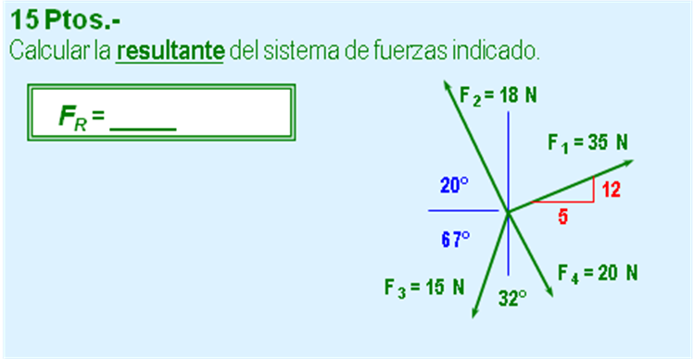

N | y/x (º) | Fx | Fy
35 | 12 | 13,4615 | 32,3077
13 | 5
18 |  | -16,9145 | 6,1564
 | 20 | 0,940 | 0,342
15 |  | -5,8610 | -13,8076
 | 67 | 0,391 | 0,921
20 |  | 3,1287 | -19,7538
 | 81 | 0,156 | 0,988
2o cuadrante |  | -6,19 | 4,90
-38,4022 | grados | 7,8926 | Lb

