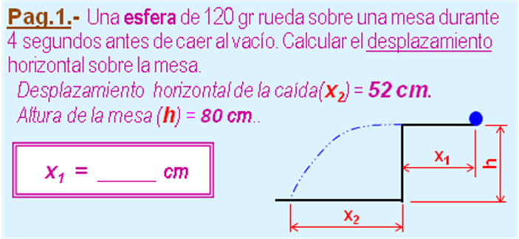

m | no | kg | #¡VALOR! | N (w)
t₁ | 4 | s
x₂ | 52 | cm | 0,5200 | m
h | 80 | cm | 0,8000 | m
 |  | t2 = (2 *h /g)^0,5
 |  | t₂ | 0,4041 | s
vx = x₃ / t₃ |  | v_{x} | 1,2869 | m/s
x1 = v₂ * t₂ |  | x₁ | 514,7737 | cm

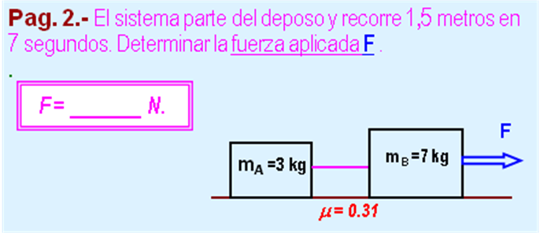

m_{A} | 3 | kg | 29,4 | N (w)
m_{B} | 7 | kg
v₁ | 0 | m/s
d | 1,5 | m | a = 2*d/ t^2
t | 7 | s | 0,0612 | m/s2
μ | 0,31
 |  | F = (m_{A} +m_{B} )*(a +μ*g)
 |  | F | 30,9922 | N

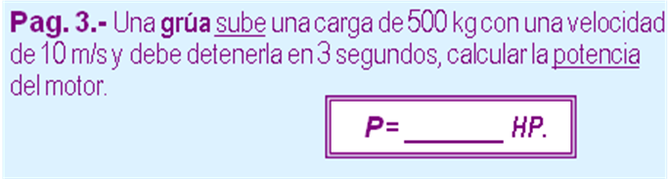

m | 500 | kg | 4900,0000 | N (w)
v₁ | 10 | m/s | 25000,0000 | J (Ec₁)
v₂ | 0 | km/h | 0,0000 | J (Ec₂)
t | 3 | s
 |  |  | -3,3333 | m/s² (a)
 |  |  | 15,0000 | m (h)
 |  |  | 73500,0000 | J (Eg₂)
 |  | P = (E_{C2} +E_{PG2} -E_{C1}) / t / 746
 |  | P | 21,6711 | HP

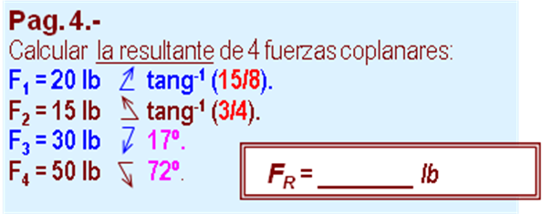

lb | y/x (º) | Fx | Fy
20 | 15 |  | 17,6471
17 | 8 | 9,411764706
15 | 3 |  | 9
5 | 4 | -12,0000
30 |  | 0,956 | -8,7712
 | 17 | -28,6891 | 0,292
50 |  | 0,309 | -47,5528
 | 72 | 15,4508 | 0,951
3er cuadrante |  | -15,8265 | -29,6769
grados | 61,93 | 33,6333 | Lb

