**CONCLUSIONES**

* El Turismo es una fuente inagotable de ingresos para los países sobre todo para el Ecuador que posee una gran cantidad de bellezas naturales y culturales.
* En términos sociales la actividad turística en el país, por ser generadora de empleo puede ofrecer un medio para mantener un nivel de actividad económica suficiente para evitar la emigración hacia zonas mas desarrolladas.
* La empresa de turismo ECUAVENTURAS, se constituirá como Sociedad Anónima formada por la participación inicial de cuatro socios que aportarán un capital de 12000 dólares.
* La empresa de turismo operará en la Ciudad de Guayaquil, e inicialmente sus actividades turísticas se llevarán a cabo dentro de la Provincia del Guayas, aunque dentro de sus objetivos está la expansión a todo el país en un largo plazo.
* La principal estrategia que ECUAVENTURAS pretende adoptar es la Estrategia de Servicio, que logrará que la empresa cumpla su objetivo de ser líder en Operación turística, manteniendo la mayor participación en el mercado.
* La Utilidad Neta de la organización será de 2803.55 dólares, y la Inversión Inicial para el presente proyecto es de 11454.38. Así mismo el periodo de recuperación del capital inicial será de 4 años, tiempo que permite considerar al proyecto como rentable pues el primer año de operación la demanda no es tan alta por que el mercado aun no la conoce, no obstante en años posteriores los beneficios podrán ser mayores si se logra la participación de mercado deseada.

**BIBLIOGRAFIA**

* BANCO CENTRAL DEL ECUADOR: Ecuador Cuentas Satélites
* Guayaquil - Octubre 2002
* CALDAS, Marco: Preparación y Evaluación de Proyectos
* Publicaciones H - Quito 1995
* HORNGREN, Charles: Introducción a la Contabilidad Financiera
* Editorial Prentice Hall - México 2000
* CARSON, Jenkins: Introducción al Turismo
* Editorial Síntesis – España 1997
* KINNEAR, Thomas: Investigación de Mercados
* Editorial Mc Graw Hill - Colombia 1999
* KOTLER, Philip: Fundamentos de Marketing
* Editorial Prentice Hall - México 2003, Sexta Edición
* KOTLER, Philip: Dirección de Mercadotécnia
* Editorial Diana - México 1987
* LAUNDER, Donald G. Manual de Organización y Administración de Turismo
* LOVELOCK, Christopher: Mercadotecnia de Servicios
* Editorial Prentice Hall – México 1997, Tercera Edición
* MAYA, Milton-SANCHEZ, Jeanette : Las microfinanzas y los microempresarios del turismo en Ecuador
* OMC : Guía de Oro de Ecuador
* OMC PubliGerencia Andina – Ecuador 2003
* PALACIOS, Libia: Contabilidad Intermedia
* Ecuador 2003, Décima Cuarta Edición
* ROMERO, José: Manual de Información Turística del Ecuador
* Editorial Científica Latina - Cuenca 1990
* SAPAG CHAIN, Nassir: Preparación y Evaluación de Proyectos
* Editorial Mc. Graw Hill - Chile 2000, Cuarta Edición

Revistas y Páginas de Internet:

* Fite 2004
* Transport 2004
* Guía de Guayaquil
* Boletín estadístico mensual, Banco Central del Ecuador
* Tendencias de los mercados Turísticos, Organización Mundial de Turismo
* [www.viveecuador.com](http://www.viveecuador.com)
* www.visitaguayaquil.com
* [www.omt.com](http://www.omt.com)
* [www.parquehistorico.com](http://www.parquehistorico.com)
* [www.bce.fin.ec](http://www.bce.fin.ec)
* www.finance.yahoo.com

**ANEXOS**

**ANEXO 1**

|  |  |  |  |  |
| --- | --- | --- | --- | --- |
| **LLEGADA DE TURISTAS EXTRANJEROS** | | | | |
| **POR PAIS DE ORIGEN** | | | | |
| (Miles de personas) | | | | |
|  | | | | |
|  | **2000** | **2001** | **2002** | **2003** |
| Europa | 104 | 129 | 113 | 135 |
| Norteamérica | 157 | 178 | 172 | 185 |
| Japón | 4 | 4 | 4 | 5 |
|  |  |  |  |  |
| Bolivia | 3 | 3 | 4 | 5 |
| Colombia | 192 | 154 | 197 | 224 |
| Perú | 91 | 58 | 107 | 110 |
| Venezuela | 12 | 12 | 12 | 16 |
| **CAN** | **298** | **227** | **320** | **354** |
|  |  |  |  |  |
| Sudamérica menos CAN | 35 | 40 | 43 | 48 |
| Caribe+C.A | 13 | 19 | 15 | 17 |
| Otros | 16 | 12 | 16 | 17 |
| **TOTAL** | **627** | **609** | **683** | **762** |
| ***Fuente:*** *Dirección de Migración del Guayas* | | | | |
| ***Elaborado:*** *Ministerio de Turismo* | | | | |

**ANEXO 2**

|  |  |  |  |  |  |
| --- | --- | --- | --- | --- | --- |
| **ENTRADAS Y SALIDAS EN EL ECUADOR** | | | | | |
|
|  |  |  |  |  | |
| **LLEGADA DE EXTRANJEROS** | | | | | |
|  |  |  |  |  | |
|  | **2001** | **2002** | **2003** | **2004** | |
| **ENERO** | 59.673 | 61.372 | 61.688 | 73.845 | |
| **FEBRERO** | 45.905 | 48.909 | 56.922 | 59.942 | |
| **MARZO** | 47.278 | 55.408 | 58.492 | 59.433 | |
| **ABRIL** | 48.967 | 45.824 | 56.327 | 68.891 | |
| **MAYO** | 47.192 | 50.812 | 55.770 | 67.721 | |
| **JUNIO** | 57.779 | 60.273 | 67.527 | 60.863 | |
| **JULIO** | 69.757 | 73.978 | 86.293 | 78.107 | |
| **AGOSTO** | 61.628 | 64.854 | 72.795 | 73.042 | |
| **SEPTIEMBRE** | 46.298 | 56.013 | 58.155 | 57.101 | |
| **OCTUBRE** | 48.750 | 60.235 | 59.966 | 63.435 | |
| **NOVIEMBRE** | 50.680 | 47.744 | 60.589 | 60.092 | |
| **DICIEMBRE** | 56.654 | 57.540 | 66.252 | 70.051 | |
| **TOTAL** | **640.561** | **682.962** | **760.776** | **792.523** | |
| ***Fuente:*** *Dirección de Migración del Guayas* | | | | |
| ***Elaborado:*** *Ministerio de Turismo* | | | | |

**ANEXO 3**

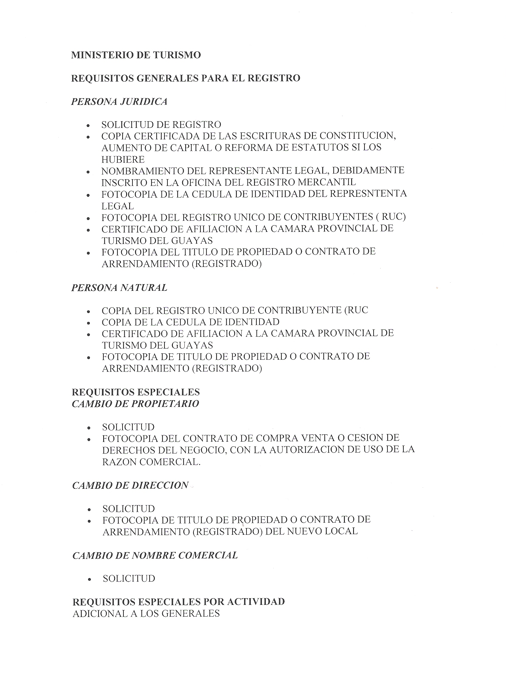

**ANEXO 4**

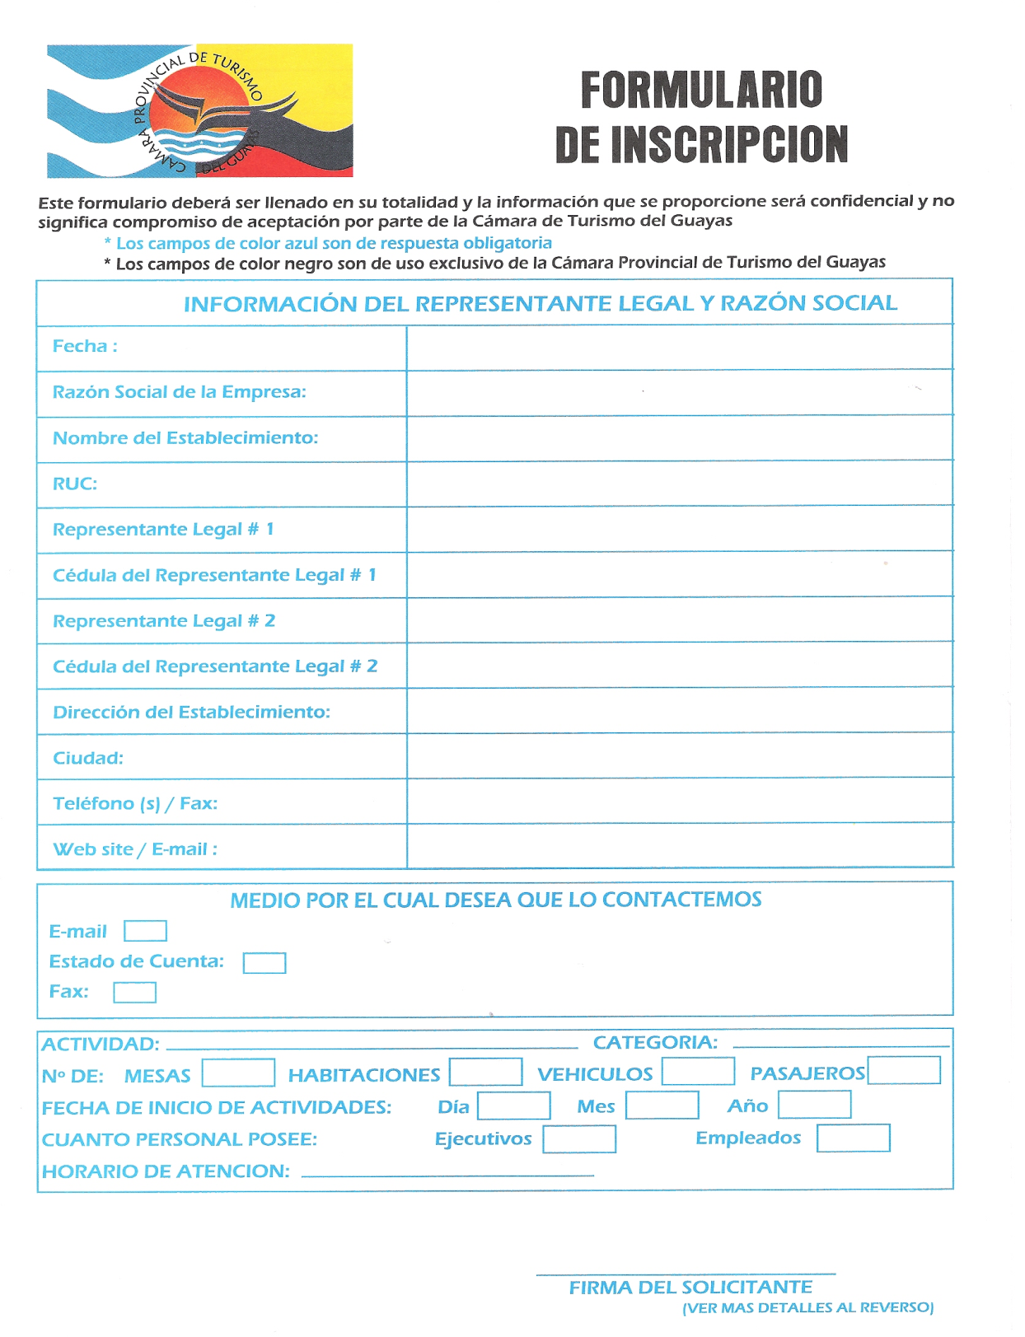

**ANEXO 5**

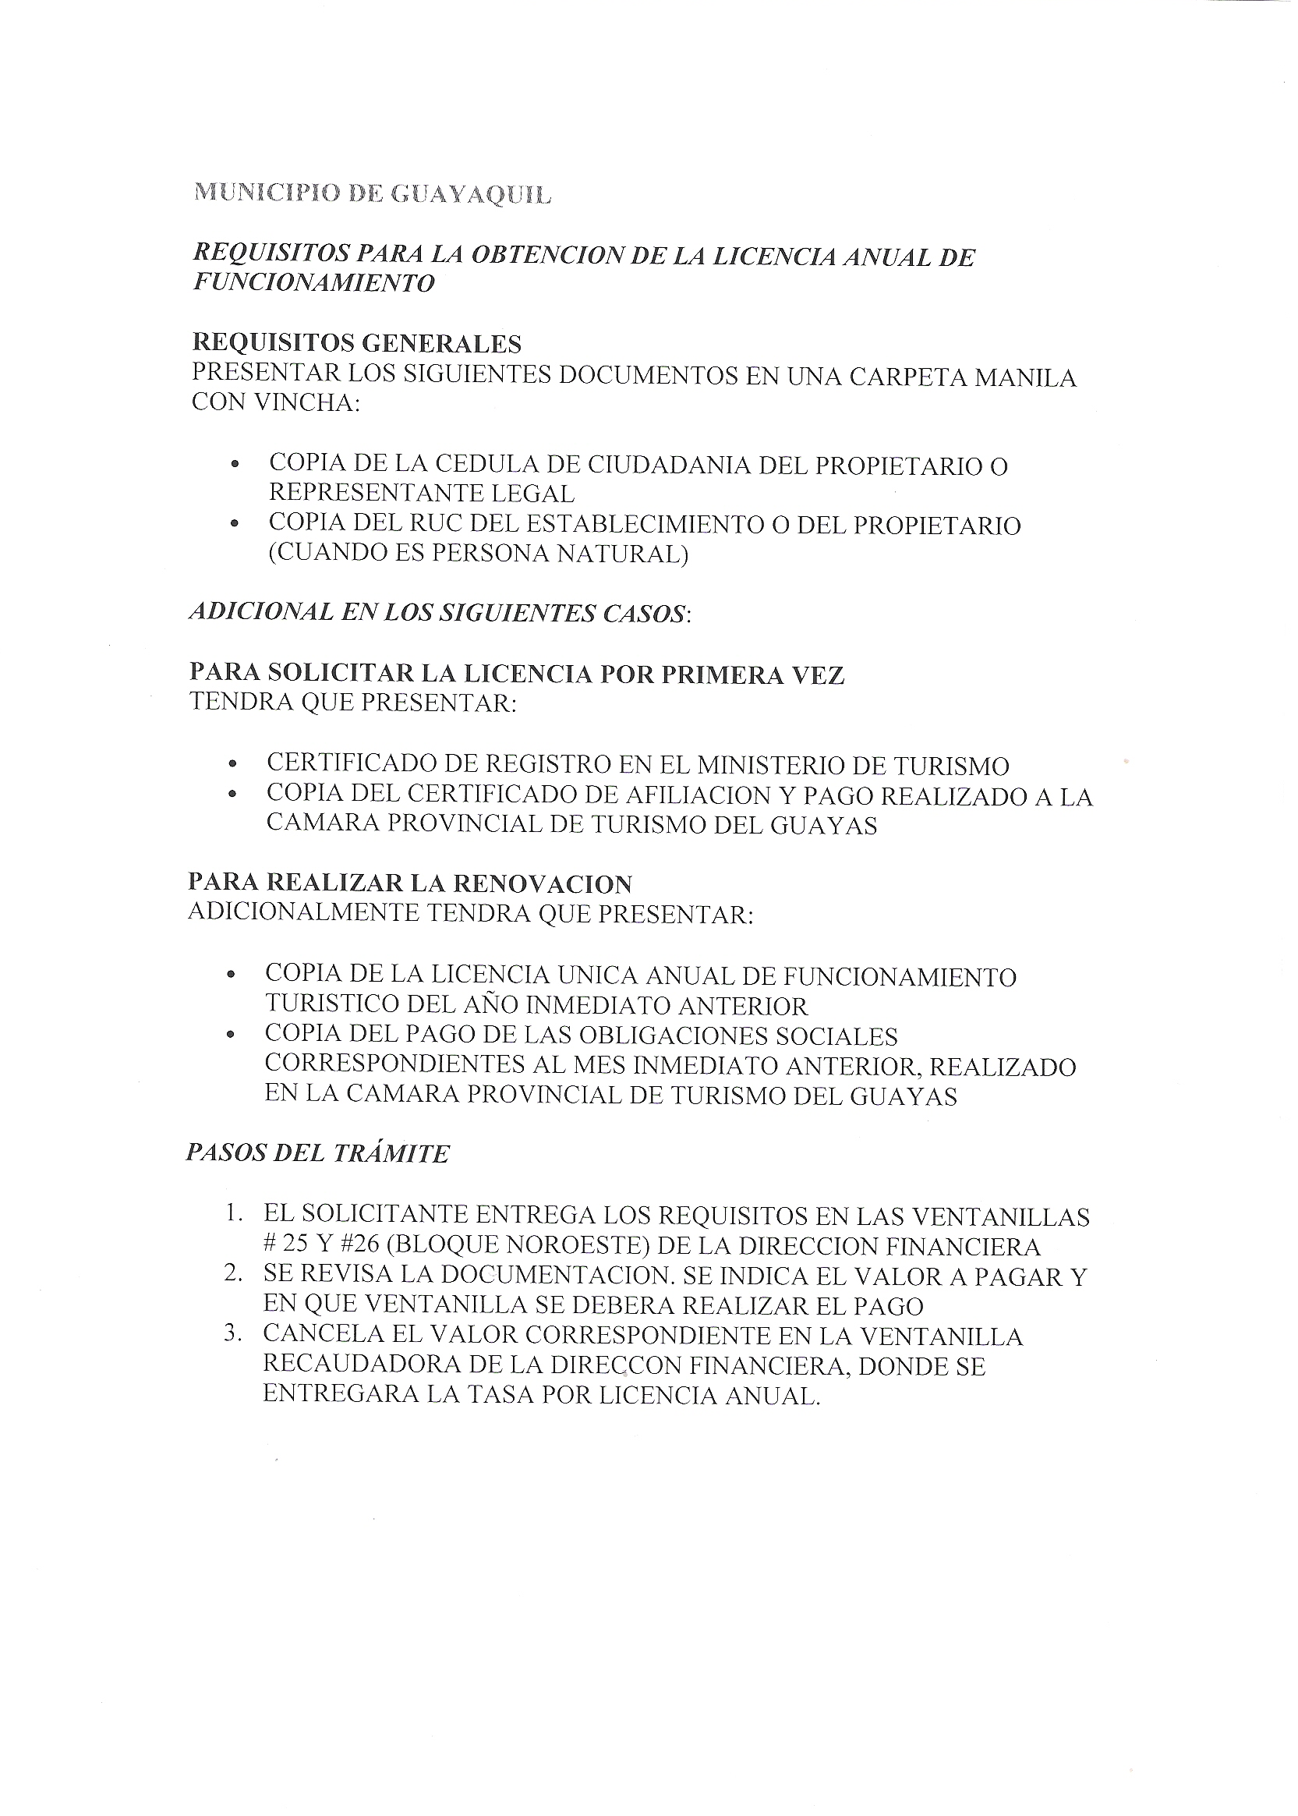

**ANEXO 6**

**Recorrido Historia**

**(15 Personas)**

1 Cerro Santa Ana

* Calle Numa Pompilio Llona
* Cruz de Santiago
* Callejón del Tesoro
* Faro
* Capilla Santa Ana

2 Malecón 2000

3 Mercado Artesanal

4 Iglesia de la Merced y Plaza Pedro Carbo

5 Iglesia San Francisco

6 Plaza Rocafuerte

7 Parque Centenario

***Duración del Recorrido***: 6 Horas

***Precio:*** USD $ 214,50

***Incluye.-*** Dinámica de Integración, Dramatización la llegada de los piratas, Relato Guayaquil en la historia, Box Lunch, Transporte, Guías.

**Recorrido Cultura y Naturaleza**

**(15 Personas*)***

1 Iglesia de Santo Domingo

2 Malecón 2000

* Jardines del Malecón
* Plaza Precolombina
* Hemiciclo de la Rotonda
* Torre Morisca
* Obelisco de la Aurora Gloriosa
* CC Bahía Malecón
* Plaza Olmedo
* Palacio de Cristal

3 Parque Seminario

4 Catedral

5 Mercado Artesanal

***Duración del Recorrido***: 5 Horas

***Precio:*** USD $ 214,50

***Incluye.-*** Dinámica de Integración, Dramatización Guayaquil en la historia, Relato de los principales hitos históricos de cada lugar visitado, Box Lunch, Transporte, Guías.

**Recorrido Sol y Playa**

**(15 Personas)**

1 Chanduy

* Museo Real Alto

2 Santa Elena

* Museo Amantes de Sumpa

3 Valdivia

* Museo Valdivia
* Acuario Valdivia

4 Salinas

* Malecón
* Chipipe

5 Manglaralto

* Dos Mangas

6 Montañita

* Surf

***Duración del Recorrido***: 2 Días

***Precio***: USD $ 1237.50

***Incluye.-*** Entrada a todos los museos, Box Lunch, Almuerzo, Cena, Desayuno, Almuerzo, Alojamiento en Salinas, Trasporte, Guías, Noche de Integración (Hotel).

**Tour Aventura**

**(15 Personas)**

1 Pto. Hondo

* Recorrido por Manglar
* Observación de Aves
* Pesca
* Paseo en canoa

2 Posorja

* Avistamiento de Delfines

3 Baños de San Vicente

4 Cerro Blanco

* Recorrido Sendero
* Camping (Opcional)

***Duración del Recorrido***: 1 Día

***Precio:*** USD $ 577.50

***Incluye.-*** Box Lunch, Entradas a lugares, Alquiler de carpas para camping, Paseo en canoa, Almuerzo, Transporte, Guías.

**Tour Full Day**

**(15 Personas)**

1 Iglesia de San Vicente

2 Cerro santa Ana

* Calle Numa Pompilio Llona
* Cruz de Santiago
* Callejón del Tesoro
* Faro
* Capilla Santa Ana

3 Museo Municipal

4 Parque Seminario

5 Catedral

6 Malecón del Salado

***Duración del Recorrido***: 8 Horas

***Precio:*** USD $ 280.50

***Incluye.-*** Dinámica de Integración, Dramatización la llegada de los piratas, Relato Guayaquil en la historia, Box Lunch, Transporte, Paseo en botes en Malecón del Salado, Guías.

**Natural’s Tour**

**(15 Personas)**

1 Jardín Botánico

2 Zoo Pantanal

3 Parque Histórico

4 Manglares de Churute

***Duración del Recorrido***: 1 Día

***Precio:*** USD $ 594.00

***Incluye.-*** Entradas a todos los lugares, Almuerzo, Guía, Transporte.

**Tour Educativo**

**(30 Personas)**

1 Museo de los Bomberos

2 Museo Nahum Isaías

3 Museo Municipal

***Duración del Recorrido***: 2 Horas

***Precio:*** USD $ 247.50

***Incluye.-*** Dinámicas de Integración, Box Lunch, Guías, Entradas a Museos, Transporte.

**Tour Arte Religioso**

**(15 Personas)**

1 Catedral

2 Iglesia San Francisco

3 Iglesia la Merced

4 Iglesia Santo Domingo

5 Cementerio General

***Duración del Recorrido***: 2 Horas

***Precio:*** USD $ 132.00

***Incluye.-*** Dinámicas de Integración, Guías Especializados, Transporte.

**Tour Recorrido en el Tiempo**

**(15 Personas)**

1 Parque Histórico

2 Malecón 2000

***Duración del Recorrido***: 5 Horas

***Precio:*** USD $ 264.00

***Incluye.-*** Dinámica de Integración, Relato Guayaquil en la historia, Entrada Parque histórico, Box Lunch, Guías, Transporte.

**ANEXO 7**

|  |  |  |  |  |
| --- | --- | --- | --- | --- |
| **SALIDA DE ECUATORIANOS** | | | | |
|  |  |  |  |  |
|  | **2001** | **2002** | **2003** | **2004** |
| **ENERO** | 46.402 | 53.011 | 53.943 | 52.454 |
| **FEBRERO** | 43.320 | 51.265 | 60.528 | 52.158 |
| **MARZO** | 49.053 | 59.754 | 69.997 | 54.852 |
| **ABRIL** | 45.581 | 48.396 | 43.019 | 60.511 |
| **MAYO** | 46.805 | 50.774 | 55.521 | 50.412 |
| **JUNIO** | 38.534 | 49.596 | 43.383 | 34.318 |
| **JULIO** | 47.337 | 50.393 | 57.274 | 43.827 |
| **AGOSTO** | 55.379 | 63.855 | 63.643 | 54.149 |
| **SEPTIEMBRE** | 51.223 | 59.668 | 49.210 | 54.828 |
| **OCTUBRE** | 46.929 | 51.158 | 39.876 | 42.495 |
| **NOVIEMBRE** | 47.754 | 44.840 | 39.411 | 48.126 |
| **DICIEMBRE** | 43.750 | 43.901 | 37.301 | 57.252 |
| **TOTAL** | **562.067** | **626.611** | **613.106** | **605.382** |
| ***Fuente:*** *Nacional de Migración* | | | | |
| ***Elaborado:*** *Ministerio de Turismo* | | | | |

**ANEXO 11**

|  |  |  |  |  |  |  |  |  |  |  |  |  |  |  |  |  |  |  |  |  |  |  |  |  |  |  |  |  |  |  |  |  |  |  |  |  |  |  |  |  |  |  |  |  |  |  |  |  |  |  |  |  |  |  |  |  |  |  |  |  |  |  |  |  |  |  |  |  |  |  |  |  |  |  |  |  |  |  |  |  |  |  |  |  |  |  |  |  |  |  |  |  |  |  |  |  |  |  |  |  |  |  |  |  |  |  |  |  |  |  |  |  |  |  |  |  |  |  |  |  |  |  |  |  |  |  |  |  |  |  |  |  |  |  |  |  |  |  |  |  |  |  |  |  |  |  |  |  |  |  |  |  |  |  |  |  |  |  |  |  |  |  |  |  |  |  |  |  |  |  |  |  |  |  |  |  |  |  |  |  |  |  |  |  |  |  |  |  |  |  |  |  |  |  |  |  |  |  |  |  |  |  |  |  |  |  |  |  |  |  |  |  |  |  |  |  |  |  |  |  |  |  |  |  |  |  |  |  |  |  |  |  |  |  |  |  |  |  |  |  |  |  |  |  |  |  |  |  |  |  |  |  |  |  |  |  |  |  |  |  |  |  |  |  |  |  |  |  |  |  |  |  |  |  |  |  |  |  |  |  |  |  |  |  |  |  |  |  |  |  |  |  |  |  |  |  |  |  |  |  |  |  |  |  |  |  |  |  |  |  |  |  |  |  |  |  |  |  |  |  |  |  |  |  |  |  |  |  |  |  |  |  |  |  |  |  |  |  |  |  |  |  |  |  |  |  |  |  |  |  |  |  |  |  |  |  |  |  |  |  |  |  |  |  |  |  |  |  |  |  |  |  |  |  |  |  |  |  |  |  |  |  |  |  |  |  |  |  |  |  |  |  |  |  |  |  |  |  |  |  |  |  |  |  |  |  |  |  |  |  |  |  |  |  |  |  |  |  |  |  |  |  |  |  |  |  |  |  |  |  |  |  |  |  |  |  |  |  |  |  |  |  |  |  |  |  |  |  |  |  |  |  |  |  |  |  |  |  |  |  |  |  |  |  |  |  |  |  |  |  |  |  |  |  |  |  |  |  |  |  |
| --- | --- | --- | --- | --- | --- | --- | --- | --- | --- | --- | --- | --- | --- | --- | --- | --- | --- | --- | --- | --- | --- | --- | --- | --- | --- | --- | --- | --- | --- | --- | --- | --- | --- | --- | --- | --- | --- | --- | --- | --- | --- | --- | --- | --- | --- | --- | --- | --- | --- | --- | --- | --- | --- | --- | --- | --- | --- | --- | --- | --- | --- | --- | --- | --- | --- | --- | --- | --- | --- | --- | --- | --- | --- | --- | --- | --- | --- | --- | --- | --- | --- | --- | --- | --- | --- | --- | --- | --- | --- | --- | --- | --- | --- | --- | --- | --- | --- | --- | --- | --- | --- | --- | --- | --- | --- | --- | --- | --- | --- | --- | --- | --- | --- | --- | --- | --- | --- | --- | --- | --- | --- | --- | --- | --- | --- | --- | --- | --- | --- | --- | --- | --- | --- | --- | --- | --- | --- | --- | --- | --- | --- | --- | --- | --- | --- | --- | --- | --- | --- | --- | --- | --- | --- | --- | --- | --- | --- | --- | --- | --- | --- | --- | --- | --- | --- | --- | --- | --- | --- | --- | --- | --- | --- | --- | --- | --- | --- | --- | --- | --- | --- | --- | --- | --- | --- | --- | --- | --- | --- | --- | --- | --- | --- | --- | --- | --- | --- | --- | --- | --- | --- | --- | --- | --- | --- | --- | --- | --- | --- | --- | --- | --- | --- | --- | --- | --- | --- | --- | --- | --- | --- | --- | --- | --- | --- | --- | --- | --- | --- | --- | --- | --- | --- | --- | --- | --- | --- | --- | --- | --- | --- | --- | --- | --- | --- | --- | --- | --- | --- | --- | --- | --- | --- | --- | --- | --- | --- | --- | --- | --- | --- | --- | --- | --- | --- | --- | --- | --- | --- | --- | --- | --- | --- | --- | --- | --- | --- | --- | --- | --- | --- | --- | --- | --- | --- | --- | --- | --- | --- | --- | --- | --- | --- | --- | --- | --- | --- | --- | --- | --- | --- | --- | --- | --- | --- | --- | --- | --- | --- | --- | --- | --- | --- | --- | --- | --- | --- | --- | --- | --- | --- | --- | --- | --- | --- | --- | --- | --- | --- | --- | --- | --- | --- | --- | --- | --- | --- | --- | --- | --- | --- | --- | --- | --- | --- | --- | --- | --- | --- | --- | --- | --- | --- | --- | --- | --- | --- | --- | --- | --- | --- | --- | --- | --- | --- | --- | --- | --- | --- | --- | --- | --- | --- | --- | --- | --- | --- | --- | --- | --- | --- | --- | --- | --- | --- | --- | --- | --- | --- | --- | --- | --- | --- | --- | --- | --- | --- | --- | --- | --- | --- | --- | --- | --- | --- | --- | --- | --- | --- | --- | --- | --- | --- | --- | --- | --- | --- | --- | --- | --- | --- | --- | --- | --- | --- | --- | --- | --- | --- | --- | --- | --- | --- | --- | --- | --- | --- | --- | --- | --- | --- | --- | --- | --- | --- | --- | --- | --- | --- | --- | --- | --- | --- | --- | --- | --- | --- | --- | --- | --- | --- | --- | --- | --- | --- | --- | --- | --- | --- | --- | --- | --- | --- | --- | --- | --- | --- | --- | --- | --- |
|  | |  |  |  |  |  |  |  |  |  |  |  |  |  |  |  |  | | --- | --- | --- | --- | --- | --- | --- | --- | --- | --- | --- | --- | --- | --- | --- | --- | | **Crystal Ball Report** | | | | | | | | | | | | | | | | |  | | **Forecast: Ingresos +1** | | | | | | | | | | | |  | | | Summary: | | | | | | | |  | | | | | | | | |  | | Display Range is from 105.713,23 to 215.432,08 USD | | | | | | | | | | | | | |  | | Entire Range is from 94.915,15 to 224.958,52 USD | | | | | | | | | | | | | |  | | After 20.500 Trials, the Std. Error of the Mean is 150,14 | | | | | | | | | | | | | |  | | | **Statistics:** | | | |  | **Value** | | | |  | | Trials | | | 20500 | | | |  | | Mean | | | 160.071,71 | | | |  | | Median | | | 160.127,02 | | | |  | | Mode | | | --- | | | |  | | Standard Deviation | | | 21.496,52 | | | |  | | Variance | | | 462.100.270,92 | | | |  | | Skewness | | | 0,00 | | | |  | | Kurtosis | | | 2,82 | | | |  | | Coeff. of Variability | | | 0,13 | | | |  | | Range Minimum | | | 94.915,15 | | | |  | | Range Maximum | | | 224.958,52 | | | |  | | Range Width | | | 130.043,38 | | | |  | | Mean Std. Error | | | 150,14 | | | |  | |  | |  |  | | | |  | | |  | | |  | | | | | | |  | | | | | | | | | | | | | | | | | | | | | | | | |  |  | | |  | | | | | | | | | | | |  |  |  |  |  |  |  |  |  | | --- | --- | --- | --- | --- | --- | --- | --- | | **Forecast: VAN** | | | |  |  |  |  | |  |  |  |  |  |  |  |  | |  | Summary: | | |  |  |  |  | |  |  | Display Range is from -36.442,78 to 167.292,41 USD | | | | | | |  |  | Entire Range is from -56.493,57 to 184.981,91 USD | | | | | | |  |  | After 20.500 Trials, the Std. Error of the Mean is 278,79 | | | | | | |  |  |  |  |  |  |  |  | |  | Statistics: | |  |  |  |  | Value | |  |  | Trials | |  |  |  | 20500 | |  |  | Mean | |  |  |  | 64.494,62 | |  |  | Median | |  |  |  | 64.597,32 | |  |  | Mode | |  |  |  | --- | |  |  | Standard Deviation | |  |  |  | 39.916,54 | |  |  | Variance | |  |  |  | 1.593.330.206,47 | |  |  | Skewness | |  |  |  | 0,00 | |  |  | Kurtosis | |  |  |  | 2,82 | |  |  | Coeff. of Variability | |  |  |  | 0,62 | |  |  | Range Minimum | |  |  |  | -56.493,57 | |  |  | Range Maximum | |  |  |  | 184.981,91 | |  |  | Range Width | |  |  |  | 241.475,47 | |  |  | Mean Std. Error | |  |  |  | 278,79 | |  |  |  |  |  |  |  |  | |  |  |  |  |  |  |  |  | |  |  |  | | | | | | |  |  | |  |  | |  |  | |  |  | |  |  | |  |  | |  |  | |  |  | |  |  | |  |  | |  |  | |  |  |  |  |  |  |  |  | |  |  |

**ANEXO 12**

|  |  |  |  |  |  |  |  |  |  |  |  |  |  |  |  |  |  |  |  |  |  |  |  |  |
| --- | --- | --- | --- | --- | --- | --- | --- | --- | --- | --- | --- | --- | --- | --- | --- | --- | --- | --- | --- | --- | --- | --- | --- | --- |
|  | |  | | |  | | |  | | | | | | | | | |  | | |  |  |  | |
| **Crystal Ball Report**  **Forecast: Ingresos -1** | | | | | | | | | | | | | | | | |
|  | |
| Summary: | | | | | | | |
|  | | Display Range is from 119.838,35 to 180.278,59 USD | | | | | | | | | | | | | | | | | | | | |  | |
|  | | Entire Range is from 113.857,01 to 182.089,85 USD | | | | | | | | | | | | | | | | | | | | |  | |
|  | | After 20.500 Trials, the Std. Error of the Mean is 79,04 | | | | | | | | | | | | | | | | | | | | |  | |
|  | |  | | |  | | |  | | | | | | | | | |  | | |  | |  |
| Statistics: | | | | | |  | Value | | | |
|  | | | Trials | | | | 20500 | | | |
|  | | | Mean | | | | 147.904,32 | | | |
|  | | | Median | | | | 147.881,10 | | | |
|  | | | Mode | | | | --- | | | |
|  | | | Standard Deviation | | | | 11.316,43 | | | |
|  | | | Variance | | | | 128.061.639,48 | | | |
|  | | | Skewness | | | | 0,00 | | | |
|  | | | Kurtosis | | | | 2,83 | | | |
|  | | | Coeff. of Variability | | | | 0,08 | | | |
|  | | | Range Minimum | | | | 113.857,01 | | | |
|  | | | Range Maximum | | | | 182.089,85 | | | |
|  | | | Range Width | | | | 68.232,84 | | | |
|  | | | Mean Std. Error | | | | 79,04 | | | |
|  | |
|  | |
|  | | | | | | | | | | | | | | | | | | |  |
|  |
|  |
|  |
|  |
|  |
|  |
|  |
|  |
|  |
|  |  | | | | | |  |
|  |  | | | | | |  |
|  | |  | | |
| **Forecast: VAN** | | | | | | | | | |  | | |  |  |  | |
|  | |  | |  | | |  | | |  | | |  |  |  | |
|  | | Summary: | | | | | | | |  | | |  |  |  | |
|  | |  | | Certainty Level is 96,58% | | | | | | | | |  |  |  | |
|  | |  | | Certainty Range is from -14.342,66 to +Infinity USD | | | | | | | | | | | | |
|  | |  | | Display Range is from -26.657,56 to 75.966,57 USD | | | | | | | | | | | | |
|  | |  | | Entire Range is from -36.813,54 to 79.041,98 USD | | | | | | | | | | | | |
|  | |  | | After 20.500 Trials, the Std. Error of the Mean is 134,20 | | | | | | | | | | | | |
|  | |  | |  | | |  | | |  | | |  |  |  | |
|  | | Statistics: | | | | |  | | |  | | |  |  | Value | |
|  | |  | | Trials | | | | | |  | | |  |  | 20500 | |
|  | |  | | Mean | | | | | |  | | |  |  | 20.996,88 | |
|  | |  | | Median | | | | | |  | | |  |  | 20.957,46 | |
|  | |  | | Mode | | | | | |  | | |  |  | --- | |
|  | |  | | Standard Deviation | | | | | |  | | |  |  | 19.214,66 | |
|  | |  | | Variance | | | | | |  | | |  |  | 369.203.326,53 | |
|  | |  | | Skewness | | | | | |  | | |  |  | 0,00 | |
|  | |  | | Kurtosis | | | | | |  | | |  |  | 2,83 | |
|  | |  | | Coeff. of Variability | | | | | |  | | |  |  | 0,92 | |
|  | |  | | Range Minimum | | | | | |  | | |  |  | -36.813,54 | |
|  | |  | | Range Maximum | | | | | |  | | |  |  | 79.041,98 | |
|  | |  | | Range Width | | | | | |  | | |  |  | 115.855,52 | |
|  | |  | | Mean Std. Error | | | | | |  | | |  |  | 134,20 | |
|  | |  | |  | | |  | | |  | | |  |  |  | |
|  | |  | |  | | |  | | |  | | |  |  |  | |
|  | |  | |  | | | | | | | | | | | | |
|  | |  | |
|  | |  | |
|  | |  | |
|  | |  | |
|  | |  | |
|  | |  | |
|  | |  | |
|  | |  | |
|  | |  | |
|  | |  | |
|  | |  | |

**ANEXO 13**

|  |  |  |  |  |  |  |  |  |  |  |  |  |  |  |  |  |  |  |
| --- | --- | --- | --- | --- | --- | --- | --- | --- | --- | --- | --- | --- | --- | --- | --- | --- | --- | --- |
|  |  | |  | |  | | | |  | |  | | |  |  | | | |
| **Crystal Ball Report** | | | | | | | | | | | | | | | | | | | |
| **Forecast: Costos +1** | | | | | | | | |
|  |  | |  | |  | | | |  | |  | | |  |  | | | |
|  | Summary: | | | | | | | |  | |  | | |  |  | | | |
|  |  | | Display Range is from 74.717,26 to 103.011,44 USD | | | | | | | | | | | | | |
|  |  | | Entire Range is from 72.403,20 to 105.290,59 USD | | | | | | | | | | | | | |
|  |  | | After 20.500 Trials, the Std. Error of the Mean is 37,89 | | | | | | | | | | | | | |
|  |  | |  | |  | | | |  | |  | | |  |  | | | |
| Statistics: | | | |  | | | Value | | |
|  | Trials | | | | | | 20500 | | |
|  | Mean | | | | | | 88.782,11 | | |
|  | Median | | | | | | 88.806,12 | | |
|  | Mode | | | | | | --- | | |
|  | Standard Deviation | | | | | | 5.425,00 | | |
|  | Variance | | | | | | 29.430.628,62 | | |
|  | Skewness | | | | | | -0,01 | | |
|  | Kurtosis | | | | | | 2,82 | | |
|  | Coeff. of Variability | | | | | | 0,06 | | |
|  | Range Minimum | | | | | | 72.403,20 | | |
|  | Range Maximum | | | | | | 105.290,59 | | |
|  | Range Width | | | | | | 32.887,40 | | |
|  | Mean Std. Error | | | | | | 37,89 | | |
|  | |  | |  | | | |  | | | |
|  |  | |  | |  | | | |  | | | |
|  | | | | | | | | | | | | | | | | | |
|
|
|
|
|
|
|
|
|
|
|
|  |  | |  | |  | | | |  | |  | | |  |  | | | |

|  |  |  |  |  |  |  |  |
| --- | --- | --- | --- | --- | --- | --- | --- |
| **Forecast: VAN** | | | |  |  |  |  |
|  |  |  |  |  |  |  |  |
|  | Summary: | | |  |  |  |  |
|  |  | Certainty Level is 95,31% | | |  |  |  |
|  |  | Certainty Range is from -23.208,37 to +Infinity USD | | | | | |
|  |  | Display Range is from -31.662,46 to 15.304,73 USD | | | | | |
|  |  | Entire Range is from -35.445,77 to 19.145,99 USD | | | | | |
|  |  | After 20.500 Trials, the Std. Error of the Mean is 62,90 | | | | | |
|  |  |  |  |  |  |  |  |
|  | Statistics: | |  |  |  |  | Value |
|  |  | Trials | |  |  |  | 20500 |
|  |  | Mean | |  |  |  | -8.042,35 |
|  |  | Median | |  |  |  | -8.082,41 |
|  |  | Mode | |  |  |  | --- |
|  |  | Standard Deviation | |  |  |  | 9.005,28 |
|  |  | Variance | |  |  |  | 81.095.117,58 |
|  |  | Skewness | |  |  |  | 0,01 |
|  |  | Kurtosis | |  |  |  | 2,82 |
|  |  | Coeff. of Variability | |  |  |  | -1,12 |
|  |  | Range Minimum | |  |  |  | -35.445,77 |
|  |  | Range Maximum | |  |  |  | 19.145,99 |
|  |  | Range Width | |  |  |  | 54.591,76 |
|  |  | Mean Std. Error | |  |  |  | 62,90 |
|  |  |  |  |  |  |  |  |
|  |  |  |  |  |  |  |  |
|  |  |  | | | | | |
|  |  |
|  |  |
|  |  |
|  |  |
|  |  |
|  |  |
|  |  |
|  |  |
|  |  |
|  |  |
|  |  |

**ANEXO 14**

|  |  |  |  |  |  |  |  |  |  |  |  |  |  |  |  |  |  |  |  |  |  |  |  |
| --- | --- | --- | --- | --- | --- | --- | --- | --- | --- | --- | --- | --- | --- | --- | --- | --- | --- | --- | --- | --- | --- | --- | --- |
|  |  | |  | | |  | | | |  | | |  | | | | | |  |  | | | |
| **Crystal Ball Report** | | | | | | | | | | | | | | | | | | | | | | |
|  |
| **Forecast: Costos -1** | | | | | | | | | |
|  |
|  | Summary: | | | | | | | | |
|  |  | | | Display Range is from 78.393,04 to 91.863,62 USD | | | | | | | | | | | | | | | | | | | |
|  |  | | | Entire Range is from 77.324,64 to 93.311,64 USD | | | | | | | | | | | | | | | | | | | |
|  |  | | | After 20.500 Trials, the Std. Error of the Mean is 18,38 | | | | | | | | | | | | | | | | | | | |
|  |  | | |  | |  | | | |  | | |  | | | | | |  |  | | | |
|  | | | | | | | Statistics: | | | | |  | | | Value | | | |
|  | | | | | | |  | | Trials | | | | | | 20500 | | | |
|  | | | | | | |  | | Mean | | | | | | 85.313,67 | | | |
|  | | | | | | |  | | Median | | | | | | 85.283,93 | | | |
|  | | | | | | |  | | Mode | | | | | | --- | | | |
|  | | | | | | |  | | Standard Deviation | | | | | | 2.631,58 | | | |
|  | | | | | | |  | | Variance | | | | | | 6.925.194,70 | | | |
|  | | | | | | |  | | Skewness | | | | | | 0,03 | | | |
|  | | | | | | |  | | Kurtosis | | | | | | 2,83 | | | |
|  | | | | | | |  | | Coeff. of Variability | | | | | | 0,03 | | | |
|  | | | | | | |  | | Range Minimum | | | | | | 77.324,64 | | | |
|  | | | | | | |  | | Range Maximum | | | | | | 93.311,64 | | | |
|  | | | | | | |  | | Range Width | | | | | | 15.987,00 | | | |
|  | | | | | | |  | | Mean Std. Error | | | | | | 18,38 | | | |
|  |  | | |  | |  | | | |  | | | |
|  |  | | |  | |  | | | |  | | | |
|  | | | | | | | | | | | | | | | | | | | | | |
|
|
|
|
|
|
|
|
|
|
|
|  | |
| **Forecast: VAN** | | | | | | | | | | |  | | | | |  |  |  | | |
|  | |  | | |  | | |  | | |  | | | | |  |  |  | | |
|  | | Summary: | | | | | | | | |  | | | | |  |  |  | | |
|  | |  | | | Display Range is from -6.365,79 to 14.998,92 USD | | | | | | | | | | | | | | | |
|  | |  | | | Entire Range is from -8.662,39 to 16.693,42 USD | | | | | | | | | | | | | | | |
|  | |  | | | After 20.500 Trials, the Std. Error of the Mean is 29,15 | | | | | | | | | | | | | | | |
|  | |  | | |  | | |  | | |  | | | | |  |  |  | | |
|  | | Statistics: | | | | | |  | | |  | | | | |  |  | Value | | |
|  | |  | | | Trials | | | | | |  | | | | |  |  | 20500 | | |
|  | |  | | | Mean | | | | | |  | | | | |  |  | 4.022,61 | | |
|  | |  | | | Median | | | | | |  | | | | |  |  | 4.069,40 | | |
|  | |  | | | Mode | | | | | |  | | | | |  |  | --- | | |
|  | |  | | | Standard Deviation | | | | | |  | | | | |  |  | 4.173,75 | | |
|  | |  | | | Variance | | | | | |  | | | | |  |  | 17.420.199,18 | | |
|  | |  | | | Skewness | | | | | |  | | | | |  |  | -0,03 | | |
|  | |  | | | Kurtosis | | | | | |  | | | | |  |  | 2,83 | | |
|  | |  | | | Coeff. of Variability | | | | | |  | | | | |  |  | 1,04 | | |
|  | |  | | | Range Minimum | | | | | |  | | | | |  |  | -8.662,39 | | |
|  | |  | | | Range Maximum | | | | | |  | | | | |  |  | 16.693,42 | | |
|  | |  | | | Range Width | | | | | |  | | | | |  |  | 25.355,81 | | |
|  | |  | | | Mean Std. Error | | | | | |  | | | | |  |  | 29,15 | | |
|  | |  | | |  | | |  | | |  | | | | |  |  |  | | |
|  | |  | | |  | | |  | | |  | | | | |  |  |  | | |
|  | |  | | |  | | | | | | | | | | | | | | | |
|  | |  | | |
|  | |  | | |
|  | |  | | |
|  | |  | | |
|  | |  | | |
|  | |  | | |
|  | |  | | |
|  | |  | | |
|  | |  | | |
|  | |  | | |
|  | |  | | |