INTERUNIVERSITY MASTER PROGRAM IN ECOLOGICAL MARINE MANAGEMENT (ECOMAMA)


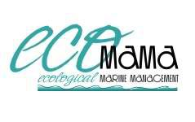


POPULATION DYNAMICS OF Metamysidopsis sp. nov. 4b (Tattersall, 1951) FROM ECUADOR

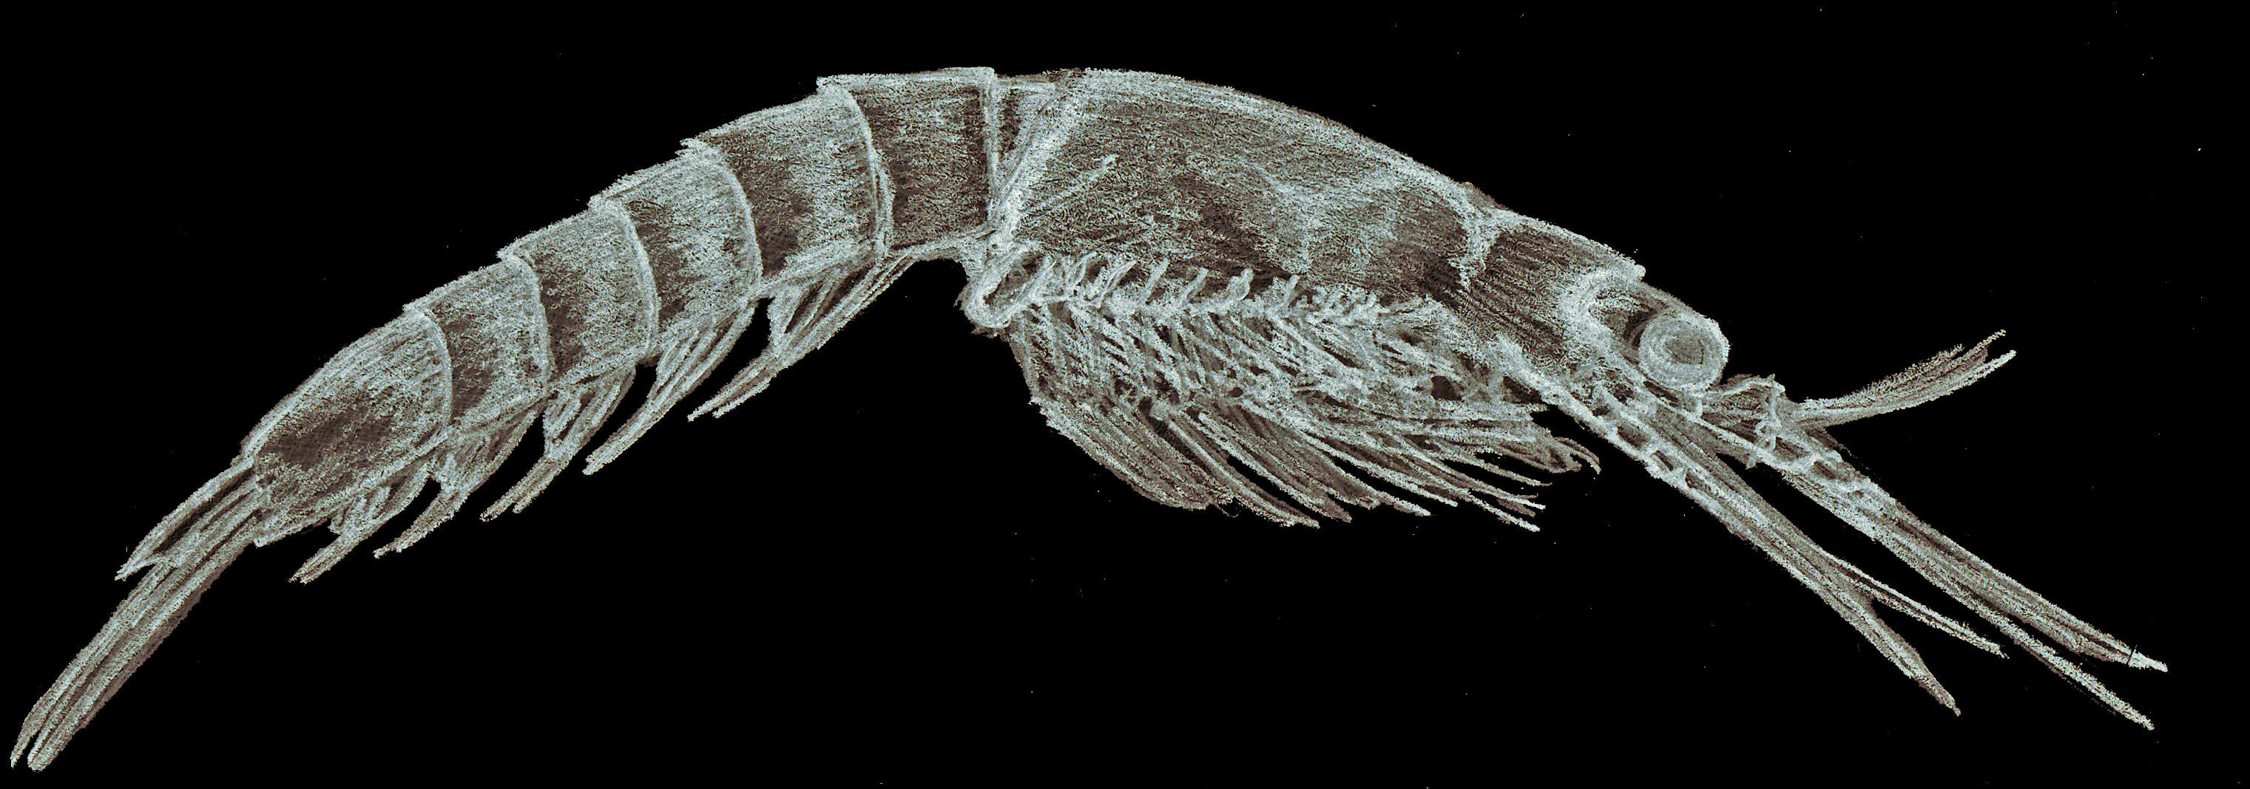
Promoter : Prof. Dr. M. Vincx Mentor : Dr. Nancy Fockedey
Supervisor : Drs. T. Vanagt Flanders Marine Institute
University of Gent, Zoology Institute
Marine Biology Section.
Thesis submitted in partial fulfillment for Master degree
in Ecological Marine Management
Sandra Miño

2006

