CHAPTER I

INTRODUCTION

Recent interest in biodiversity, arising from the 1992 UN conference on Environment and Development in Rio de Janeiro, has prompted much discussion about appropriate means of inventorying and monitoring the biodiversity of different groups of organisms in a strictly comparative way (Di Castri et al., 1992).

Marine benthic communities have a very high diversity. This is especially true of the meiofauna, the small metazoans living in or on sediments, other animals and plants, or on hard substrates such as rocks. The meiofauna is defined on a methodological basis as all metazoans retained on a sieve of 42µm (Mare, 1942). Meiofauna occur in freshwater and marine habitats, although most ecological studies on meiofauna have been performed in the marine environment.

Twenty-three higher taxa of the thirty-three metazoan phyla have some meiobenthic representatives: Nematoda, Turbellaria, Oligochaeta, Polychaeta, Copepoda, Ostracoda, Mystacocarida, Halacaroida, Hydrozoa, Nemertina, Entoprocta, Gastropoda, Aplacophora, Brachiopoda, Holothuroidea, Tunicata, Priapulida, Sipunculida. The phyla Gastrotricha, Gnathostomulida, Kinorhyncha, Loricifera and Tardigrada are exclusively meiobenthic (Vincx, 1996).

Free-living marine nematodes are bottom living meiofauna that occur in a wide range of habitats, often numbering millions per m². They are small worms and structurally rather simple; they are the most abundant animals in the meiobenthos (Gerlach, 1971).

Free-living marine nematodes are the most species rich of multicellular organisms in the seabed, which is reflected in an equal diversity in ecological niches. In order to utilize these nematodes as a biological tool in ecological studies (Tietjen & Lee, 1984), it is of major importance to identify accurately that many species in a sample.

Often second in numerical importance are the harpacticoid copepods but the diversity of meiofauna is such that many phyla are represented and some phyla contain only meiofauna species (Heip, 1982).

Nematodes and copepods are abundant in almost every marine habitat (normally ranging between 500 and 10 000/10cm²), making them suitable for ecological and statistical analysis. Nematodes are particularly notable for their persistence as a taxon, and are found in all environmental conditions that can support metazoans. The high diversity of meiobenthic organisms has been used in the past as an argument against the use of these organisms for biomonitoring purposes, because of the difficulties encountered in identifying the numerous species (Vincx and Heip, 1990).

Ecuador is probably the world's most biodiversified country in both flora and fauna, thanks to its climate and the variety of habitats (alpine grasslands, coastal swamps and tropical rainforest).

This study provided the first overview of the meiobenthos of Ecuadorian sandy beaches. Meiobenthos is used as an indicator of environmental impact. Several beaches with different anthropogenic impact will be compared.

In the last twenty years, much ecological information about meiofauna is illustrating the picture that these small creatures are important in marine sediments, both indirectly, by processes such as bioturbation and the stimulation of bacterial metabolism, and also directly, as food sources for higher trophic level organisms (Nicholas, 1975; Dayton & Hessler, 1971; Bell & Coull, 1978; Vincx, 1996).

AIM

The present study is to focus on the sandy beach meiofauna, and more in detail on the most dominant metazoan taxon, the nematodes.

The objectives of current study are:

▪ To inventory the meiobenthos to higher taxa level of five sites from Santa Elena Peninsule (Guayas province in Ecuador). Also to get an idea about the biodiversity of this area.

▪ To identify the nematode communities (most abundant taxa) to genus level.

▪ To determine the meiofauna total density and nematode composition.

▪ To establish a relationship between the nematode and the environmental factors such as temperature, salinity and sediment characteristics.

▪ To establish the value of meiofauna (nematodes) as bio-indicator of environmental impact.

STUDY AREA

The investigation was carried out in an area of Guayas Province along the Ecuadorian coast.

Locations of the five sample stations (Playas, Salinas I, San Pablo, Cenaim and Olon I) are shown in Fig. 1.

Salinas (Figure 1a), Playas and Olon are recreational beaches (during weekends and holidays) that are strongly affected by anthropogenic influences (e.g. pollution, mechanical disturbances, etc.). Salinas beach is situated in a small sheltered bay.

San Pablo (Figure 1b) and Cenaim are lesser disturbed, except for the ongoing local artisanal fishery activities and the occasional presence of larveros (catchers of larvae of camarones, penaeides, mostly at high tides).

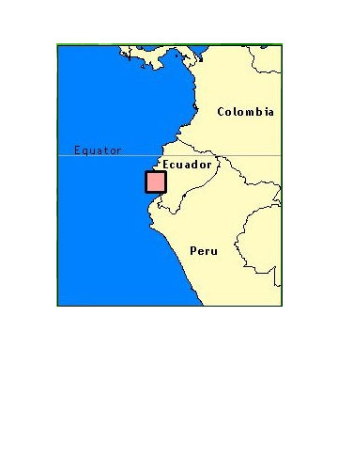
Position Ecuador-South America

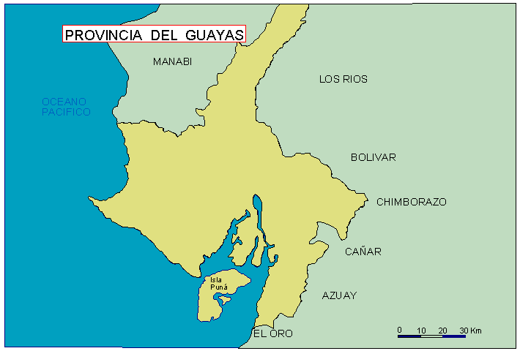
Cenaim

Olon I
1°30’
81°00’ 80°30’ 80°00’ 79°30’
Playas
Salinas I
San Pablo
2°30’
2°00’
N
Figure 1. Map of Guayas Province (Ecuador)
Sampling stations

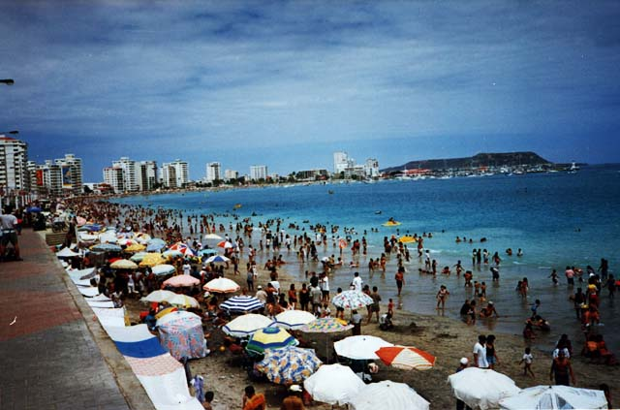
Figure 1a. Salinas (Tourist beach)

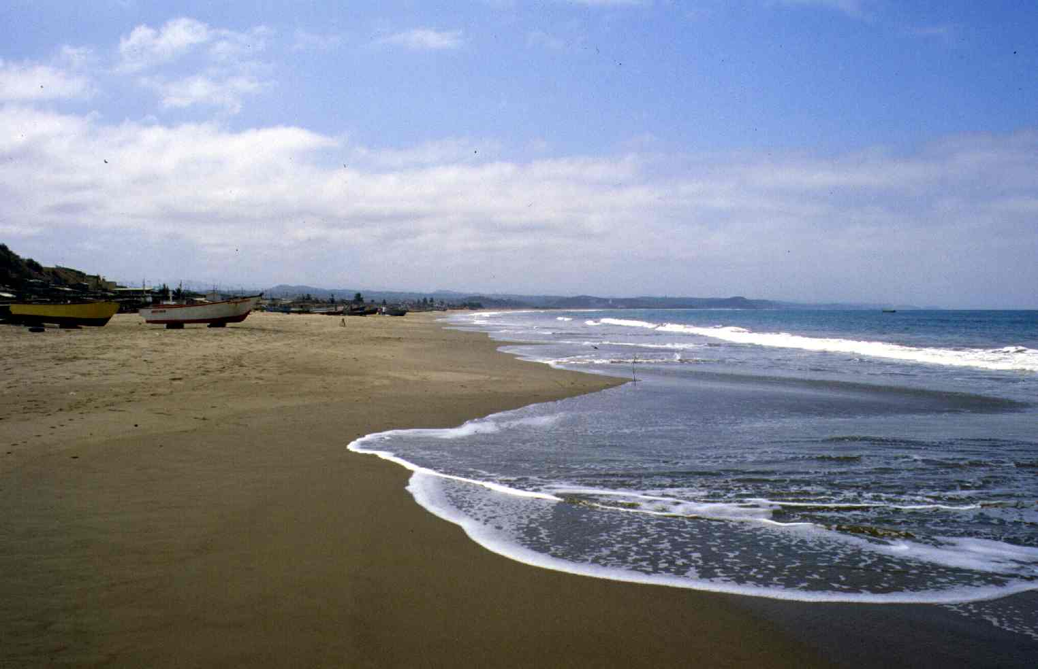
Figure 1b. San Pablo (Artisanal beach)

