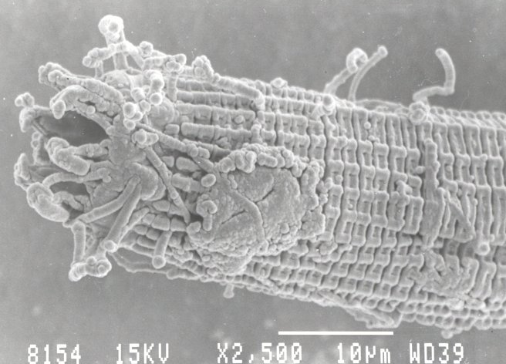A

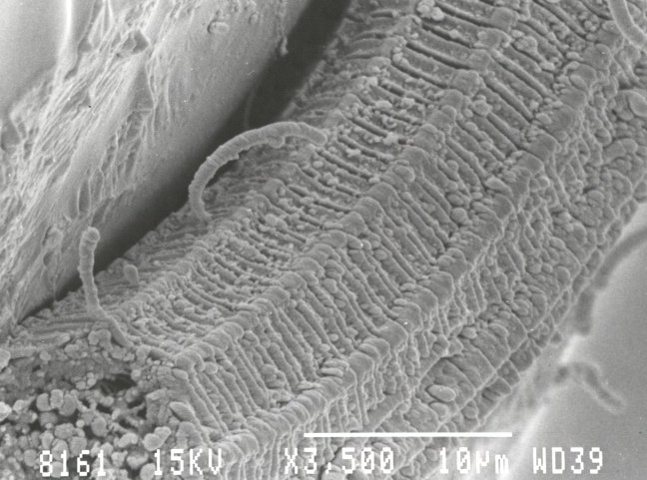C

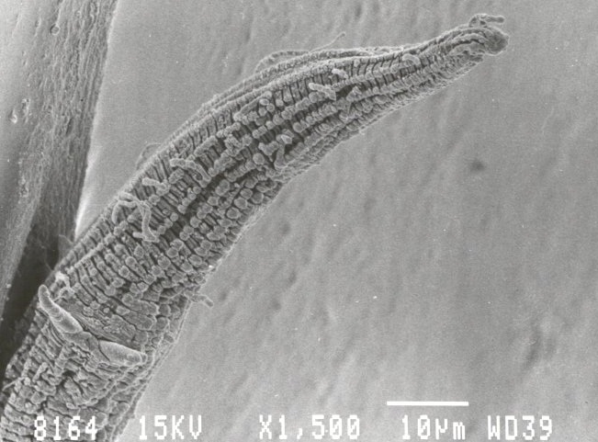
E

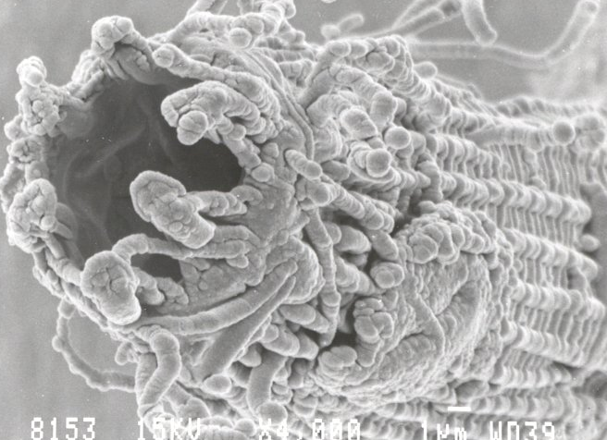B
Plate 1. Gonionchus sp.n. A. ₁ Anterior view; B. ₁ Head region lateral view showing position of amphid; C. ₂ Cuticule; D. ₃ Longitudinal section showing buccal cavity; E. ₁Tail tip; F. ₂ Spicules.
(Scale bars indicate 1 µm in B, D, F and 10 µm in A, C, E)

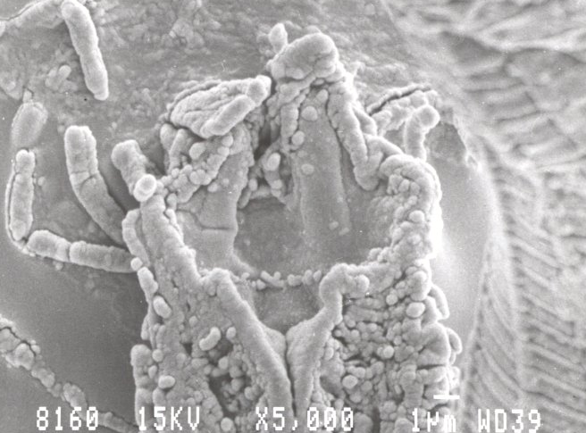D

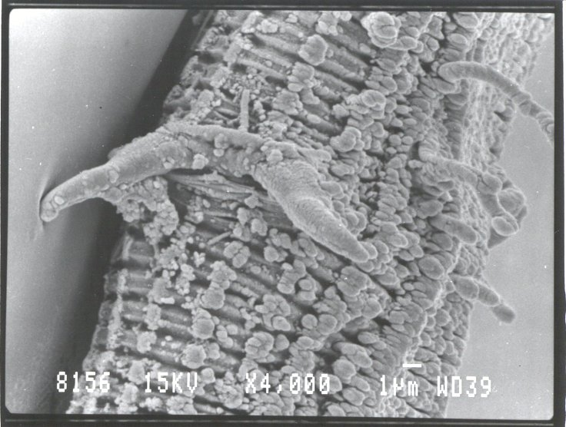
F

