Detection of Individual Specimens in Populations Using
Contour Energies
Daniel Ochoa
, Sidharta Gautama
, and Boris Vintimilla
1, 2
1
2
Department of telecommunication and information processing, Ghent University, St-Pieters
1
Nieuwstraat 41, B-9000, Ghent, Belgium
Centro de Vision y Robotica, Facultad de Ingenieria en Electricidad y
2
Computación, ESPOL University, Km 30.5 via perimetral, 09015863, Guayaquil, Ecuador
{dochoa,sid}@telin.ugent.be, boris.vintimilla@espol.edu.ec
Abstract.
In this paper we study how shape information encoded in contour
energy components values can be used for detection of microscopic organisms
in population images. We proposed features based on shape and geometrical
statistical data obtained from samples of optimized contour lines integrated in
the framework of Bayesian inference for recognition of individual specimens.
Compared with common geometric features the results show that patterns
present in the image allow better detection of a considerable amount of
individuals even in cluttered regions when sufficient shape information is
retained. Therefore providing an alternative to building a specific shape model
or imposing specific constrains on the interaction of overlapping objects.
Keywords:
recognition, feature extraction, statistical shape analysis.
1 Introduction
An important tool for biotechnology research and development is the study of
populations at molecular, biochemical and microbiological levels. However, to track
their development and evolution non-destructive protocols are required to keep
individuals in a suitable environment. The right conditions allo w continuous
examination and data collection that from a statistically meaningful number of
specimens provide support for a wide variety of experiments. The length, width and
location of microscopic specimens in a sample are strongly related to population
parameters such as feeding behavior, rate of growth, biomass, maturity index and
other time-related metrics.
Population images characterized by sample variatio n, structural noise and clutter
pose a challenging problem for recognition algorithms [1]. These issues alter negatively
the estimated measurements, for instance when parts of the detected object are out of
focus, two or more individuals can be mistakenly counted as one or artifacts in the
sample resembles the shape of specimens of interest. A similar condition occurs in
tracking applications when continuous identification of a given individual, while
interacting with others of the same or different phylum is required. Nevertheless the
increasing amount of digital image data in micro-biological studies prompts the need of
reliable image analysis systems to produce precise and reproducible quantitative results.
J. Blanc-Talon et al. (Eds.): ACIVS 2007, LNCS 4678, pp. 575–586, 2007.
© Springer-Verlag Berlin Heidelberg 2007

576 D. Ochoa, S. Gautama, and B. Vintimilla
The nematodes are one of the most common family of animals; they are ubiquitous
in fresh water, marine and terrestrial eco-systems. As a result nematodes populations
had become useful bio-indicator for environmental evaluation, disease expressions in
crops, pesticide treatments, etc. A member of the specie, the C. Elegants nematode is
widely applied in research in genetics, agriculture and marine biology. This
microorganism has complete digestive and nervous systems, a kno wn geno me
sequence and is sensitive to variable environmental conditio ns.
Intensity thresholding and binary skeletonization followed by contour curvature
pattern matchin g were used in images containing a single nematode to identify the
head and tail of the specimen [2]. To classify C.Elegans behavioral phenotypes in [3]
motion patterns are identified by means of a one-nematode tracking system,
morphological operators and geometrical related features. The advantages of scale
space principles were demonstrated on nematode populations in [4] and anisotropic
diffusion is proposed to improve the response of a line detection algorithm; but
recognition of single specimens was not perfo rmed.
In [8] nematode population analysis relies on well-known image processing
techniques namely intensity thresholding followed b y filling, drawing and measuring
operations in a semi-automatic fashion. However sample preparation was carefully
done to place specimens apart from each other to prevent overlapping. Combining
several image processing techniques when dealing with biological populations
specimens increase the complexity of finding a set of good parameters and
consequently reduce the scope of possible applications.
Daily lab work is mostly manual, after the sample image is captured a bio logist
define points along the specimen, then line segments are drawn and measurement
taken. User friendly approaches like live-wire [5] can ease the process as while
pointing over the nematode surface a line segment is pulled towards the nematode
centerline. Tho ugh in cluttered regions line evidence vanishes and manual corrections
are eventually required. Considering that a data set usually consists of massive
amounts of image data with easily hundreds of specimens, such repetitive task entails
high probabilities of inter-observer variation s and conseq uently unreliable data.
Given the characteristics of these images, extracting reliable shape information for
object identification with a restricted amount of image data, overlapping, and
structural noise pose a difficult task. Certainly, the need of high-throughput screening
of bio-images to fully describ e bio logical processes on a quantitative level is still very
much in demand [6]. Unless effective recognition takes place before any p ost-
processing procedure the utilization of artificial vision software for estimating
statistical data from population samples [7] will not be able to provide with accurate
measurements to scientists.
As an alternative to past efforts focused at deriving shape models from a set of
single object images using evenly distributed feature points [14]. We propose recover
shape information by examining the energies of sample optimized active contours
from a population image. In order to assert the efficiency of such approach we
compare them with geometrical measurements. Our aim is to prove that patterns
extracted from sample contours can lead to recognition of individual specimens in
still images even in the presence of the aforementioned problems.

Detection of Individual Specimens in Populations Using Contour Energies 577
This paper is organized as follows. In section 2 the active contour approach is
discussed. Shape features of detected nematodes are proposed and used for
classification in Section 3. Comparative results are shown in Section 4; finally
conclusions and future work is presented in Section 5.
2 Segmentation Using Active Contours
Nematodes are elongated structures of slightly varying thickness along their length,
wide in the center and narrow near both ends. Contrary to one might think its simple
shape makes segmentation process a complex task in population images because
nematodes interact with the culture medium and other specimens in the sample.
Nematodes lie freely on agar substrate and explore their surroundings by bending
their body. While foraging, nematodes run over different parts of the image, crawl on
top of each other and occasionally dive into the substrate. This behaviour leads to
potential issues in segmentation because substantial variations in shape and
appearance are observed in population images.
Nematodes exhibit different intensity level distributions either between individuals
or groups when image background is non-homogeneous. Darker areas appear every
time internal organs become visible or at junctions when two or more specimens
overlap. Some parts get blurred as they get temporarily out of focus when diving into
the sustrate. Regarding shape, the lack of contour features and complex motion
patterns prevent using simple shape descriptors or building models able to account for
the whole range shape configurations. These two characteristics also make difficult to
find a set of geometrical constrains that can illustrate all the junction types found in
overlapping situations Fig. 1.
Under these conditions, thresholding techniques commonly used in images of
isolated specimens fail to provide a reliable segmentation. Approaches based on
differential geometry [11] can handle better the intensity variation, but a trade off
between the image-content coverage and conciseness [12] is needed to set appropriate
parameter values. Statistical tests on hypothetical center-line and background regions
at every pixel locations as proposed in [23] rely on having enough local line evidence,
which precisely disappear at junctions where saddle regions form. The inherent
disadvantages of the aforementioned techniques allow in practice to obtain only a set
of unconnected points hopefully the majority located on the traversal axis of some of
the nematodes present in the image.
Line grouping based on graph search and optimisation techniques enforcing line
continuity and smoothness were applied to integrate line evidence [13,23], but
segmentation of objects based on linear segments requires relevant local segments
configurations that capture objects shape characteristics [22]. Shape modelling
assuming evenly distributed landmark points along nematode body proved a complex
issue, although non-linear systems had been devised [10] the complete range of
nematode body configurations is still far from being model. Spatial arrangement of
feature points at different scales were exploited in [15] to search for regions of high
probab ility of containing a rigid wiry object in different cluttered environments, yet in
populations clutter is mostly caused by nematode themselves.

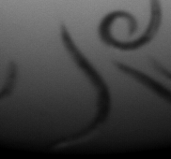
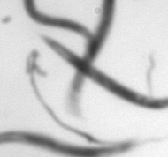
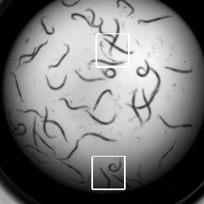
578 D. Ochoa, S. Gautama, and B. Vintimilla
Fig. 1.
Left: Nematodes in a population image. Center: Structural noise produced by internal
organs, and overlapping. Right: Non-homogenous background cause differences in appearance.
In this paper we propose the utilization of active contours energies to capture
relevant statistical shap e information for recognition applied to nematode d etection in
population images. Active contours introduced by Kass with a model called snake
[16] has drawn attention due to their performance in various problems. Segmentation
and shape modeling in single images proved effective by integrating region-based
information, stochastic approaches and appropriate shape constrains [17, 18].
Active contours co mbine image data and shape modeling through the definition of
a linear energy function consisting of two terms: a data-driven component (external
energy), which depends on the image data, and a smoothness-driven component
(internal energy) which enforces smoothness along the contour.
E
=
·
E
+
·
E
(1)
co nt o ur
1
i nt
2
ext
The internal energy can be decomposed further into tension and bending energies,
they report higher values as the contour stretches or bends during the optimization
process. The goal is to minimize the total energy iteratively using gradient descent
techniques as energies components balance each other.
S
S
E
=
e
(s)
+
e
(s)ds
,
E
=
e
(s)ds
(2)
i nt
t
b
e x t
e x t
0
0
The proposed approach is based on the idea that given convergence of the active
contours mostly data-driven, appearance and geometrical data can be recovered from
the resulting energy component value distribution. Contrary to other works that tried
to embed partial shape information to guide the evolution of the contour [21], we
consider the analysis of energy based derived features a natural way to explore the
range of possible nematode shape configurations in a set of population images
without having to build an specific mo del or making explicit constrains about objects
interaction [19 ]. We leave to the active contour optimization process the task of
locating salient linear structures and focus on exploiting the distribution of energy
values for recognition of those contours corresponding to nematodes.
For segmentation we used ziplock snake [20], this active contour model is
designed to deal with open contours. Given a pair of fixed end points optimization is

Detection of Individual Specimens in Populations Using Contour Energies 579
carried out from them towards the center of the contour using in every step a
increasing number of control points. This procedure is intended to raise the
probab ility of accurate segmentation by progressively locating control points on the
object surface. They can encode shape information explicitly [21] and provide faster
convergence than geodesic snakes.
It is important to p oint out that as in any deterministic active contour formulation
there are situations in which convergence tends to fail. For instance in the presence of
sharp turns, self-occlusion or in very low contrast regions. Nevertheless as long as the
number of correct classified contours represent a valid sample of the population we
can obtain meaningful data for bio-researchers. In the context of living specimens we
sho uld expect that eventually every individual will have the possibility of match with
a nicely converged contour.
For our experiments, the tension energy
e
was defined as the point distance
t
distribution, the bending energy
e
calculated by means of a discrete approximation of
b
the local curvature and a normalized version of the intensity image was employed as
energy field
e
.
e xt
·
(
x
·
y
-
x
y
)
a
e
I(x,
y),
e
=
x
+
y
,
e
=
2
2
(3)
(
x
+
y
)
e x t
t
b
2
2
3
/
2
The main bottleneck in the automated use of ziplock snakes is the need for
specifying matching end points for a contour. The absence of shape salient features in
head and tail nematode sectio ns prevents building a reliable matching table. The only
option is to examine all possible combination of points, but this can lead to a
combinatorial explosion of the search space. In this context we devised two criteria to
constrain the number of contours to analyze:
•
Matching end points within a neighborhood of size proportional to the expected
nematod e length,
•
Matching end points connected by path showing consistent line evidence.
Fig. 2 depicts initial conto urs generated after applying the both criteria. In the first
case the nematode length was derived from a sample nematode, in the second case the
raw response of a line detector [24] was used to look for line evidence between end
points. Any path between a pair of end points consisting of non-zero values was
considered valid and allows the initialization of a contour.
Once the contours had converged, we observe different situations regarding their
structure:
•
The contour can be located entirely on a single nematode.
•
The contour sections correspond to different nematodes.
•
Part of the contour lies on the image background.
The first case requires both end points to be located on the same object, occurs
when the specimen is isolated or the energy optimization is able to overcome
overlapping regions. The second type of contour appears when a contour spreads
among overlapping nematodes while fitting a smooth curve between its end points. If

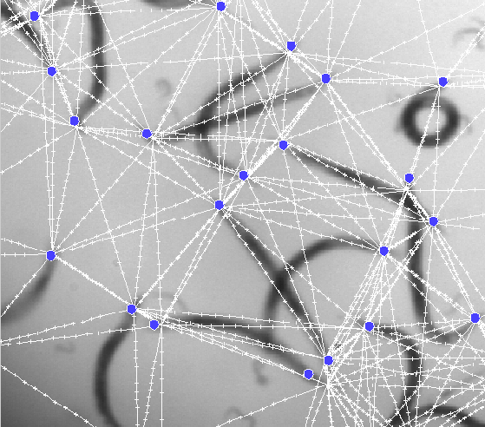
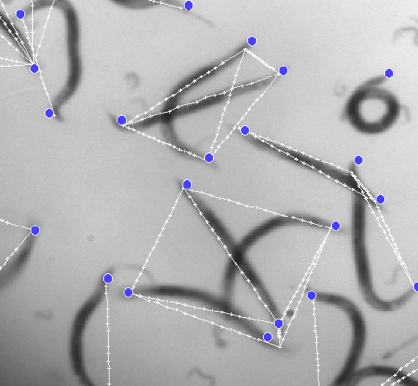
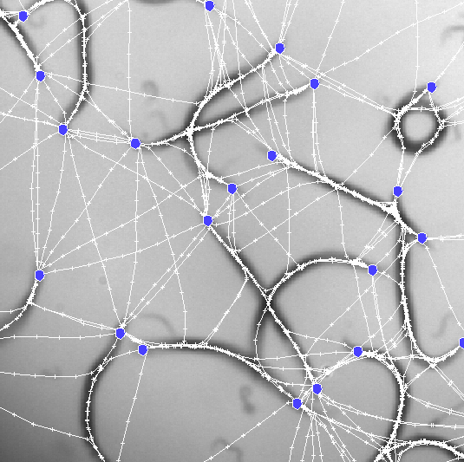
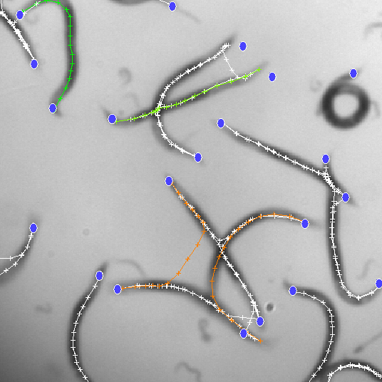
580 D. Ochoa, S. Gautama, and B. Vintimilla
the smoothness constrain can not be enforce some contour sections might rest on the
image background.
In the following we will refer to contours located on single nematode as nematode
contours and the remaining cases as non-nematode contours. Our interest is to extract
nematode contours reliably, but as can be seen in Fig. 2. there is no simple way to
distinguish them without additional processing steps and the inconvenient problems
mentioned previously. Hence the suggested solution is presented in the following
section.
Fig. 2.
Contours (white) from end points (blue) matching criteria. Left column: expected
length. Right column: line evidence. First row: before convergence. Second row: after
convergence. Right bottom: Examples of nematode (green) and non-nematode (orange) contour
classes.
3 Detection of Specimens Using Energy Features
The goal of our experiments is to explore the feasibility of classifying a given
contour
in a corresponding nematode
w
or non-nematode
w
classes. Let
C
be the set of
n
t
contours
{c
,...,c
}
generated after the convergence process and define a contour
c
as a
1
m
sequence of
n
control points (
x
,...,x
)
.
Two types of shape measurements based on
1
n
the three relations (length, curvature and line evidence) encapsulated in the energy
terms are defined.
The expected point energy
M
captures the average value of a given energy term
e
e
along the contour:

Detection of Individual Specimens in Populations Using Contour Energies 581
{}
M
=
e
,
e
e
,
e
,
e
(4)
c
,
e
c
t
b
ext
and the point sequence energy
S
integrates the control point’s energy in a vector
e
providing evidence about the effect that different shape and appearance
configuratio ns have on the individual contour components:
{}
S
=
(e
,...,
e
)
,
e
e
,
e
,
e
c
c
(5)
x
c
,
e
x
t
b
ext
n
1
The distributions of these energy based feature
values allows us to study the
similarity between contours belonging to objects of interest and their properties. It
seems reasonable to expect that the energy configuration space should display clusters
in regions linked to objects of consistent shape and appearance.
The relevance of using active contours and their associated energies becomes
manifest when comparing contours after convergence. In background regions, control
points are collinear and equidistant, therefore
M
features should report rather fixed
e
values. For nematode contours, control point spatial distribution is not homogeneous
because their location is determined by the foreground image data and body
geometrical configuration. Since at some degree they look alike and share similar
movement behavior a suitable set of
S
features values could capture such limited
e
configuration space.
Other patterns can be deduced, but it is unlikely that features derived from any
individual energy term will provide by itself a reliable recognition outcome. The
combination of energy based features in a statistical framework is proposed to
measure their discriminative power. To that aim the Bayes rule was applied to classify
contours as nematode o r non-nematode. The ratio of the a posteriori probabilities of
nematode to non-nematode classes given the values of an energy based feature set
was defined as discriminant function.
The prior prob abilities were regarded homo geneous to test the effectiveness of the
proposed features, however they can be modeled for instance by the distribution of
control point distances to the nearest end point or by the distribution of line evidence.
This reduces the d iscriminant functio n to the ratio of the prob abilities of feature
values given that a contour is assigned to a particular class. Assuming independence
between energy terms and control point locations theses distributions can be readily
defined as the product of the probabilities of the feature set elements given a class
w
{
w
,
w
}
:
n
t
{}
P(M
|
w)
=
P(
e
|
w)
,
e
e
,
e
,
e
(6)
c
,
e
c
t
b
e x t
e
{}
P(S
|
w)
=
P(e
|
w)
,
e
e
,
e
,
e
(7)
c
c
,
e
x
t
b
e x t
e
x
Finally, the computational cost for contour classification in a population image
depends on the size of
C
, the feature type selected and the number of energy terms
included. In the case of
S
there is no extra cost because their components are the
e
terms of
E
,
M
calculations requires an additional step to calculate the associated
c ont ou r
e
average.

582 D. Ochoa, S. Gautama, and B. Vintimilla
4 Experimental Evaluation
The proposed methodology was evaluated on a set of high resolution time-lapse
images depicting populations of adult nematodes with approximately 200 specimens.
The end point set was extracted from ground truth images and straight initial contours
placed between pairs of matching points according to the criteria presented in section 2.
Both contour sets with 903 and 1684 elements, each having 16 control points, were
optimized until convergence. To estimate the conditional probability distributions we
built a training set of 50 randomly selected nematodes and non-nematode contours.
Given the non-gaussian nature of
P(M
|w)
and
P(S
|w)
data we fitted them using
e
e
weibull and gamma probab ility density functio ns respectively to extract the
distribution parameters.
The features derived from
the expected point energy
and the point sequence energy
definitio ns,
comprised all the possible combinations of energy terms. Every feature
type was
evaluated separately and combined totaling 21 energy based features. For
completeness we includ ed also the total contour energy
E
.
We additionally
c ont ou r
performed energy based feature classification considering different number of control
points. To do that an increasing number of control points on both ends of every
contour was gradually discarded.
To assert the performance of the proposed energy based features we compared
them to geo metrical features used in previous work on nematode classification [3].
They include: the contour length
Len
, the summation of signed distance from the end
points to the contour’s centroid that provides a measure of symmetry
Sym
, a
compactness
Cmp
metric calculated as the ratio between the contour length and its
eccentricity, and the angle change rate
Acr
computed from the summation of the
difference in angles between contour segments normalized by the length and number
of control points. We tested them separately and combined using the same
probab ilistic framework d escrib ed in section 3 .
Table 1. summarizes the classification results, it shows the true positive
Tp
rate,
the
false positive
Fp
rate, and the distance
D
to perfect detection corresponding to best
performance for every feature type. In the case of energy based features the first
Table 1.
Best classification results for energy and non-energy based feature combinations
Line Evidence Expected length
D Tp Fp D Tp Fp
S
16
,
,
0.263 0.884 0.236 0.137 0.911 0.104
(e
e
e
)
t
b
e xt
M
1 0
,
0.406 0.614 0.125 0.227 0.800 0.108
( e
e
)
t
ext
M
+
S
,
0.543 0.467 0.106 0.398 0.604 0.044
1 2
(e
e
)
t
ex t
0.479 0.924 0.473 0.352 0.901 0.338
Len + Sym +Acr
E
0.747 0.924 0.743 0.736 0.923 0.732
c ont ou r

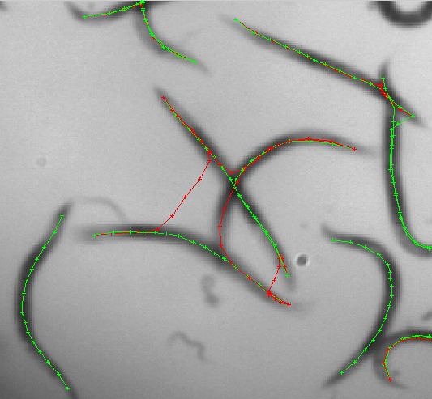
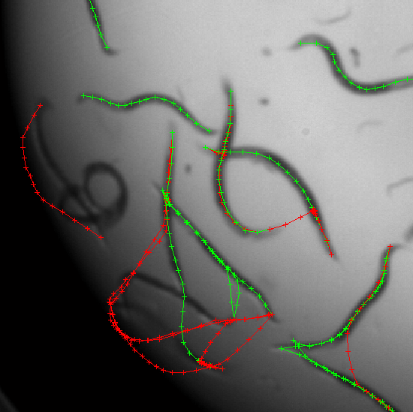
Detection of Individual Specimens in Populations Using Contour Energies 583
column also specifies the energy terms included and the amount of control points.
The proposed energy based features consistently show a better trade off between true
and false detection rates compared to other features. Though in combination
the true
positive detection drops it is still co mparable with non-energy based features that
despite of detecting most nematode contours have a high rate of false detections. The
total contour energy
E
performed poorly.
c ont our
Point sequence features discriminative power increases as more control points are
added while for expected point energy features results improves when this number
decreases. This is indicative that nematode and non-nematode contour classes have
similar average energy value distributions and only when the contour’s central part is
analyzed the difference is large enough to allow reliable classification. A possible
explanation relies on the fact that nematodes central area is the less flexible part of
their body so contour variations become prominent if we use only the central control
points. Regarding the two search spaces we noticed that results improve as we
include more initial contours since we have more possibilities of segmenting all the
nematodes contained in the sample.
Fig. 3.
Classification results for nematode (green) and non-nematode contours (red) some non-
nematode contours were remove to improve visibility
The results showed that the single most discriminating energy term for
M
,
S
and
e
e
M
+
S
features is the tension energy term
e
, the spatial distrib ution of contro l points
e
e
t
appears to capture nematode evidence accurately. This observation is explained in
terms of the relations between energy terms during optimization. Since in our image
set nematod es show
lower external energy
e
values near the center, control points
e x t
tend to gather in that area however as they move
e
increases in the vicinity of contour
t
ends and pulls them in the opposite direction. Therefore, the distance between control
points varies depending on the regions they are located, in our specimens these
regions correspond to nematode appearance features. It must be noted that only by
combining several energy terms the false positive rate can be consistently reduced. As
expected bending energy
e
allow us to filter out contours with sharp turns and the
b

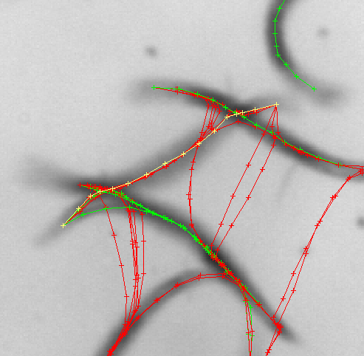
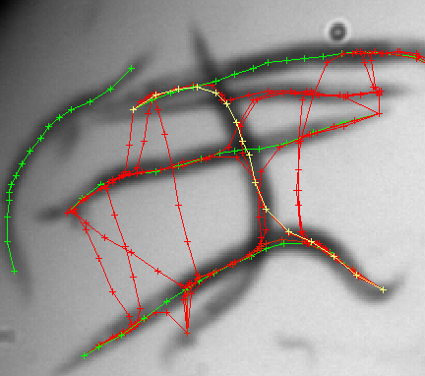
584 D. Ochoa, S. Gautama, and B. Vintimilla
external energy
e
, those with spatial intensity distribution too different from those
e x t
found in the population Fig. 3.
Nematode contour misclassification occurs when appearance information is lost or
in the presence of an unusual shape configuration. The first case includes nematodes
close to the petri dish border where lightning conditions reduce the contrast between
foreground and background. The other case is frequently the result of optical
distortion produced by the microscope lens. Non-nematode contours can be
mistakenly classified when most of their control points converge towards a real
nematode, for instance in the presence of parallel nematodes very close to each other,
or when in heavy overlapping regions a contour manages to run over parts of several
objects and still resemble a real nematode Fig. 4.
Fig. 4.
Misclassification examples (yellow).
Right: nematode contour affected by blur. Left:
non-nematode contour partially running over different nematodes in overlapping region.
The change of relative optical density at junction constitutes the main source of
structural noise. The resulting darker areas affect negatively the spatial distribution of
control points during the optimization process and hence the recovered energy values.
The more occluded is a nematode the less its discriminant function value, nevertheless
correct detection of a number of nematodes in overlapping regions is feasible when
enough shape information is retained. We also noticed that nematode contours sharing
a end point with wrongly detected contours have a consistently higher discriminant
function value, this relatio n could be used to improve detection results further but has
not explored yet in these experiments.
5 Conclusions
A set of features for detection of individual nematodes in population has been
proposed. The resultant patterns from a set of optimized contours proved a valid
source of shape evidence for recognition of specimens in difficult scenarios.
Detection rates allowed us to reject most non -nematode contour while keep ing a
significant number of correct detected nematodes.

Detection of Individual Specimens in Populations Using Contour Energies 585
The proposed approach differ from existing shape modeling approaches where
feature points are manually located on salient regions on individual object to build
linear and non-linear shape model. We use the evolution of active contour models to
capture object statistics therefore constraining the range of possible appearance and
geometrical configurations to those present in the current sample set.
Features based on average and local contour energy component distributions were
tested on manually segmented images in the framework of Bayesian inference.
Experimental results with two different contour initialization strategies sho w that
energies based features provide better detection rates that geometrical based features
commonly applied in image processing of biological samples. In particular energy
term combination displayed a consistent performance for true nematode detection.
When nematode and non-nematode contours have similar average feature values the
results can be improved if only the central region of the contour is evaluated which is
consequent with the morphological characteristic of these specimens captured during
the optimization process.
Despite the limitations of active contours to converge correctly in low contrast
regions or in the vicinity of sharp corners we found out that recognition is still
feasible if a sufficient amount of shape information is retained even in overlapping
regions. Further improvement in detection rates could be achieved if interactions
between classified contours and prior knowledge about line evidence are included
however this work is out of the scope of this paper. We let for future work extending
our findings to video sequences for tracking moving nematodes in occlusion
situations.
Acknowledg ments.
This work was supported by the VLIR-ESPOL program under
the component 8, the images were kindly provided by Devgen Corporation.
References
1. Bengtsson, E., Bigun, J., Gustavsson, T.: Computerized Cell Image Analysis: Past, Present
and Future. In: Bigun, J., Gustavsson, T. (eds.) SCIA 2003. LNCS, vol. 2749, pp. 395–
407. Springer, Heidelberg (2003)
2. Fdez-Valdivia, J., De la Blanca, P.N., Castillo, P., Gomez-Barcina, A.: Detecting
Nematode Features from Digital Images. Journal of Nematology 24, 289–298 (1992)
3. Wei, G., Cosman, P., Berry, C., Zhaoyang, F., Schafer, W.R.: Automatic tracking, feature
extraction and classification of C. elegans phenotypes. IEEE transactions in Biomedical
Engineering 51, 1811–1820 (2004)
4. Van Osta, P., Geusebroek, J., Ver Donck, K., Bols, L., Geysen, J., ter Haar Romeny, B.M.:
The Principles of Scale Space Applied to Structure and Color in Light Microscopy.
Proceedings Royal Microscopical Society. 37, 161–166 (2002)
5. Meijering, E., Jacob, M ., S arria, J.-C.F., Unser, M.: A Novel Approach to Neurite Tracing
in Fluorescence Microscopy Images. Signal and Image Processing. 399, 96–148 (2003)
6. Meijering, E., Smal, I., Danuser, G.: Tracking in Molecular Bioimaging. IEEE Signal
Processing Mag. 3, 46–53 (2006)
7. Moller, S., Kristensen, C., Poulsen, L., Cartersen, J., Molin, M.: Bacterial Growth on
Surfaces: Automated Image Analysis for Quantification of Rate-Related Parameters.
Applied and Environmental Microbiology 6(1), 741–748 (1995)

586 D. Ochoa, S. Gautama, and B. Vintimilla
8. Baguley, J., Hyde, L., Montagna, P.: A Semi-automated Digital Microphotographic
Approach to Measure Meiofaunal Biomass. Limnology and Oceanography Methods. 2,
181–190 (2004)
9. Tomankova, K., Jerabkova, P., Zmeskal, O., Vesela, M., Haderka, J.: Use of Image
Analysis to Study Growth and Division of Yeast Cells. Journal of Imaging Science and
Technology 6, 583–589 (2006)
10. Twining, C., Taylor, C.: Kernel Principal Component Analysis and the Construction of
Non-Linear Active Shape Models. In: British Machine Vision Conference, pp. 26–32
(2001)
11. Kirbas, C., Quek, F.K.H.: Vessel Extraction Techniques and Algorithms: A Survey. In:
Proceedings 3th IEEE Symposium on BioInformatics and BioEngineering, pp. 238–246.
IEEE Computer Society Press, Los Alamitos (2003)
12. Aylward, S., Bullitt, E.: Initialization, noise, singularities, and scale in height ridge
traversal for tubular object centerline extraction. IEEE Transactions in Medical
Imaging. 21, 61–75 (2002)
13. Geusebroek, J., Smeulders, A., Geerts, H.: A minimum cost approach for segmenting
networks of lines. International Journal of Computer Vision. 43, 99–111 (2001)
14. Hicks, Y., Marshall, D., Martin, R., Rosin, P., Bayer, M., Mann, D.: Automatic
landmarking for biological shape model. In: P roceedings IEEE International Conference
on Image Processing, vol. 2, pp. 801–804. IEEE, Los Alamitos (2002)
15. Carmichael, O., Hebert, M.: Shape-based recognition of wiry objects. Pattern Analysis and
Machine Intelligence. 26, 1537–1552 (2004)
16. Kass, M., Witkin, A., Terzopoulos, D.: Snakes: Active contour models. International
Journal of Computer Vision. 4, 191–200 (1997)
17. Foulonneau, A., Charbonnier, P ., Heitz, F.: Geometric shape priors for region-based active
contours. In: Proceedings IEEE International Conference on Image Processing, vol. 3, pp.
413–416. IEEE Computer Society Press, Los Alamitos (2003)
18. Tsechpenakis, G., Rapantzikos, K., Tsapatsoulis, N., Kollias, S.: A snake model for object
tracking in natural sequences. Signal Processing Image Communications. 19, 219–238
(2004)
19. Zimmer, C., Olivo-Marin, J.: Coupled parametric active contours. IEEE Transactions on
Pattern Analysis and Machine Intelligence. 27, 1838–1842 (2005)
20. Neuenschwander, W., Fua, P., Iverson, L., Székely, G., Kubler, O.: Ziplock snakes.
International Journal of Computer Vision. 23, 191–200 (1997)
21. Jiankang, W., Xiaobo, L.: Guiding ziplock snakes with a priori information. IEEE
Transactions on Image Processing. 12, 176–185 (2003)
22. Dong Joong, K., JongEun, H., In So, K.: Fast object recognition using dinamic programing
from combination of salient line groups. Pattern Recognition. 36, 79–90 (2003)
23. Lacoste, C., Descombes, X., Zerubia, J.: Point Processes for Unsupervised Line Network
Extraction in Remote Sensing, IEEE Trans. Pattern Analysis and Machine Intelligence 27,
1568–1579 (2005)
24. Steger, C.: An unbiased detector of curvilinear structures. IEEE Trans. Pattern Anal
Machine Intell. 20, 113–125 (1998)

