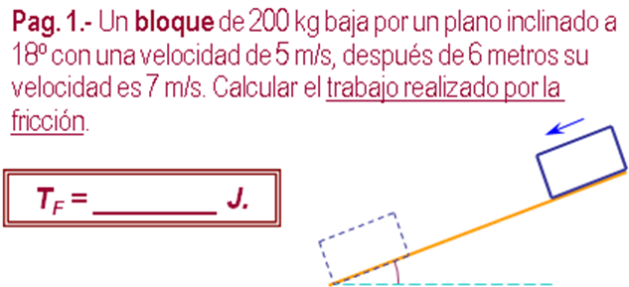
m | 200 | kg
v₁ | 5 | m /s | 2500.0000 | J (Ec₁)
v₂ | 7 | m /s | 4900.0000 | J (Ec₂)
d | 6 | m | 2.0000 | m/s² (a)
α º | 18 | 0.32 | 1.8541 | m (h)
 | 1.051 | 1 | 3634.0399 | J (Epg₁)
 | TF= Epg1 +Ec1 -Ec2
 |  | TF | 1234.0399 | J

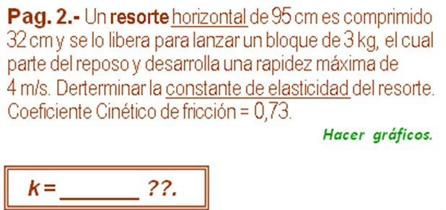

L₀ | no | cm
x | 32 | cm | 0.3200 | m
m | 3 | kg
v₁ | 0 | m/s | 0.0000 | J (Ec₁)
v₂ | 4 | m/s | 24.0000 | J (Ec₂)
μ | 0.73 |  | 6.8678 | J (Tf )
 | k= (Ec2 - Ec1 +Tf)*2 /x^2
 |  | k | 602.8875 | N /m

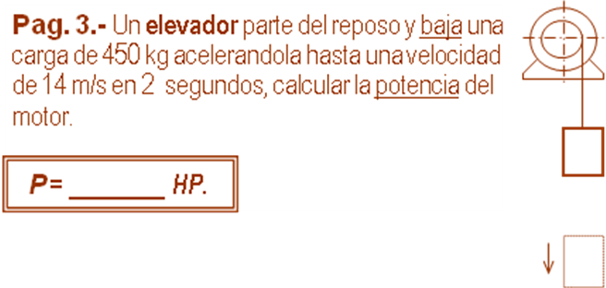

m | 450 | kg | 4410.0000 | N (w)
v₁ | 0 | m/s | 0.0000 | J (Ec₁)
v₂ | 14 | m/s | 44100.0000 | J (Ec₂)
t | 2 | s | 7.0000 | m/s² (a)
h = ( v₂² -v₁² ⁾/ 2 a_{Y} |  |  | 14.0000 | m/s² (h)
 |  |  | 61740.0000 | J (Eg₁)
 | T = (E_{C2} -E_{PG1} -E_{C1})
 |  | T | -17640.0000 | J
 | P = (T / t) *(1 /746)
 |  | P | -11.8231 | HP

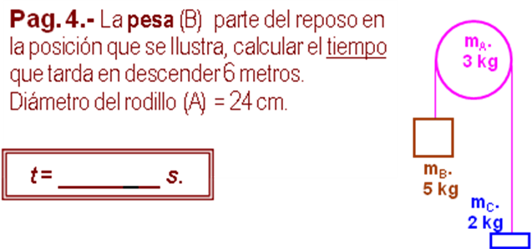

m_{A} | 3 | kg | 29.4 | N (w_{A})
R | 0.12 | m
r | 0 | m | 0.0216 | kg m² (I)
m_{B} | 5 | kg | 49 | N (w_{B})
m_{C} | 2 | kg | 19.6 | N (w_{C})
h | 6 | m
v₂ =(g*h*(m_{B} -m_{C}) /((1/2)*m_{B} +(1/2)*m_{C} +(1/4)*m_{A}))^0.5
 |  | v₂ | 6.4425 | m/s
 | t = 2 *h / v₂
 |  | t | 1.8626 | s

