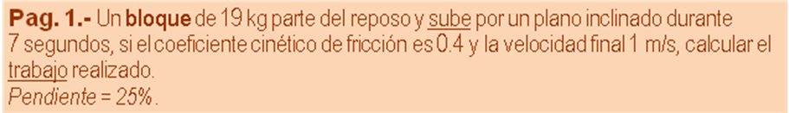
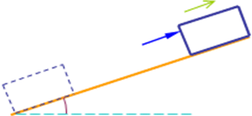
m | 19 | kg
v₁ | 0 | m /s | 0,0000 | J (Ec₁)
v₂ | 1 | m /s | 9,5000 | J (Ec₂)
t | 7 | s | 0,1429 | m/s² (a)
μ | 0,4 |  | 252,8967 | J (T/ μ)
y | 25 | 103,08 | 3,5000 | m (d)
x | 100 |  | 0,8489 | m (h)
 |  |  | 158,0605 | J (Epg₂)
 | T =E_{C2} +T/μ +E_{PG2} -E_{C1}
 |  | T | 420,4572 | J

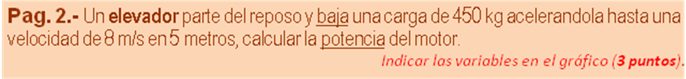
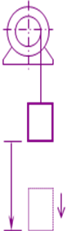
m | 450 | kg | 4410,0000 | N (w)
v₁ | 0 | m/s | 0,0000 | J (Ec₁)
v₂ | 8 | m/s | 14400,0000 | J (Ec₂)
h | 5 | m | 22050,0000 | J (Eg₁)
a_{Y} = v₂² -v₁² / 2 h |  |  | 6,4000 | m/s² (a)
t = v₂ -v₁ / a |  |  | 1,2500 | s ( t )
 | T = E_{C2} -E_{PG1} -E_{C1}
 |  | T | -7650,0000 | HP
 | P = (T / t )*(1/746)
 |  | P | -8,2038 | HP

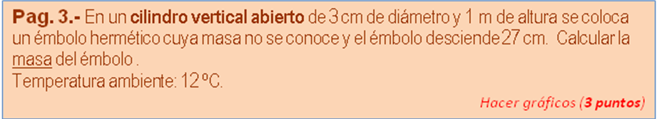
P_{ATM} = | 101325 | Pa
ρ _{AIRE =} | 1,29 | kg /m³

Diám. | 0,03 | m | 0,0007 | m² (A)
T₁ | No | ºC
h₁ | 1,00 | m | 0,0007 | m³ (Vol)
y₂ | 0,27 | m | 0,7300 | m (h₂)
 | m = ((P_{ATM}*(h₁/h₂) -P_{ATM})*A)/g
 |  | m | 2,7031 | kg

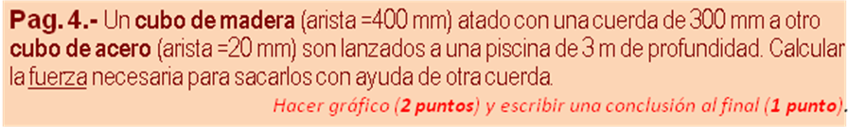
ρ _{MADERA =} | 810 | kg /m³
ρ _{ACERO =} | 7800 | kg /m³
ρ _{AGUA =} | 1000 | kg /m³

a _{MAD} | 0,40 | m | 0,0640 | m³ (V_{M})
a _{A} | 0,02 | m | 0,0000 | m³ (V_{A})
 | m _{M} = V_{M} * ρ_{M} |  | 51,8400 | kg (m_{M})
 | m _{A} = V_{A} * ρ_{A} |  | 0,0624 | kg (m_{A})
 | w _{M} = m _{M} * g |  | 508,0320 | N (w_{M})
 | w _{A} = m _{A} * g |  | 0,6115 | N (w_{A})
 | E _{M} = V_{M} *ρ_{H2O} |  | 627,2000 | N (E_{M})
 | E _{A} = V_{A} *ρ_{H2O} |  | 0,0784 | N (E_{A})
 |  | F = w_{M} +w_{A} -E_{M} -E_{A}
 |  | F | -118,6349 | N

