POLYTECHNIC SCHOOL OF LITORAL


Escuela de Diseño y Comunicación Visual

RESEARCH TITLE
“INCLUSION OF DISABLED PEOPLE IN GUAYAQUIL COMPANIES”
RESEARCH PROJECT PRIOR TO OBTAINING THE TITLE
BILINGUAL SECRETARY IN INFORMATION SYSTEMS
AUTHOR:
JENNIFER VILLAMAR ALUME
TUTOR:
MSC. HILDA FLOR PÁEZ
GUAYAQUIL – ECUADOR

2011 – 2012

ACKNOWLEDGEMENT
This research project would not have been possible without the support of many people. First of all, God Almighty who blessed us with the gift of life, and strengthened us through the years. I would like to express my gratitude to our tutor Hilda Flor Páez, Msc. for her guidance, continuous encouragement, inspiration and dedication during my project. Finally, I take this opportunity to express my profound gratitude to my mother, for her truthful, patience and advice. I’ll never forget her sacrifice and spiritual support throughout my life.

Jennifer Villamar Alume

ABSTRACT
This project describes human rights; among them we can find the rights for disabled people, which are going to be my focus along this paper. One of the points this study stands for is that disabled people deserve respect on labor, human and environmental fields. People physically and mentally disabled are commonly accepted or rejected for a work position depending on the kind of disability. The Ecuadorian law protects these people. Many benefits are offered for their inclusion in the labor force.

EXPRESS STATEMENT

Responsibility for the contents of this Final Graduation, is solely me, and the intellectual heritage of the same to the Polytechnic School of Litoral

COURT GRADUATION

_______________________________
Hilda Flor Páez, MSc.
PROJECT DIRECTOR

_______________________________
Mae. Jorge Lombeida Ch.
DELEGATE
AUTHOR'S PROJECT GRADUATION

______________________________
Jennifer Villamar Alume
TABLE OF CONTENT
General Framework of Investigation
INTRODUCTION I
STATEMENT OF THE PROBLEM II
SPECIFIC OBJECTIVE II
STUDY PLACE III
STATEMENT OF HYPOTHESIS III
THEORETICAL AND PRACTICAL IMPLICATIONS III
LITERATURE REVIEW V
BACKGROUND VI
METHODOLOGY VI
1 CHAPTER 1: KINDS OF RIGHTS 1
1.1 Human Rights 1
1.1.1 Definition 2
1.1.2 History 3
1.1.3 Universal Declaration of Human Rights 4
1.1.4 The Role of Nongovernmental Organizations 6
1.1.4.1 Types of Nongovernmental Organizations 7
1.1.5 The Motivation of Human Rights 8
1.2 Laboral Rights 9
1.2.1 Definition 9
1.2.2 History 11
1.2.3 Labor rights issues 11
1.2.4 International Labour Organization 13
1.3 Environmental Rights 15
1.3.1 Definition 15
1.3.2 History 16
2 CHAPTER 2: MOST COMMON TYPE OF DISABILITIES AND THE USE OF TECHNOLOGY 18
2.1 Disability 18
2.2 Impairment 18
2.3 Handicap 19
2.4 Types of disabilities 19
2.4.1 Physical disability 19
2.4.1.1 Sight Disability 20
2.4.1.2 Hearing Disability 20
2.4.1.3 Heart Disease 20
2.4.1.4 Epilepsy 21
2.4.2 Mental Disorder 21
2.4.2.1 Down's syndrome (Mongolism) 21
2.4.2.2 Autism 22
2.4.2.3 Cretinism (Thyroid Deficiency) 23
2.4.2.4 Cranial Anomalies 23
2.4.2.4.1 Microcephaly 23
2.4.2.4.2 Hydrocephalus 24
2.4.3 Learning disability 25
2.4.3.1 Developmental and Language Disorder 25
2.4.3.2 Developmental Articulation Disorder 26
2.4.3.3 Developmental Expressive Language Disorder 26
2.4.3.4 Developmental Receptive Language Disorder 27
2.4.3.5 Academic Skills Disorders 27
2.4.3.5.1 Developmental Reading Disorder 27
2.4.3.5.2 Developmental Writing Disorder 28
2.4.3.5.3 Developmental Arithmetic Disorder 28
2.4.3.6 Obsessive Compulsive Disorder (OCD) 29
2.4.4 Assistive technology 30
2.4.4.1 Ergonomic aids 30
2.4.4.2 Large/LCD Monitors 31
2.4.4.3 Read and Write software 31
2.4.4.4 Mind-mapping 32
2.4.5 Access to communication media 32
2.4.6 Medical Technology 33
3 CHAPTER 3: THE LAW FOR DISABLED PEOPLE 34
3.1 Article 47 - Ecuadorian Constitution 34
3.1.1 Specialized Attention in Public and Private Entities 34
3.1.2 Public and Private Transportation 35
3.1.3 Permanent Assistance 36
3.1.4 Equal rights 37
3.1.5 Equal opportunities 37
3.2 Article 48 from the Ecuadorian Constitution 38
3.2.1 Specialized Education 38
3.2.2 Free Psychological Attention 39
3.2.3 Social Inclusion 40
3.2.4 Obtaining loans and discounts 40
3.3 Article 49.- Ecuadorian Constitution. 41
3.3.1 Support for Disabled people family 41
4 CHAPTER 4: RESEARCH REPORT 43
4.1 Introduction 43
4.2 Objectives 44
4.3 Problem 44
4.4 Theoretical framework 44
4.5 Methodology 46
4.6 Hypothesis 46
4.7 Design 47
4.8 Samples 47
4.9 Materials 47
4.10 Results 47
4.10.1 Quantitative Data 47
4.10.2 Qualitative Data 51
4.10.2.1 First Investigation 51
4.10.2.2 Third Investigation 52
4.11 Analysis 52
4.12 Appendixes 54

Table of figures

Figure 1 Physical Abuse 2
Figure 2 Hurt to people 3
Figure 3 World War II 3
Figure 4 English Revolution 4
Figure 5 Eleanor Roosevelt’s 5
Figure 6 Non Governmental Organization 7
Figure 7 Advocacy NGOs 8
Figure 8 Laboral Relationship 10
Figure 9 Karl Marx 11
Figure 10 Working Condition 12
Figure 11 International Labour Organization 13
Figure 12 New Zealand, Employment and unemployment 14
Figure 13 Technical Cooperation ILO 14
Figure 14 Environmental Right - Shelter 16
Figure 15 Rights for indigenous people 16
Figure 16 Sight Disability 20
Figure 17 Hearing Disability 20
Figure 18 Epilepsy 21
Figure 19 Down syndrome 22
Figure 20 Autism 22
Figure 21 Microcephaly 24
Figure 22 Hydrocephalus 24
Figure 23 Learning disability 25
Figure 25 Developmental Writing Disorder 28
Figure 24 Developmental Reading Disorder 28
Figure 26 Developmental Arithmetic Disorder 29
Figure 27 Ergonomic writing aids 30
Figure 28 LCD monitor 31
Figure 29 Read and write software 31
Figure 30 Mind-mapping 32
Figure 31 Specialized Attention 35
Figure 32 Technical Aids given to disabled people 36
Figure 33 Specialized education 38
Figure 34 Psychological attention 39
Figure 35 Door to door visits 40
Figure 36 Visits made by specialist and doctor 42
Figure 37 disabilities causes in workplace 46

INTRODUCTION
One of the most important reasons I chose this topic is to point out the Rights and Duties established in the law for disabled people.
According to The Journal of ERW and Mine Action more than 13 percent of Ecuador’s population—at least 1.6 million—has some sort of disability. At the beginning, the disabled people’s life was very difficult because they were not allowed to work. These days, the government is giving job and professional growth opportunities to them. On the other hand, the state provides rehabilitation services to individuals in remote and rural areas. It also promotes victim-capacities assistance. Thus, laws for disabled people intend to be fair and protect their integrity and dignity.

STATEMENT OF THE PROBLEM
Mental and physical disabilities have different levels. Many disabled people have had no law support through centuries. Their inclusion in the society was a dream. Even though a law existed for a long time, no government supported it or put it into practice until President Rafael Correa, started the process in 2009.
When a handicapped person is hired in a company, usually the companies do not know how to handle their special situation and make them feel comfortable. Dealing with disabled people is sometimes difficult. Being patient, giving support and paying attention to their requirements certainly helps them a lot. Also, coworkers have to make some adjustments when a disabled employee joins the workforce.
The broad objective of this study is to address the hiring systems for disabled people and raise awareness about the respect of their rights which are established by the Ecuadorian law.

SPECIFIC OBJECTIVE
The objective for each unit is to give necessary information about the disabled people: their rights, duties and benefits inside the companies and their obligations of law.
The first chapter is about the historical background of the human rights. The second chapter refers to types of disabilities and the use of technology to help disabled people. The third chapter refers to Ecuadorian law for disabled people. The last chapter is addressed to a company where I found a case study information about how disabled employees feel working there and to how companies can improve their hiring system in order to support people with disabilities.
The final result of this study--- will be:
- Overview on the inclusion people with disabilities at the workforce
- Address appropriate hiring processes in Ecuadorian companies
- Raise awareness on how companies can provide the appropriate work environment

Study Place
This project takes place in Fire Station of Guayaquil (BCBG). It has 100 employees. This research will be carried out for non-disabled employees working in this company.

STATEMENT OF HYPOTHESIS
When a company hires disabled people, it is setting the sample for other companies. Therefore, more and more companies trust the capacity of many disabled people and their performance in their different positions. Some executives resist the idea of hiring disabled people. It is considered an expense because a company has to do many adjustments, provide accommodation and comfortable job facilities.
However, nowadays, disabled people are part of our society and labor force because progress has been made in understanding, integrating and encouraging them to reach their goals.
I will describe how disabled people are able to develop many activities inside the companies. Currently, they are preparing personally and professionally. In the future, many of them could be able to manage companies. Therefore, people with disabilities will have better job opportunities.

Theoretical and Practical Implications
Most people agreed and others disagreed about the inclusion of disabled people in companies. According to Carlos Pereyra López (2003) Doctor in Jurisprudence who develops many social and cultural activities in in benefit of many institutions stated: “disabled people especially through vindication and the work of associative movement, have advanced significantly. They have supplied and overcome the old concept of social welfare, of gracious aids, passing from an acknowledgement of their collective needs to a subject of fundamental rights that demands equality of opportunities, not as a favor, but as an actual right.”
Practical Implication
Law for disabled people was created to protect their integrity and respect the rights of disabled people. The government offers many benefits, welfare and medical attention, which are essential for disabled people life.
Theorical Implication
María de los Ángeles Figueredo Delgado (2003) President of Federación Española de Asociaciones de Padres de sordos (FIAPAS) stated, “We have seen from support to a social concept and charitable assistance in the world of the disabled individual, who was socially segregated and only subjected to the goodwill of the government as charity organizations and benefactors. Until recently the classification of professional figures among them was as justification for not working. The disabled person was dependent on the taxpayer voluntariness of others.”

Practical Implication
Nowadays, disabled people can decide what they want to do and according to law established they are in conditions to work and to be included in all the social activities that government or organizational plans.
Theoretical Implication
Gloria Canals Sans (2003) Licenciada en Psicología y Pedagogía Terapéutica stated “there are disabled people associations and other associations for parents and friends. Not everybody has the same capability but it is clear that we have always relied on its own diminished opportunities and we have obtained results above expectations. It is necessary to find the meeting point between the freedom of the disabled and the collaboration of parents and friends. This includes the disabled non-self and external support, not supplying their choice more than it is necessary.”

Practical Implication
Everyday many institutions create strategies to help disabled people and their family. These entities are supported by the government in the economic aspects with the purpose of avoid people with disability suffer any kind of abuse especially in public institutions where workers are not trained to attend in a good way.

Literature Review
Until the 1950s, children with disabilities were hidden away or put into institutions. This was better than the previous century when they were put into prisons or poorhouses with common criminals. In the late nineteenth century and early twentieth century, it was decided to create more positions for people with disabilities. Disabled people would not live in separate institutions where they were manipulated by people who could ignore them because of literally no supervision. Separate institutions created another sort of abuse. Instead of being abused by fellow inmates - they were neglected horribly by the people who were supposed to provide them care. This sounds quite awful and it was, but at the time it seemed more humane than the previous alternatives.
In the 1950s, parents wanted their children to have a different kind of life. They started to try to get more adequate institutions where children would be taught. They wanted cleaner places and schools. All these changes eventually happened, and at the same time seemed quite forward thinking and amazing on this further vision.
All these changes gave birth to inclusion. There are two kinds of inclusion. One should be called dumping. Kids are dumped into regular classes, where they are given very little support and have very little success. They are unlikely to make friends. Teachers are frustrated because they do not know what to do with them, and they do not get support either. Dumping is abusive. Inclusion does not have to be that way.
Mistreatment of people with disabilities has often been done by well meaning people who thought what they were offering was better than what was available. It was, but not good enough.

Background
Handicapped are people who are suffering any type of physical and mental disability. These are the most common ones. At the moment, they receive support from the government and associations. Some of the benefits they receive are free medical service, specialized education, appropriate housing and one of the recent rights is being included in laboral fields.
In the past, people believed that having a disability was a punishment from God; also being disabled was a sign of being weak or inferior, with less value as a human being. Due to their limitations, disabled people were killed or forced to live in the dark (hidden from other people). Some other disabled people were abandoned in hospices, hospitals and mental institutions because their families couldn't "take care of them."
Integrating disabled people in laboral fields will show companies that their inclusion is not going to mean an expense for companies, and they are able to carry out any assigned activity.

Methodology
My research paper has been done applying the following methods of investigation.
Deductive: The first step of our research was to look for the necessary bibliography in order to select the information that would give structure to the theoretical frame of this work and to support the scientific basis of this project.
Exploratory: This method allowed understanding an issue or situation, bringing the conclusions of a problem.

CHAPTER 1

Kinds of rights

CHAPTER 1: Kinds of Rights
Have you ever heard about people with disability? In Ecuador there are a good number of people suffering different kinds of disabilities. These disabled people have the same rights and duties as a no-disabled person. In the next part we will know about the most common type of rights, which include human, labor, and environmental.

Human Rights
Human rights have not been abrogated by any government because they are part of the people rights and are supported by the law. To accomplish the human rights it is important to know and understand about what human rights refer to according to what the government has established. These rights have helped people receive certain benefits and improve the treatment for all humans simply because of the fact that they are human beings. Human rights have to be respected by everybody. It is important that the government always give support to the human. The next pie chart shows the percentage of how much we know about Human Rights in Spain.
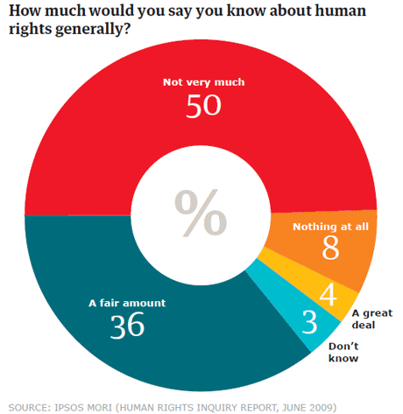

Human rights refers to equal rights and freedom for everybody, these rights mean no distinction of any kind of race, color, sex, language, religion, political beliefs or other opinions. For this reason it is important to know the definition and history of Universal Declarations of Human Rights, The Role of Nongovernmental Organizations, and The Motivation of Human Rights
I pretend to create a clear mind on how the work rights have to be respected and the accomplishment of the Ecuadorian Constitution.

Definition
Human rights are supported by an International Convention; this organism is named the United Nation's Universal Declaration of Human rights. We as human beings do not know important things because we do not read or do not have interest in it. In the next paragraph I am going to provide many concepts about the meaning, explain the different terms and the classifications.

First definition for right is a positive or negative treatment and assistance from others. Verbal, physical and sexual abuse suffered by children and women has been an enormous trouble in our country, because our fear has ignored it. Approximately one out of three adolescent girls in the United States is a victim of physical, emotional or verbal abuse from a dating partner – a figure that far exceeds victimization rates for other types of violence affecting youth.

Figure 1 Physical Abuse
A second definition of rights refers to personal security, personal freedom and property. All the people have the right to enjoy life, health and the free use of their belongings as they wish without anybody controlling or affecting their personal reputation. James Brighenti Member of “Lifeseekers” webpage said:” I am free to make my own choices and decisions in life, they are very important to me. I see my personal freedom as a gift and I consider it is a marvelous thing when used positively. However, I do not always use my freedom responsibly. I am human and I suppose, all of us at times, fail to consider other people's needs in our decision making”
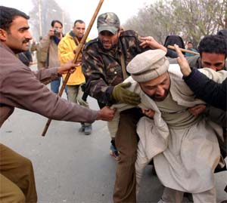
The last concept is that rights are privileges that allowed to be free and supported, or to receive equal treatment. These rights are there for protection against people who might want to harm or hurt you. They are also there to help us get along with each other and live in peace.

Figure 2 Hurt to people

History
The history of Human Rights took place in Greece, where the rights began to be part of humanity, Later on we heard about them in Rome, where people believed that natural rights belonged to every person because it did not exist any law. To continue with this history in the next paragraph we will know more important facts about the origin of Human rights.
Firstly, the History of Human rights has developed religious, cultural, philosophical and legal issues. In World War II people acquired rights and responsibilities depending on their family group, indigenous nation, religion, class, community, or state.


Figure 3 World War II

Secondly, there were differences between today’s Human Rights and those of the past. Past rights refer to abuses because there were slaves; this goes against today’s law. Nowadays, this has changed. People are more informed and know the law that protects them. As a fact In Attica, there were around 400,000 slaves. The Greeks justified slavery alleging that there were certain barbarians who were slaves by nature. As a matter of fact, the slaves in Greece were for the most part barbarians by race. In exceptional cases, Greeks also were captured in war, and were thus reduced to permanent slavery; but, as a rule, they were exchanged or freed on the payment of a ransom.
Finally, it is important to mention that political participation and freedom of religion were abrogated by the English Revolution of 1640. After that, things changed because of the Glorious Revolution of 1688, which supported the protection of the rights so that people can live in peace.


Figure 4 English Revolution
Now, the countries have received the support of the world nations. Respect for human rights is becoming a universal principle of good government.

Universal Declaration of Human Rights
All human beings are born free and equal in dignity and rights. They are endowed with reason and conscience and should act towards one another in a spirit of brotherhood. The next paragraph describes information of the Universal Declaration of Human Rights; it refers to when rights were declared.
First of all we have to know that The Universal Declaration of Human Rights was proclaimed and adopted on December 10, 1948 by the General Assembly of United Nations. After this historic act, the Assembly asked all member countries that the rights were distributed, displayed, read and commented principally in schools and other educational institutions, As a fact The 60th anniversary of the Universal Declaration of Human Rights is being commemorated in a year-long campaign by the UN system, providing an opportunity to mobilize the whole of the United Nations and to evaluate progress in respecting and promoting human rights. The motto of this campaign is “Dignity and Justice for All of Us”.
Then the members of the United Nations began to respect human rights of all. To reach this goal, the UN established a Commission on Human Rights guided by Eleanor Roosevelt’s and wrote a detailed document where the meaning of the fundamental rights and freedom proclaimed in the Charter were explained. This captured the world’s attention.
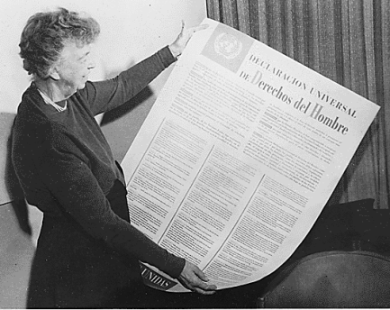
Figure 5 Eleanor Roosevelt’s

After that, the influence of the UDHR “Universal Declaration of Human Rights” has been substantial. Its principles have been incorporated into the constitutions of more than 185 nations that now are in the UN. Although a declaration is not a legally binding document, the Universal Declaration has achieved the status of customary international law because people regard it as a common standard of achievement for all people and all The Universal Declaration of Human Rights identifies many rights. For example:
  - Life, liberty and security of people
  - Freedom from slavery and servitude
  - Freedom from torture, or cruel, inhuman or degrading treatment or punishment
  - Equality before the law (isonomy)
  - Not being subjected to arbitrary arrest, detention or exile
  - Freedom of movement and residence
  - Nationality
  - The right to marriage and to found a family
  - Freedom of thought, conscience and religion
  - Peaceful assembly and association
  - Work
  - Health
  - Education.
The study of human rights includes values and attitudes, and these needs to be confirmed or confronted. There are no easy ways to avoid the horrific evidence of abuses, the consequences of which some people live with every minute of every day. If we want a world where human rights abuses are consigned to history, then it is up to all people, as individuals, communities and nations to be vigilant, and knowledgeable about human rights.

The Role of Nongovernmental Organizations
The Nongovernmental Organization provides necessary services to their communities, and thorough planning during the start-up process is crucial to develop an effective and professional organization that is able to meet the challenges faced by the world today.
I will start with the Role of Nongovernmental Organization. NGO are nonprofit organizations that have not been established by governments. According to Harold Jacobson, author of one of the established texts in international organization, NGOs, like intergovernmental organizations (IGOs), have their members regularly program meetings of their members' representatives, where decision-making procedures are specified, as well as a permanent staff.
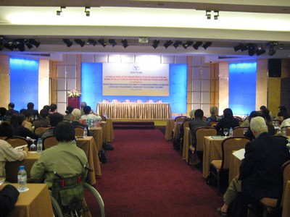

Figure 6 Non Governmental Organization
The Universal Declaration of Human Rights is a call to freedom and justice for people throughout the world. Every day governments that violate the rights of their citizens are challenged and called to task. Every day human beings worldwide mobilize and confront injustice and inhumanity.

Types of Nongovernmental Organizations
Nongovernmental Organizations are divided into two groups: Operational and advocacy. Each of them has their objectives and activities.
First, it is important to know that Operational Nongovernmental Organizations (ONOGs) are in charge of mobilizing resources, in the form of financial donations, materials or volunteer labor.
The ONOGs needs to have an office and the staff specialized on the field, in order to sustain their projects and programs. In 1992 The International NGOs channeled over $7.6 billion of aid to developing countries. It is now estimated that over 15 percent of total overseas development aid is channeled through NGOs. While statistics about global numbers of NGOs are notoriously incomplete, it is currently estimated that there is somewhere between 6,000 and 30,000 national NGOs in developing-process countries. The purpose of the Operational NGOs has been contributed to the development of many countries through its projects and programs.
Second, I will write about the Nongovernmental Advocacy Organizations, which are in charge in most part of the same activities but with a difference between them. For example: They persuade people to donate their time to organize events which allows attracting favorable publicity to raise funds. The aim of the Nongovernmental Advocacy Organizations is defend the projects and promote to reduce the victims of discrimination and injustice.


Figure 7 Advocacy NGOs

The Motivation of Human Rights
With an acceptance of human rights, Moslems, Hindus, Christians, capitalists, socialists, democracies, or tribal oligarchies may all disapprove something in which they disagree on. If Human Rights did not exist, people would not be kind and respectful in our world.
One of the motivations for established human rights is the fear consequences of denying their existence because without the support of organizations it would be impossible to defend the oppression. Robert Alan said: "The evolution of the human rights movement clearly illustrates humanity's ongoing struggle toward creating a better world." Years ago the oppression formed part of people’s lives. It did not exist something that made them feel secure and safety.
The main benefit of human rights is that they are seen as a fundamental factor for human existence, without oppression of any other consideration. Human rights may be an example to other societies to accomplish them and the citizens can protest if they are not being recognized.

Laboral Rights
Do you know what laboral rights are? Being Human has rights in the laboral field too. The owners of the companies most of the time do not give all the employees benefits established by the law; they give only what they think convenient.
Labor rights or workers' rights are a group of legal rights that employees have to receive from part of the company and in the agreed time. In general, companies have to pay benefits, wages and safe working conditions to the employees. One of the most central of these "rights" is the right to unionize. Unions are currently advocating new federal legislation that would allow workers to elect union representation by only signing cards. The current process established by federal law requires at least 30% of employees to sign cards for the union, and then wait 45 to 90 days for a federal official to conduct a secret ballot election in which a simple majority of the employees must vote for the union in order to obligate the employer to bargain. Unions report that, under the present system, many employers use the 45 to 90 day period to conduct anti-union campaigns. Unions inside the companies help to increase the salaries of the workers and require respect of their rights.
For understanding better you have to know the definition of labor rights, the History, the laboral rights issues, and International Labor Organization.

Definition
Laboral rights bring many definitions to our mind. In our society this unknown subject is especially for people of low income that when get a job they think that the company pays
the appropriate salary, without this being actually true. The salaries of our country are reduced this depends of the economic situation.
First of all let me explain the definition of labor according to classical economics. It is the amount of work completed by humans; it is also one of the three factors of production. Lewis Thomas said: “For me, the word "labor" does not come with unfavorable connotations, but it certainly spans both ends of the scale for others”. It is important the companies acknowledge the effort in the job of their workers, if it were possible give a recognition that motivated the employees work better.
As a second definition it is known as employment law, which regulates the relationship between workers and employers through the various systems of work that characterize humans. 90% of the rural female labor force are called "housewives" and are excluded from the formal definition of economic activity. If all the companies apply this system and accept the rights of their workers, demands against the companies will not exist.
As a third definition, we could say that labor right is based on a protective principle, which as opposed to the private law is based on a principle of legal equality. All the employees of a company have to receive the same benefits and in equal parts because this law was created to improve the Labor relations in a company.


Figure 8 Laboral Relationship

History
The history of laboral rights began during the Middle Ages, the Peasants' Revolt, in England, in which people expressed demand for better wages and working conditions. One of the leader of the revolt was the famous John Ball, who argued that people were born equal saying, "When Adam delved and Eve span, who was then the gentleman?"
In the 19th century after the creation of the labor unions, laboral rights became a modern characteristic of the human rights. Many of associated groups that defend the rights of the workers were influenced by Karl Marx who stands out as one of the earliest and most prominent advocates for workers rights.

Figure 9 Karl Marx

Thanks to Karl Marx the labor unions were created to defend the rights of the workers.

Labor rights issues
Laboral rights suffer many issues; the creation of them was not an easy work because the collaboration and the influence of Karl Marx made it possible.
First, it was established the limit hours in the work place. The employees have to work Eight-hour day, 40 hours weekly or less according to the standards in many countries. A 35-hour workweek was established in France in 2000, but this standard has been considerably weakened since then. Workers may agree with employers to work for longer, but the extra hours are payable overtime. In the European Union the working week is limited to a maximum of 48 hours including overtime. Many companies do not recognize the effort of their workers; they work for long hours and do not receive any extra paid; they are exploited.
Labor rights advocates have also worked to struggle child labor. Child labor is seen as an exploitative, cruel, and often economically damaging issue. Child labor opponents often argue that working children are deprived of education. The main industries in which children are engaged are
  - Agriculture, hunting and forestry (58% of the total)
  - Trade (14%)
  - Manufacturing (11%)
  - Agriculture, hunting and forestry for both boys and girls (80%)
  - Working children who reside in rural areas (36%)
  - The government should help prevent children from working. Either they work because they do not have economic resources to study, or most of the time their parents force them to do it, or children do not receive any benefit.
Labor rights advocate improving workplace conditions. The workplace needs to be in good conditions, has to be comfortable and clear in order not affect the employees´ job efficiency. The next bar chart shows the percentage of worker participation in working conditions measured by gender in California
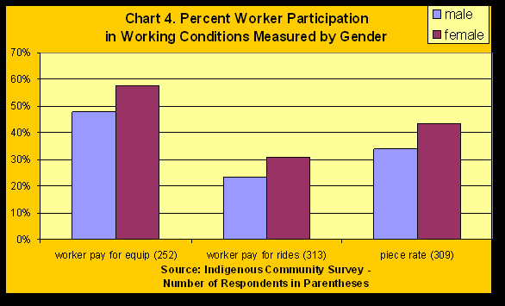

Figure 10 Working Condition

International Labour Organization
The International Labour Organization (ILO) was created in 1919, became the first specialized agency associated with the United Nations. This organization was adopted by countries in 1919 and in 1971 grew to 121 members.
The ILO has three major tasks: the first task is the adoption of international labor standards, called Conventions and Recommendations, for implementation by member states. The Conventions and Recommendations contain guidelines on child labor, protection of women workers, hours of work, rest and holidays with pay, labor inspection, vocational guidance and training, social security protection, workers' housing, occupational health and safety, conditions of work at sea, and protection of migrant workers.

Figure 11 International Labour Organization

The second task covers questions of basic human rights, among them, freedom of association, collective bargaining, the abolition of forced labor, the elimination of discrimination in employment, and the promotion of full employment. Here is a graph of New Zealand employment versus unemployment. It was taken from New Zealand Statistics figures for the past two decades.

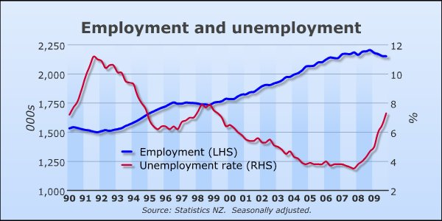

Figure 12 New Zealand, Employment and unemployment

The third major task is the technical cooperation to assist developing nations. These activities are concentrated in four areas: development of human resources, through vocational training and management development; employment planning and promotion; the development of social institutions in such fields as labor administration, labor relations, cooperatives, and rural development; conditions of work and life: a few examples are occupational safety and health, social security, remuneration, hours of work, welfare, etc. The owner of a company has to give all the benefits established by the law and the government to all the employees.

As a final task, standard-setting and technical cooperation are supported by an extensive research, training, education, and publication program. The ILO is a major source of publications and documentation on labor and social matters. It has established two specialized educational institutions: the International Institute for Labor Studies in Geneva, and the International Center for Advanced Technical and Vocational Training in Turin, Italy.

Figure 13 Technical Cooperation ILO

Environmental Rights
Human rights protection and environmental protection are well-developed and important in our world. As activists, scholars, and policy practitioners have increasingly the intersection of these two areas, calls for the protection of environmental rights have intensified.
Few international human rights organizations that have programs focused on protecting the environment do not generally have as their aim on humans; the goal is to defend environmental rights, which include: social justice issues such as the disproportionate suffering of poor, indigenous, and minority communities from toxic industrial activity. The East Europeans should implement enforceable environmental laws, both constitutional and statutory; for them, environmental protection is a necessity, not a luxury. Eastern Europe is an environmental disaster area. Forty-five years of communism resulted in lives significantly shortened by exposure to pollution, forests destroyed by acid rain, waters polluted with industrial waste and sewage, and unbreathable air in many places.
In the next paragraphs we will learn about the definition, history, environmental justice, and the environmental injustice that are the most important factors in environmental rights.

Definition
Have you ever thought on what environmental rights mean? This refers to preserving the environment and caring about the natural resources that exist in our nature. In the next paragraphs some definitions about environmental rights are explained.
The first definition for Environmental rights is the access to natural resources that allow survival, including land, shelter, food, water and air. They also include more purely ecological rights, including the precise animals have to live. These rights are crucial sources that haven’t disappeared for the human being because without them we couldn’t survive.


Figure 1 Environmental Right - Shelter
Figure 14 Environmental Right - Shelter
The second is Environmental rights also include political rights like rights for indigenous people and other collectivities, the right to information and participation in decision-making, freedom of opinion and expression, and the right to resist unwanted developments. Everybody has the right to say what they think even if they have differing opinions; we have to respect it.
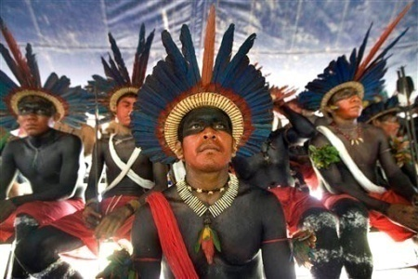

Figure 15 Rights for indigenous people

All of these rights are equally important, and they are all interdependent. Environmental rights are human rights, as people's livelihoods, their health, and sometimes their very existence depend upon the quality of and their access to the surrounding environment as well as the recognition of their rights to information, participation, security and redress.

History
Environmental Rights have a transcendental history, which explains when, where and how was the origin of environmental rights.
Environmental history emerged in the United States as a new discipline that grew out of the environmental movement of the 1960s and 1970s and much of its impetus still stems from present-day global environmental concerns. All human experience is based in the natural world; almost anything might be considered suitable material for research, a situation that acts as an incentive to ground the subject in particular time-scales, geographic regions, or key themes.
Through this history, I have made a description of the human rights and their mentors. Contributions made to the humanity by these rights and declaration of human rights. Also, I have described the labor rights and when and where they were proclaimed. How people have benefitted by them. Finally, I have mentioned the environmental rights which can guide us to understand the type of physical and environmental facilities to be provided to people with disabilities.

CHAPTER Ii

MOST COMMON TYPES OF DISABILITIES AND THE USE OF TECHNOLOGY

Chapter 2: Most common types of disabilities and the use of technology
Physical and mental impairments may be acquired at birth or through accidents or diseases. That is why we have clear knowledge about what disability means and how it has been developed in order to help people. It is important to know that if you want to make a difference for disabled people’s lives, you must change the society and the way people deal with impairments. There are an interesting number of disabilities which affect People. According to Consejo Nacional de Discapacidades (CONADIS), in Ecuador there are 1´600.00 people who have hearing, physical and intellectual disabilities. Only 35.146 people with disabilities are registered and have a permanent employment.
In this chapter, I will focus on the most common physical and mental disabilities. I would like to start by stating the definition of disability, impairment and handicap. Then, I will briefly detail the different types of disabilities. Finally, I would describe how technology helps disabled people.

Disability
Disability is a complex phenomenon, reflecting an interaction between features of a person’s body and features of the society in which he or she lives. Disable is the most generally accepted term to refer to people with a permanent illness or injury that makes it difficult for them to use parts of their body completely or easily. i.e., it refers to a stable and persistent deficit in function

Impairment
Impairment is a problem in body function or structure; an activity limitation is a difficulty encountered by an individual in executing a task or action; consequently, the participation restriction is a problem experienced by an individual in involvement of life situations. Thus, the consequence of impairment is confined to the individual.

Handicap
Handicap is a slightly old-fashioned term and many people now think it is offensive. People also now prefer to use the word disability rather than handicap. i.e., it refers to the limitation on carrying out social roles defined as appropriate for an individual of certain age, gender or class.
An individual may also qualify as disabled if he/she has had impairment in the past or is seen as disabled based on a personal or group standard or norm. Such impairments may include physical, sensory, and cognitive or developmental disabilities. Mental disorders (also known as psychiatric or psychosocial disability) and various types of chronic disease may also be considered qualifying disabilities.
A disability may occur during a person's lifetime or may be present from birth. A physical impairment is any disability which limits the physical function of limbs or fine or gross motor ability.

Types of disabilities
The most common type of disabilities are: physical, mental and learning disabilities; These can affect an individual`s daily activities or limit the performance in daily activities. For example, blind people find it hard to do some things like going to school or work.

Physical disability
In Ecuador, physical disability is a common illness that many people suffer; it might be possible that you have seen some cases. This type of disability affects the senses. The physical disability may be congenital or a result of injury, muscular dystrophy, multiple sclerosis, cerebral palsy, amputation, heart disease, pulmonary disease or more. Some persons may have hidden (no visible) disabilities which include pulmonary disease, respiratory disorders, epilepsy and other limiting conditions. In the next paragraphs, we will know about sight, hearing, heart, epilepsy disabilities and different types of disorders.

Sight Disability
Eyesight disability is when you do not have appropriate vision even if you wear eyeglasses or contact lenses. Visual impairment may be caused by several eye diseases like age related, muscular degeneration, and cataracts, among others. There are vision impairments that can be treated medically, but there also that can’t be corrected medically after accidents or inherited ocular disorders.


Figure 16 Sight Disability

Hearing Disability
This disability includes people who are completely deaf or have partial hearing in one or both ears. However, to correct this problem, you are required the use of a hearing aid. As we have noticed, there are people who have hearing disability and yet they can still communicate through sign language.
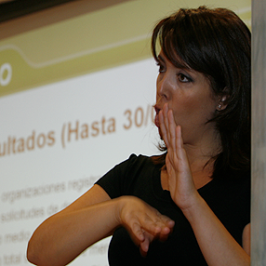

Figure 17 Hearing Disability

Heart Disease
It is also called cardiovascular disease. Different kinds of problems occur when the heart and blood vessels are not working the way they should. The heart is the center of the cardiovascular system. Through the body's blood vessels, the heart pumps blood to all of the body's cells. The blood carries oxygen, which the cells need. Sharon Shields Member of American Heart Association said: “Walking is my passion as well as part of my recovery” – she will inspire you to get moving!

Epilepsy
Epilepsy is a general term used for a group of disorders that cause disturbances in electrical signaling in the brain. Like an office building or a computer, the brain is a highly complex electrical system, powered by roughly 80 pulses of energy per second. These pulses move back and forth between nerve cells to produce thoughts, feelings, and memories. People who suffer epilepsy have a hard life because they do not know the moment convulsion comes and need the help of the people.
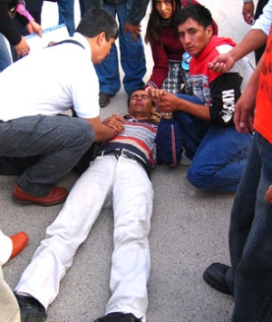
Figure 18 Epilepsy

Mental Disorder
Mental disorder or mental illness is a psychological or behavioral pattern associated with distress or disability that occurs in an individual and it is not a part of normal development or culture. There are many types of mental disorders. In the following paragraphs, I will provide the concepts of Down's Syndrome (Mongolism), Autism, Cretinism(Thyroid Deficiency, Cranial Anomalies, Microcephaly, and Hydrocephalus,

Down's syndrome (Mongolism)
The most appropriate term is Mongolism. People who have this syndrome have slanting shaped eyes. There are many children who have the features of Down’s syndrome. Most of the time, down syndrome is due to random events that occurred during formation of the reproductive cells, the ovum or sperm. 100% of people with Down syndrome will develop some physiologic signs of Alzheimer’s when they are over 35 years old in the US (Association for Children with Down syndrome).
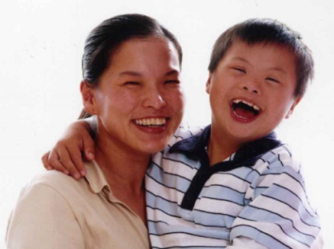

Figure 19 Down syndrome

Autism
Doctors have never been able to determine the actual cause of autism, but many believe that the disorder is triggered by the environment. Although there has been much debate regarding the actual effects of the environment, researchers have been able to successfully pinpoint at least seven major genes found in people diagnosed with the disorder.
Autism is a brain development disorder, which usually occurs in the first years of childhood and it is characterized by problems with non verbal communications and social interactions.
According to the research by Centers for Disease Control Prevention in 2007, autism affects 1 in every 150 children in the United States. Statistics also show that autism is three times more common in boys than in girls.

Figure 20 Autism

Cretinism (Thyroid Deficiency)
Cretinism provides a dramatic illustration of mental retardation resulting from endocrine imbalance. In this condition, the thyroid either has failed to develop properly or has undergone degeneration or injury. In either case, the infant suffers from a deficiency in thyroid secretion... Bridget Coggins, mother of a girl who suffers this deficiency, explains her personal experience: “I have been going to the doctors for at least 2 years to figure out what's wrong with my daughter. I know I took some medicine when I was pregnant for Hyperthyroidism and the doctor said in low dose it was safe. I have been investigating this for months and realize that she may have Cretinism. I am awaiting a call from the Neurologist soon for me to discuss my concerns. I need to prepare myself because I blame myself. I know it is not my fault but I wish I was told in more detail the risks. I wish I opted for a natural way to control this, but I fear it is too late”. Brain damage resulting from this insufficiency is most marked during the prenatal and early postnatal periods of rapid growth.

Cranial Anomalies
It refers to a mental retardation associated with a number of conditions in which there are relatively gross alterations in head size and shape, and where the causal factors have not been definitely established. Inside this group we can find two types of cranial anomalies: microcephaly and hydrocephalus.

Microcephaly
The term microcephaly means "small headedness". It refers to a type of mental retardation resulting from impaired development of the brain and a consequent failure of the cranium to attain normal size. One of the features is small head that exceeds 17 inches compared with the normal that is 22 inches. This illness is considered moderate, severe, and profound categories of mental retardation; it shows little language development and it is extremely limited in mental capacity.
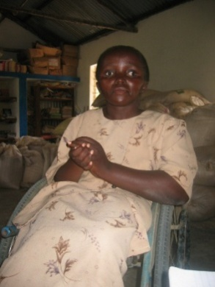

Figure 21 Microcephaly

Hydrocephalus
It is a condition where an abnormal amount of cerebrospinal liquid is accumulated within the cranium, causing damage to the brain tissues and enlargement of the cranium. The disorder can also develop in infancy or early childhood following the development of a brain tumor or subdural hematoma. A good deal of attention has been directed to the surgical treatment of hydrocephalus, and with early diagnosis and treatment this condition can usually be arrested before severe brain damage has occurred.

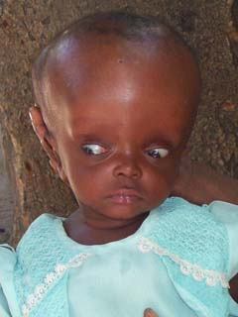
Figure 22 Hydrocephalus

Most part of the people suffering this disorder is poor people who do not have the appropriate economic resources to access medical treatment on time. Nowadays, the Ecuadorian government is worried for this type of disease. The government is creating programs and has made agreements with foreign doctors that come to our country and give free medical appointments and surgeries to people with these mental and psychological disabilities. Therefore, patients suffering these disorders are receiving free surgeries, treatment and supporting benefits.

Learning disability
Learning disabilities are often categorized as mild, moderate or severe. People with a learning disability vary a great deal in the help they may need in meeting their basic needs. Learning disabilities are those disorders that impact a person's ability to hear, speak, read, write and calculate. Some people may require help with washing and dressing for example, while many others will live quite independently with much less support.
Learning disability (LD) is a neurological disorder affecting one or more basic psychological functions such as understanding or using written or spoken language. People with this disability will have difficulty in speaking, reading, listening, writing, spelling and mathematical calculations.
There are many types of learning disabilities that affect people in various ways: developmental speech and language disorders, academic skills disorders, and obsessive compulsive disorder.


Figure 23 Learning disability

Developmental and Language Disorder
When a person is unable to produce speech sounds correctly or fluently, or has problems with his or her voice, then he or she has a Language disorder. Difficulties pronouncing sounds, or articulation disorders, and stuttering are examples of speech disorders.
Developmental language disorders differ from the absence of mental retardation or any other impairment may be hereditary, or genetic. This category can be further classified, based on the specific diagnosis. In the subsequent paragraphs, I am going to provide you with the most common concepts about the Developmental Articulation Disorder, Developmental Expressive Language Disorder, Developmental Receptive Language Disorder.

Developmental Articulation Disorder
This disorder are easily noticed when errors made in speech sounds consistently occur irrespective of the context. The anomaly is common in young children but if it persists after the age of five, the condition needs to be examined closer. The anomaly may be caused by such things as facial muscle weakness. Examples of articulation disorders include slips of the tongue, substitution of the "y" sound for "l" and difficulty with blends involving r, l or s (e.g. brick, clip, slap).
This disorder is common, and appears in at least 10 percent of children under the age of 8. Children with this disorder find it difficult to control their speech rate. However, children are seen to be successfully treated with speech therapy.

Developmental Expressive Language Disorder
A person with an expressive language disorder understands language better than he/she is able to communicate. In speech-language therapy terms, the person’s receptive language (understanding of language) is better than his/her expressive language (use of language).
It is when a person finds it difficult to express themselves in speech. Expressive language disorders can also be acquired (occurring as a result of brain damage/injury), as in aphasia. It is a disorder that results from damage to portions of the brain that are responsible for language. For most people, these are areas on the left side (hemisphere) of the brain. Aphasia usually occurs suddenly, often as the result of a stroke or head injury, but it may also develop slowly, as in the case of a brain tumor, an infection, or dementia. An expressive language disorder could occur in a child of normal intelligence, or it could be a component of a condition affecting mental functioning more broadly (i.e. mental retardation, autism).

Developmental Receptive Language Disorder
Sometimes a person has trouble with this kind of disorder when using spoken and sometimes written language. When this is the case, a Receptive-Expressive Language Disorder may be diagnosed.
Receptive language disorder means children have difficulties with understanding what is said to them. The symptoms vary between individuals but generally, problems with language comprehension usually begin before the age of four years. Other names for receptive language disorder include central auditory processing disorder and comprehension deficit. Toddlers do not respond to their names, and children make mistakes in correlating name of objects with the actual object. For example, when asked for a ball, they give a bell. Thus, even though they hear the words correctly, they are unable to comprehend what they hear.

Academic Skills Disorders
Have you heard about a person who develops their academic skills slower than their classmates? This category is further classified as: Developmental Reading Disorder, Developmental Writing Disorder, and Developmental Arithmetic Disorder.

Developmental Reading Disorder
Developmental reading disorder (DRD) is not caused by vision problems, but rather by problems with the brain's ability to recognize and process symbols. It refers to a condition in which reading ability is significantly below the norm in relation to chronological age and overall intellectual potential. This disorder is also known as dyslexia, and affects 2 to 8 percent of elementary school children. Children who suffer from this reading and language-based disability have difficulties with language skills such as writing, spelling, recognizing words, and pronouncing words.
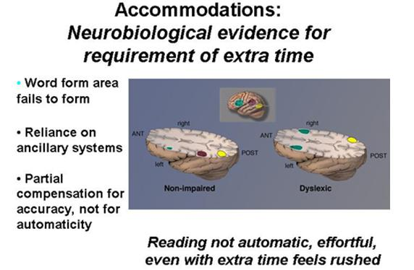
Figure 24 Developmental Reading Disorder

Developmental Writing Disorder
Difficulties with reading and writing commonly occur in special populations (e.g. children with Down Syndrome), as well as in adult populations (e.g. traumatic brain injury). Children who have spoken language impairment are four to five times more likely to experience literacy difficulties, than children without language impairment. These children are unable to construct complete grammatical sentences. To write, the brain networks for grammar, vocabulary, memory and hand movement must function correctly.
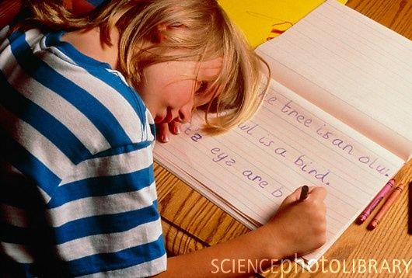
Figure 25 Developmental Writing Disorder

Developmental Arithmetic Disorder
Neurologic in origin, learning disorders does not allow a person's ability to store, process, and/or produce information. Learning disorders can affect the ability to read, write, speak, or compute mathematics and can impair socialization skills. The central clinical feature of a learning disorder is the lack of normal developmental skill, either cognitive or linguistic. This disorder is also known as dyscalculia, and involves a lifelong difficulty related to mathematical calculations. These children have difficulty in understanding simple mathematical concepts and are unable to solve math problems.
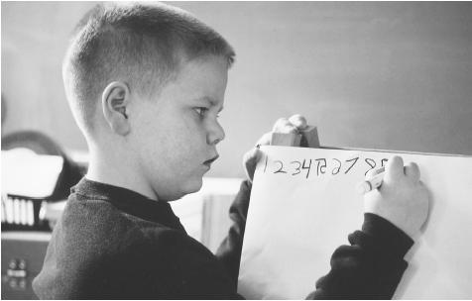

Figure 26 Developmental Arithmetic Disorder

Obsessive Compulsive Disorder (OCD)
Obsessive–compulsive disorder (OCD) is a mental disorder characterized by intrusive thoughts that produce anxiety, repetitive behaviors aimed at reducing anxiety, or by a combination of such thoughts (obsessions) and behaviors (compulsions). In the United States, one in 50 adults has OCD. OCD sufferers generally recognize their thoughts and subsequent actions as irrational, and they may become further distressed by this realization. Multiple psychological and biological factors may be involved in causing obsessive–compulsive syndromes.
I have briefly described the different types of disorders which may affect people and cause disabilities. In the following paragraphs, I will mention the available technology to help people with disabilities and its importance in providing the necessary tools for their professional development.
Technology for disabled people
Technology for disabled people can help to do things easier, but this depends if the company wants to invest on this essential tools. Technology offers many different ways to help people with disabilities to lead more normal lives. Devices that help them perform an activity are called assistive technology. Assistive, medical, and information technology can help people reach their personal and professional goals.

Assistive technology
It is technology used by individuals with disabilities in order to perform functions that might otherwise be difficult or impossible. We can call assistive technology to any item, piece, equipment or product system modified or customized used to increase, maintain, or improve the functional capabilities of a person with a disability. There are many types of assistive technology: ergonomic aids, Large/LCD Monitors, read and write software, mind mapping, other law tech aid,

Ergonomic aids
A person with tremors, or spastic movements could benefit from this type of keyboard. It is an adaptation to standard keyboards, which achieve the same results. In some cases, adaptive keyboards come with specialized software with word-completion technology, allowing the person to type with fewer keystrokes, since typing can be rather laborious and slow.
Ergonomics is the study and use and these aids can help reduce the Relative Strength Index (RSI) and tiredness. Anyone who uses a computer, particularly Office workers, can benefit from these types of aids e.g. wrist rests, anti-glare screen, ergonomic keyboards, tracker ball mice, ergonomic furniture.

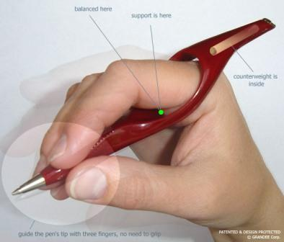
Figure 27 Ergonomic writing aids

Large/LCD Monitors

People with disability really need this kind of support. Sometimes they could not do their job efficiently but we do not know what the cause of this issue is. It is important to be in contact with disabled people working into the companies and ask them about their special needs. Large monitors are an important equipment item for visually impaired users. As mentioned above, this is particularly important if someone is using screen magnification software, as it will ensure a larger proportion of information can be viewed on screen at any time
Figure 28 LCD monitor

Read and Write software
Read & Write is a literacy support tool designed to assist users of all ages who require extra assistance when reading or composing text. It is designed to help computer users with reading and writing difficulties. It can read text aloud and help you construct words and sentences. It also has many other features, such as advanced spell checking and word prediction.


Figure 29 Read and write software

Mind-mapping
Everyone could use a little help organizing their thoughts, being it for a term paper or the end of year financial report. Mind-mapping or brain-storming are creative techniques of getting your thoughts down quickly and then organizing them. You can use paper and a pen which is very low cost or there are software packages such as Inspiration and Mind Genius.
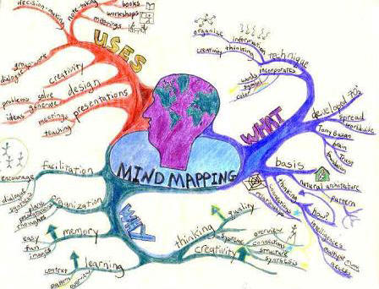
Figure 30 Mind-mapping
Computers have become more dominant in the workplace, making the ability of disabled individuals to use this technology increasingly. It will make the difference between being productive and independent members of society or being dependent on social support.

Access to communication media
When people become disabled as a result of a road traffic accident, stroke or another condition, they may often lose their ability to control themselves within the environment surrounding them and communicate with others by conventional means. There are various systems available which provide alternative methods of performing these tasks. There are many ways of communication for example: techniques, the use of gestures, sign language and facial expressions to the use of alphabet or picture symbol boards.
If you know about sign and symbols to communicate with disabled people, this is a way we show interest in them and can learn about their feelings.

Medical Technology
Do you know what involves medical technology? How it can help people with disability and how is it going to be developed? Medical technology was created to extend and improve disabled people life. Billions of patients worldwide depend on medical technology at home, at the doctor’s, at hospital and in nursing homes. Medical technology refers to the diagnostic or therapeutic application of science and technology to improve the management of health conditions. medications such as targeted therapies for cancer, antidepressants, medical and surgical procedures, medical devices such as magnetic resonance imaging (MRI) and computed tomography (CT) scans, screening tests such as fecal occult blood test for colorectal cancer, electronic support systems such as telemedicine, and electronic medical records.

CHAPTER Iii

ECUADORIAN LAW FOR DISABLED PEOPLE

Chapter 3: The Law for Disabled People
The objective of this law is to establish a disability prevention system, attention and inclusion of people with disabilities, which allows opportunities of having an active role in the community. To understand this law better, I am going to explain about articles 47, 48 and 49 in Ecuadorian Constitution.

Article 47 - Ecuadorian Constitution
Ecuadorian government gives prevention policies of disabilities and it combines ways of assistance from the society and families, public and private entities in order to provide equal opportunities for disabled people and their social inclusion. All disabled people have the same rights as able-bodied people. The rights of disabled people should be the same in the following areas: employment, access to goods, facilities and services, buying or renting land or property, education and transportation. The next part explains about Specialized Attention, Discount in Public and Private Services, Permanent Assistance, Equal rights, and Equal Opportunities.

Specialized Attention in Public and Private Entities
What do you think about the attention provided to Ecuadorian disabled people in public and private Organizations? Many people say that in public companies the customer service is the worst. When you go to one of these organizations, you can observe the difference between the services you receive and it is important to evaluate the service. Disabled people need to receive the best attention in public and private health entities and according to the Ecuadorian law these entities have to provide free medicine in particular for people who need long time treatment.

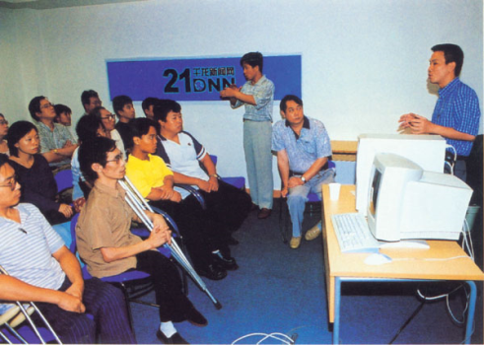

Figure 31 Specialized Attention

Companies have to insure their employees in the Social Security Institute. There is a mandatory insurance program for disability, old age and survivors' benefits, sickness and maternity, work injuries and occupational diseases as well as control and information services for citizens.

Public and Private Transportation
Most people with disability need to be commuted from one side to another because of their sickness. I have seen public and private transport do not want to pick up people with disability and give bad treatment to them. All people with disability have the right to a half trip-fare in the public and private transportation, services and events. In fact people with disabilities hardly eve use public transportation, and even they have quitted their daily journeys, or they have often chosen more expensive and less convenient ways of transportation. In our city, the buses do not offer accommodation to disabled people. Some buses do not have ramps or a section where disabled people can seat during the journey. Some efforts have been made in Ecuadorian cities. For example, in Guayaquil, the regenerated area of the city which covers the downtown business area provides ramps and spaces for people in wheelchairs. Also the metro via transportation system provides ramps and specific sections and spaces where disabled people can seat.

Permanent Assistance
As you know, people with disabilities attend constantly to medical appointments. It is necessary to check their health and they must follow the instructions doctors give them. Disabled people need to have integral rehabilitation, permanent assistance, and technical support. Technical support refers to specialist equipment and adaptations can make it much easier to live independently. For example if you are physically disabled, and especially if you are a wheelchair user, you may need to get equipment and have permanent fixtures installed at home so that you can live there independently.
Examples of equipment and adaptations include:
- stair lifts
- ceiling hoists
- powered or manual height-adjustable beds
- powered leg-lifters for people who have difficulty lifting their legs into bed
You may also need to have adaptation work done in your home - for example, having doorways widened or a ramp installed. In the following chart, there is a detail of the technical aids received by Ecuadorian people from “Manuela Espejo” Foundation (July, 2009 to November 2010)
Figure 32 Technical Aids given to disabled people

The 2011year will be full of challenges as Ecuadorian government has pointed out. Medical teams continued with the diagnostic of disabled people, their attention and medical-scientific study for the cases which were not studied. Provision of technical aids and an integral attention will be given to the population which was attended for the first time in all their rights.

Equal rights
People with disabilities as citizens of their societies should have the same rights and duties as all other citizens. There is an increasing awareness by governments of their duties to grant equal rights to all of their citizens. It is ultimately the responsibility of all governments to ensure that disabled people:
  - Live a dignified and independent life-style within the community;
  - Take an active part in the general, social and economic development of society;
  - Receive education, medical care and social services within the ordinary structures of their societies.
Ecuadorian government pretends that disabled people receive equal rights as other people. This is becoming real these days.

Equal opportunities
In Ecuador, disabled people lived discriminated in a situation of exclusion and poverty, without opportunities to be included in public political life of the country. This situation changed when Rafael Correa, Economist´s government assumed its command and decided to look after those who had been neglected. On May 23rd, 2007, Vice-presidency raised the Program “Ecuador without Barriers” as a reply to the years of abandonment of other governments to the most sensible and unprotected population.
Governments can enact laws to guarantee equality and to prevent discrimination. The cost of denying equal opportunities to people with disabilities is high, not only in financial terms, but also in the loss of their contribution to society. Equal opportunities enable disabled persons to govern their own lives with self-respect and personal integrity.

Article 48 from the Ecuadorian Constitution
The Ecuadorian State has the obligation to defend the human rights, protecting the health of the population; it will assure the continuity of subsistence resources and rehabilitation of the handicap people; it will help the living conditions improvement of people with disability and their family. The next section in the article mentions appropriate housing, specialized education, free psychological attention, access to communication media, social inclusion, and obtaining loans and discounts.

Specialized Education
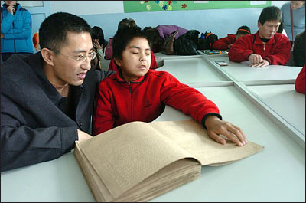
State shall guarantee freedom of education, academic freedom in higher education and the right of people to learn in their own language and cultural matters. Special education is the education of students with special needs in a way that addresses the students' individual differences and needs. Ideally, this process involves the individually planned and systematically monitored arrangement of teaching procedures, adapted equipment and materials, accessible settings, and other interventions designed to help learners with special needs achieve a higher level of personal self-sufficiency and success in school and community than would be available if the student were only given access to a typical classroom education.

Figure 33 Specialized education
Currently students with these kinds of special needs attend regular schools where they receive the education like normal children. Regretfully, most of the teachers are not prepared to work with children with this kind of problem but I know that private educative institutions are making efforts to train teachers, allow them the use of technology and incorporate a specifically teaching area, or resource room which contributes to the fast learning of children who have disabilities. Specifically, in Guayaquil, in a well known private kindergarten, they include children with Down syndrome in their regular classes and teachers have to dedicate extra time, effort and strategies to help these students.

Free Psychological Attention
People with any impairment or disability need to be in constant contact with a psychologist to guide them to stand by. This service is provided to the community in public hospitals, “Manuela Espejo” Foundation has hundreds of specialized psychologist doctors prepared to attend people with disability because they require it and sometimes the attention is extended to the family and there is institutional approach where appropriate.
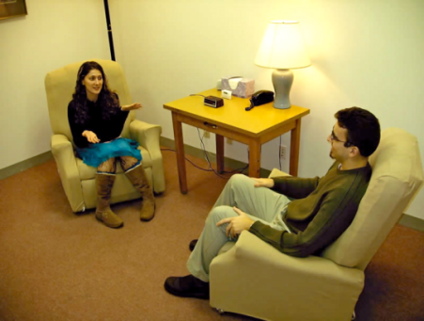
Figure 34 Psychological attention

First, a diagnosis and psychological assessment of people with disabilities is made. Then, they are provided with advice based on the diagnosis of disability, as well as early intervention and guidance against the inclusion or inclusive education and work.

Social Inclusion
People with disability have to be included in public and private plans and programs according to article 4 of Disabled Law. Their participation is necessary in political, social, cultural, economic and educational fields. In order to discuss the inclusion of the disabled people, it is necessary to understand the concept and institutionalization of the disability. The evolution of social and human rights, as integral part of an individual subjective right turned out to be an important achievement for the insertion of the disabled people in the work market. An important example of social and political inclusion in our country is the one carried out by the Ecuadorian Vice-President, Lenín Moreno Garcés. He has personally dedicated his efforts to manage campaigns to help Ecuadorian disabled people.
The pie chart below details the results of identified people in the door to door visit made in many provinces of our country according to data given by “Manuela Espejo” Foundation.
Figure 35 Door to door visits

Obtaining loans and discounts
Banks and many Institutions in Ecuador offer loans for disabled people, giving payment facilities and low interest. Loans for people are a step taken by the financers to help out the disabled people. These loans will benefit them at the time of financial emergency. If they face or are currently facing shortage of funds, they can easily apply for these loans and obtain cash within 24 hours without completing any time-wasting formalities. For this reason, many Ecuadorian institutions like the Federaciones Nacionales para la Discapacidad (FENEDIF), the United States Agency for Development (USAID) and the Inter-American Development Bank have organized the First Microenterprise Contest exclusively with physical disabilities.
At 52 years, Mercedes Alava, Ecuadorian citizen with physical disability, is applying to this type of credit. This woman is an expert in developing Household cleaning products. She mentioned that it was difficult to work in a company. She said, “I am interested in winning the Contest of Microenterprises.”

Article 49.- Ecuadorian Constitution.
Facing forgetfulness, carelessness and urgency to assist the necessities of all disabled people, two historic mutually blinding missions were created: “Manuela Espejo” and “Joaquin Gallegos Lara”. The first one to study and register all people with disability and the second, to care for more vulnerable people with intellectual or physical disability or multi disability.
In addition, to give support to these unpublished programs, in January 2011, vice presidency implemented a System of Prevention of Disabilities in all public hospitals and medical centers of the country and induce the beginning and growing a new generation of Ecuadorian.
In the next part, I will explain about the support for disabled people family some examples and statistics of the work done by the important programs mentioned before.

Support for Disabled people family
Not all the families that have disabled members take care of them. Actually, we have seen that families abandon disabled people on the streets or in institutions where they receive all the support they never received at home. The Ecuadorian government gives support and incentives for productive projects in favor of the families of disabled people. One of these projects was the creation of “Manuela Espejo” Foundation that visited 1´286.331 homes on 24 provinces and 221 cantons of Ecuador here identified a study of 294.166 disabled people. A complete diagnosis was made in areas, where the country has made little improvement such as genetic clinic. The following bar chart shows the results of the visits made to people with disability by specialist and doctor of “Manuela Espejo” Foundation (July, 2009 to November 2010)

Figure 36 Visits made by specialist and doctor

In this chapter, I have emphasized in the Ecuadorian law, specifically articles forty seven, forty eight and forty nine, which mainly address people with disabilities. Also, I made a description of the programs carried out by the Ecuadorian Vice President and included statistic data provided by the government. Additionally, I mentioned other benefits such as loans and a contest for micro entrepreneurs provided to Ecuadorian disabled people. Finally, I included the benefits provided to families with disabled people and figures about the visits made by specialists to different Ecuadorian provinces.
To close up this chapter I must consider is very important that the governments of all countries must increase other social programs in benefit of disabled people because they need to have a better life style trying to satisfy their necessities, such as: housing, medical attention, commodities, technical equipments, a dignifies job, loans to establish their own business in house, free payment transportation, etc.

CHAPTER IV
RESEARCH REPORT

Chapter 4: Research Report

Introduction
When we talk about disabled people in Ecuador, we find different visions about this issue. We also observe the existence of a wide ignorance on the part of the population on the topic regarding the rights of the people with disability. This goes in combination to the generally discriminatory treatment towards the persons who possess this condition. The problem worsens when the vision that the general population of the country has is the same that many of the civil employees of the government holds. Coincidentally, civil employees are those who generate the policies and take the conductive measurements for the improvements of disabled people inside a company.
As mentioned in the previous chapter, the Ecuadorian government is planning the inclusion of disabled people in the society. The general aim is equal treatment of citizens with disabilities. Many policies are developed to reach this goal. We have laws and international agreements, which protect people with disability and raise their quality of life. Also, the laws state improvements of the working conditions for the disabled. On the other hand, most enterprises do not design concrete infrastructures to favor disabled people. There is not even a real will of the workers and the institutions to enforce these policies. It seems that further awareness of people with disabilities is necessary.
The social problems generated by people with disabilities will affect the educational and communication perspective at work. I will focus in a special area of the working environment. It is well known that the work area is one that generates the persons' highest index of accidents at work and can cause diseases on people with disability

Objectives
The objectives of this chapter are:
- Determine if the company is accomplishing the percentage of hiring disabled people.
- Identify what are the benefits disabled people receive from the company.
- Explore the relationship between disabled employees and non-disabled employees.
- Recognize what is the type of support disabled employee has received from their colleagues

Problem
Some companies think hiring disabled people will mean an extra expense for them, because in some cases they need special equipments to work. Also, the company managers have to make many considerations in the work schedule and believe this is going to affect in the company’s growth. What we do not see, is the high potential a person with disability has and what an important resource they can be for the company.

Theoretical framework
Disability is not an isolated situation in the society as we commonly tend to believe; on the contrary, chances of accidents or illnesses that leave some degrees of disability are always present in our daily lives. In fact, the great majority of people with disabilities were not born with this condition, but acquired it by some kind of accident or illness during their lifetime. We find that some people are born with a disabling condition and others acquire it as stated in the course of their life.
On the other hand is the fact that the number of people with disabilities has grown over the years mainly caused by accidents, wars, diseases, natural disasters, among others. Many of these people belong to the working age and in fact they can and should be productive. However, our societies are not aware of creating mechanisms for the inclusion and integration in social, academic work and people with disabilities. The exclusion of people with disabilities in productive, social and academic processes can be caused by ignorance and lack of training about the situation of people with this condition by the other people who have no disability.
In the labor environment, the level of exclusion of people with disabilities is enormous. The truth is that the risk process in the world of work is constant and permanent. This goes hand by hand with the information and training in the area of prevention. However, to understand the magnitude of this problem worldwide, I am including fragments of a report of the International Labour Organization, on the situation of people with disabilities in the workplace.
According to the International Labour Organization (ILO) the situation of people with disabilities in working age is as follows: One, out of ten people worldwide, has disabilities. There are about 650 million people of which about 450 million are of working age. Some have jobs and are fully integrated into society, but as a group, people with disabilities often face poverty and unemployment. Social exclusion deprives companies of between 1.37 and 1.94 trillion dollars in annual losses of the Gross Domestic Product (GDP). About 80 percent of all people with disabilities live in rural areas of developing countries and have little or no access to the services they require. For these reasons, providing decent work for persons with disability has a social and economic impact. (ILO, 2007).
Given the situation described by the data given in the ILO, we see the enormous impact on societies representing the exclusion of people with disabilities in the world of work and production processes. Even though these statistics exclude people with disabilities in the job market, this has become a constant in almost all countries.
That is, we face three major problems. On one hand, we have the high rate of people left with some degree of disability due to occupational accidents and diseases. The other edge of the problem is the exclusion of people with some degree of disabilities in the workplace. Another important point is the high degree of occupational accidents and diseases that occur constantly, leaving behind a lot of worse problems and increasing the number of people with disabilities obtained during the work. The next pie chart shows you the causes of people disabilities in the workplace.

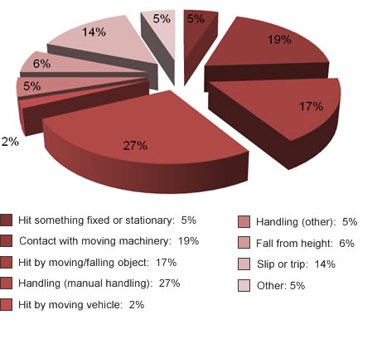

Figure 37 disabilities causes in workplace

Methodology
The methods I decided to use were Descriptive and Exploratory. The Descriptive method helps me to know how the attitude of the workers toward disabled people was. The situation in which they work and the customs among them. The Exploratory Method

Hypothesis
Fire Station of Guayaquil (BCBG) has in its staff people with disabilities but they are accomplishing with the law, but they need to adequate places where disabled people feel comfortable and secure. For this reason I consider they have to do some changes in the physical structure of their building to provide the facilities to work with efficiency.

Design
It was a no experimental investigation. I obtained data through surveys and interviews related to the topic. It shows graphics and the explanation of the most relevant results. In addition, there are images of the problem.

Samples
In this essay, I will use Internet pages to investigate a little about this topic and have knowledge about people opinion. Also, I will do survey to workers in the company and interview professionals who are in charge of hiring them and a disabled person which tell us how he deals with his disability.

Materials
For this research, I made surveys and interviews which are attached at the end of the document.

Results

Quantitative Data
I interviewed the 10% of 100 employees; the average age was from 30 to 40. I established an age range, from 20 to 30 and 40 to 50. From the total of employees surveyed the 90% like working with disabled people. Opinions varied, the relevant information is detailed hereby:
Opinion of employees who liked working with disabled people
An interesting data was that the 60% of the employees give the reason of why they like work with disabled people. They said:
- (10%) They are human beings, and everybody is equal
- (10%) They are equal and do not limit their intellect
- (10%) They are more committed in their duties
- (10%) They are human beings and need to be integrated into our society
- (10%) Everybody has and is capable of having a work position regardless of physical or natural condition.
- (10%) Everybody deserves to work, to be useful and productive
Another important data is that only a 10% of the employees said that he or she likes working with disabled people but depending on the type of activity.
Only 30% of the disabled people answered that they like working with disabled people but did not explain the reason.
Relationship with disabled people
The 50% of the employees answered that the relationship they maintain with disabled people is excellent, the 30% good, 10% regular and the other 10% gave no answer.
Support provided to disabled people
The kind of support disabled people have received from their colleague is the 60% , psychological, 20% economic and the other 20%, another type of help was moral.
The frequency employees help disabled people are occasionally 40%, always 30%, almost never 10%, never 10% and almost always 10%.
Professional training for disabled people
Finally, the last question was if the employees consider important disabled people receive professional formation. The 100% answered yes and the reasons were:
- They are people who have lot of capacity, equal to a normal person.
- Open job opportunities
- Improvement in laboral field
- Everybody needs to learn and know new things to grow as human being and a professional.

Do you like working with disabled people? Yes or no and Why??

How is the relationship you have with your disabled coworkers?

`
What type of support have you given to disabled people? If your answer is other specify please

How frequently do you help disabled employees in the assigned activities?

Do you consider important that disabled employees receive professional training?

Qualitative Data

First Investigation
In the company I did the research, I interviewed Miss Jacqueline Campos, Human Resource Director of Fire Station of Guayaquil (BCBG).
In that company there are a total of 100 employees and the 4% percent of them are people with disability, which complies with what was established in the Art. 42 numeral 33, of the Código de Trabajo.
There are people with different types of disabilities, especially for administrative functions, for example dislocation problems.
According to the type of disability, professional degree, and requirements the company establishes the position for disabled people. Examples of positions are: messenger, receptionist, operator and secretary. The age is not an important factor because the Disp. Ad. 2ª L 63/1997 (Disposición Adicional Segunda de la Ley # 63/1997) has no established limit in the age for disabled employees.
All the employees are affiliated to IESS and inside the company there is an IESS branch, where they are taken care of when they feel ill.
The company did not buy or provide disabled people technical equipments because they did not required it to work.
According to the Technical National Secretary of Development of Human Resources and Salaries (SENRES), the wages for disabled people varies by the position and the degree that they have.
All the employees are hired according to the Procedure of the public sector institutions.

Third Investigation
I interviewed a man who suffers an illness called Poliomyelitis; his name is Marino Hernández Macías and he works as a Security Guard at ESPOL. He said that the cause of his disability was a misplaced injection at nine years old; the consequence was a deviation in the spine and three centimeter lower instep. He received medical treatment at nine years old. Unfortunately, years ago advanced technology did not exist. Due to his low economic resources, he has not had a treatment; only when he feels ill, he goes to the doctor.
Despite his disability, he has lived a normal life. His coworkers and authorities have supported him and he received the benefits established by the Ecuadorian Law. Also, he mentioned he is vice-president of a neighborhood brigade. The purpose of this brigade is give security to the people who live in that sector.
As a reflection message he said: “We have to persevere to reach the goals in our life; a disability does not have to be an impediment for doing what we want”.

Analysis
According to the CONADIS statistics, out of the total of population in Ecuador, the 13.2% are people with some kind of disability (1`600.000 people), On the table below you can see the kinds of disabilities up to now approximately exist in our country:

Number of people | Type of disability
592.000 | Physical deficiency
432.000 | Mental y psychological deficiency
363.000 | Visual deficiency
213.000 | Hearing and language deficiency

In this study, we found some companies are in the hiring process of disabled people, they do not comply with the law at 100% but it is likely that as time goes by, they will include in the workforce more disabled people. An important data is that people with disability are able to do as many activities as non-disabled people. We have the example of Mr. Hernández who works in ESPOL and despite his disability; he gives security to his neighborhood at night.
Currently, the government supports disabled people. This was discussed in Chapter three of this study. Also, technology is advanced and there many treatments they obtain in many medical centers every day, where they receive free medicines, free psychological attention and priority to be assisted. Although many efforts have been made by the Ecuadorian government for the inclusion of people with disabilities, there is a still a long way to go through in order to have a great number of disabled people integrated to our productive society. Probably in the future, the person who manages a company will be people with impairment. They will teach us that in order to get what we want, it is important to have strong will and trust in what we do.

Appendixes
Company Name: Fire Station of Guayaquil (BCBG).
Name of Interviewee: Ms. Jacqueline Campos
Position: Human Resource Director
Objective: Prove if companies are complying with disabled people hiring process established by the Ecuadorian Constitution.
Questions for Human Resource Department interview
How many disabled employees are there in the company?
What types of disabilities are accepted?
What types of disabilities are rejected?
What are the common positions for disabled people in your company?
What is the age accepted?
Which are the benefits disabled people received?
Which medical support does the company provide?
Which technical equipment does your company provide?
What are the minimum wages?
Which are work facilities?

Company Name: ESPOL
Name of Interviewee: Mr. Marino Hernández
Position: Security Guard
Objective: To know the life style of a person with disability inside and outside the company.
Questions for disabled people interview
What is the cause of your disability?
How long have you had the disability?
What kind of service or attention have you received?
What type of medical support do you use?
What do you do?
Has it been difficult to get a job due to your disability?
Why do you think it has been difficult to get a job?
Does the company provide an appropriate workplace to facilitate your performance?
Who supports you in your daily activities?
What are the activities for which you require support?
What is the message you give to all human beings?

Survey for the thesis “Inclusion of disabled people into different companies in Ecuador”
Objective: Prove that exist human and laboral relationship between disabled and non-disabled employees.
Choose your age
20 -30 30-40 40-50 onwards
Mark with an X the most appropriate answer
Survey
Do you like working with disabled people. Yes or no and Why??
Yes No
Why? _________________________________________________________

How is the relationship you have with your disabled coworkers?
Bad Regular Good Excellent

What type of support have you given to disabled people? If your answer is other specify.
Economic Physiological Other

Other ____________________________________________________________

How frequently do you help disabled employees in the assigned activities?
Never Almost never Occasionally

Almost always Always

Do you consider important that disabled employees receive professional training?
Yes No
Why? _________________________________________________________

Nombre de la empresa:
Nombre del Entrevistado:
Denominación del puesto:
Objetivo: Comprobar si las empresas están cumpliendo con el proceso de contratación de personas discapacitadas establecido por la Ley.

Entrevista al encargado del Departamento Recursos Humanos
¿Cuántos empleados discapacitados hay en la compañía?
¿Qué tipo de discapacidades son aceptadas?
¿Qué tipo de discapacidades son rechazadas?
¿Cuáles son los puestos más comunes para los discapacitados dentro de la compañía?
¿Cuál es la edad que la empresa acepta de los discapacitados?
¿Cuáles son los beneficios que las personas discapacitadas reciben por parte de la empresa?
¿Qué soporte medico les da la compañía?
¿Qué equipos técnicos les da la compañía?
¿Cuál es el salario mínimo que reciben los discapacitados?
¿Qué facilidades de trabajo reciben las personas discapacitadas

Nombre de la empresa:
Nombre del Entrevistado:
Denominación del puesto:
Objetivo: Conocer un poco de la vida de un discapacitado dentro y fuera de las empresas.

Entrevista a persona discapacitada
¿Cuál es la causa de su discapacidad?
¿Desde cuándo tiene la discapacidad?
¿Qué tipo de atención o servicios ha recibido?
¿Qué tipo de apoyo técnico utiliza actualmente?
¿En qué trabaja?
¿Su discapacidad le ha dificultado conseguir empleo?
¿Por qué cree que se le dificulta encontrar un empleo?
¿La empresa adecuó su entorno para facilitar su desempeño?
¿Quién lo apoya en sus actividades cotidianas?
¿Para qué actividades requiere apoyo?
¿Cuál es el mensaje que da a todos los seres humanos?

Encuesta para la tesis de inclusión de los discapacitados dentro de las empresas en el Ecuador
Objetivo: Comprobar que existe relaciones laborales y humanas entre los empleados discapacitados y no discapacitados.
Especifique su edad
20 a 30 30-40 40-50 en adelante
Marque con una X la respuesta más apropiada
Encuesta
¿Le gusta trabajar con personas discapacitadas. Si o No y por qué?
Si No
Por qué? _________________________________________________________

¿Cómo es la relación que tiene con sus compañeros discapacitados?
Mala Regular Buena Excelente

¿Qué tipo de ayuda ha brindado a los discapacitados? Si su respuesta es otras especifique.
Económica Psicológica Otras

Otras ____________________________________________________________

¿Con qué frecuencia ayuda a los trabajadores discapacitados en las actividades asignadas?
Nunca Casi nunca De vez en cuando

Casi siempre Siempre

¿Considera importante que los empleados discapacitados reciban formación profesional?
Si No
Por qué? _________________________________________________________

BIBLIOGRAPHY

(2009) Journal of ERW and Mine Action, Introduction retrieved from http://maic.jmu.edu/journal/13.1/profiles/ecuador/ecuador.htm
Gaceta Constitutional, Human Rights June 1998, retrieved from http://www.humanrightsmoreira.com/dhnceingles.htm

Web Finance 2011, Definition of Human Rights retrieved from
http://www.businessdictionary.com/definition/human-rights.html
Eleanor Roosevelt, Universal Declaration of Human Rights, 10 December 1948 retrieved from http://en.wikipedia.org/wiki/History_of_human_rights
Woods, Michael; Woods, Mary B. (2009) History of Human Rights retrieved from http://library.thinkquest.org/C0126065/hrhistory.html

Earth Summit (1992) the Role of Non-governmental Organizations: Partners for Sustainable Development, retrieved from http://en.wikipedia.org/wiki/Non-governmental_organization
Manilla, International Labour Organisation 2006, retrieved from http://en.wikipedia.org/wiki/Labor_rights
(Spring 2004) Environmental Rights April 21, 2004 Carnegie Council retrieved from http://www.carnegiecouncil.org/resources/publications/dialogue/2_11/a_intro/4442.html
Thomas C. Weiss (2010) Types of disabilities, retrieved from http://www.disabled-world.com/disability/types/
Tony Stevens (2007) Assistive Technology retrieved from http://www.lifetracks.com/working/work-survival/your-rights-at-work/assistive-technology
Ecuadorian Law http://www.asambleanacional.gov.ec/documentos/constitucion_de_bolsillo.pdf
Leggio, Contenidos y Aplicaciones Informáticas, S.L , Disposiciones Adicionales de la Ley http://noticias.juridicas.com/base_datos/Laboral/rdleg1-1995.t4.html
Demand Media (1999-2011) Medical technology retrieved from http://www.ehow.com/about_4672066_medical-technology.html
http://www.mintrab.gov.ec/
http://www.educacion.gov.ec/_upload/l3.pdf
Rights for disabled people retrieved from http://www.conadis.gob.ec/
http://www.nidcd.nih.gov/health/voice/aphasia.html

